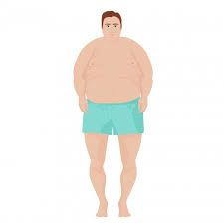Napis odpovede

Is he fat?

Is he slim?

Is he tall?

Is he small?

Is he Michal Vojtek?