**Multiphase Flow: Impact of Interfacial mass transfer on bubble dynamics**

**Kenechukwu Ezenduka**

**The Pennsylvania State University**

**Abstract**

Dry Ice sublimates in water to form captivating bubbles. These bubbles produce a mist like solution as they rise in hydrostatic water indicating the presence of interfacial mass transfer between the bubbles and the water. However, since air bubbles do not give off any solution or indication of interfacial mass transfer like the Dry Ice bubbles, it is imperative to see if any significant differences occur between the dynamics of the air and dry ice bubbles. Therefore, this experiment serves to test and measure the differences, with regards to the rising velocity and rising path, between the dry ice and air bubbles using high-speed cameras, a water tunnel and image processing algorithms.

**Introduction**

The dynamics of air bubbles rising in quiescent water has been rigorously studied in the last few decades, with most research confirming that the bubbles rise in spiral paths (Tripathi, Sahu & Govindarajan, 2015). However, air bubbles do not experience interfacial mass transfer with water as they rise and given the importance of interfacial mass transfer in fields like nuclear engineering, where in nuclear and chemical reactors, bubbles formed by boiling water experience interfacial mass transfer and they rise through water and also due to the lack of knowledge of the effects of interfacial mass transfer on bubble dynamics, it is imperative to study the effects, if any, of interfacial mass transfer on the dynamics of bubbles rising in quiescent bubbles. On the other hand, dry Ice bubbles experience interfacial mass transfer while rising in quiescent water, evidently by the formation of mist solution at the top of the water after the bubbles have burst and during the phase change of the dry ice from solid to gas when placed in water. Furthermore, this experiment serves to study the bubble dynamics of dry ice bubbles and to compare the results with that of air bubbles to discern the difference between dynamics the bubbles.

**Methods**

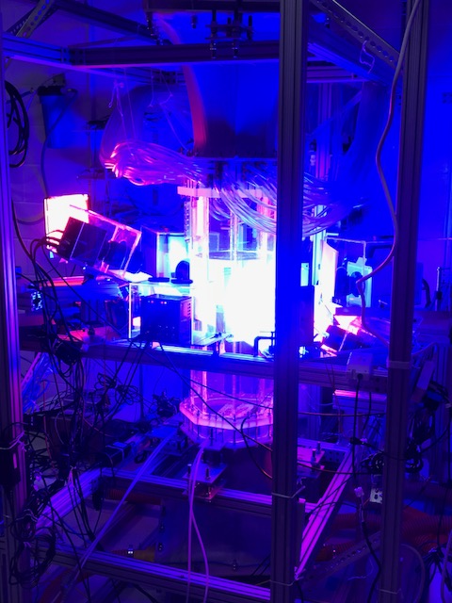Dry ice was put in a bottle filled with water which was then lowered into a water tank surrounded by six high speed cameras. The bottle was filled with water initially to prevent the capture of air bubbles. The dry ice was segmented into cubes of various sizes to control the sizes of the bubbles produced. Images of rising bubbles were captured with the cameras and an in- house image processing algorithm was used to derive the rising velocities and trajectories of bubbles from the captured images.

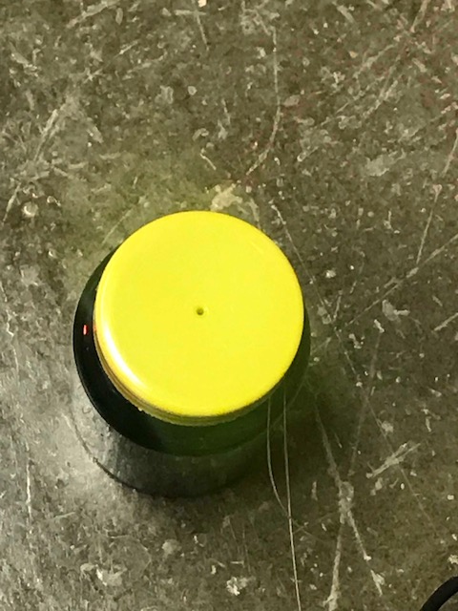

*Figure B: Water Tunnel*

*Figure A: Bottle containing Dry Ice*

**Results**

After the experiments where conducted, the images were run through an image processing computer program that processes the images and produces the rising velocity and paths of the bubbles. The rising velocities and paths were plotted on a graph.

*Figure C : Dry ice bubble rising*

*Figure D: Air bubble rising*

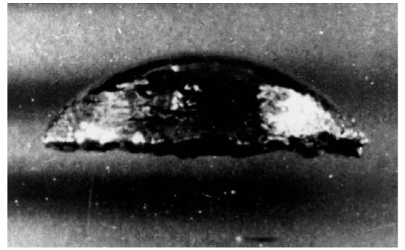

Figure C & D provides some insight to the effects of interfacial mass transfer on bubble deformation. From the figures, we see that dry ice bubbles deform in more unconventional shapes when compared with air bubbles that deform in more consistent spherical shapes (Hager & Weber, 1981). Thus, we can infer that interfacial mass transfer may make bubble deform in more unusual shapes than the commonly known spherical shape (Brennen, 2006).

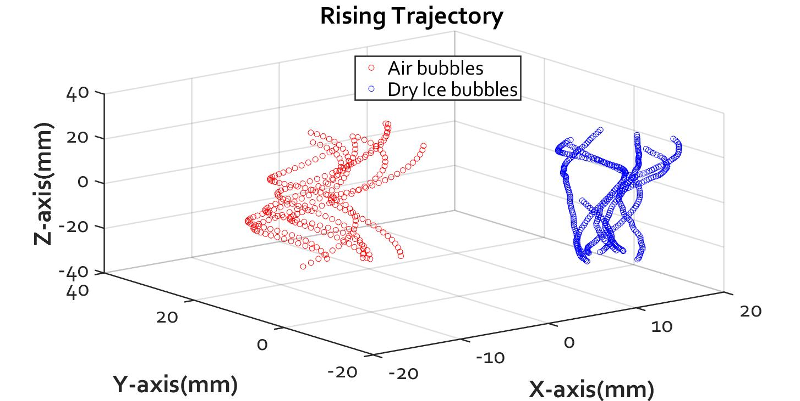

*Figure E: Rising trajectory of air and dry ice bubbles*

Figure E shows that dry ice bubbles rise with less lateral spread than the air bubbles of the same size (Talaia, 2007). This shows that presence of interfacial mass transfer may alter the rising path of the bubbles, specifically, by reducing the lateral spread of the bubbles as they rise through water.

*Figure F: Rising velocity of dry ice bubbles vs air bubbles*

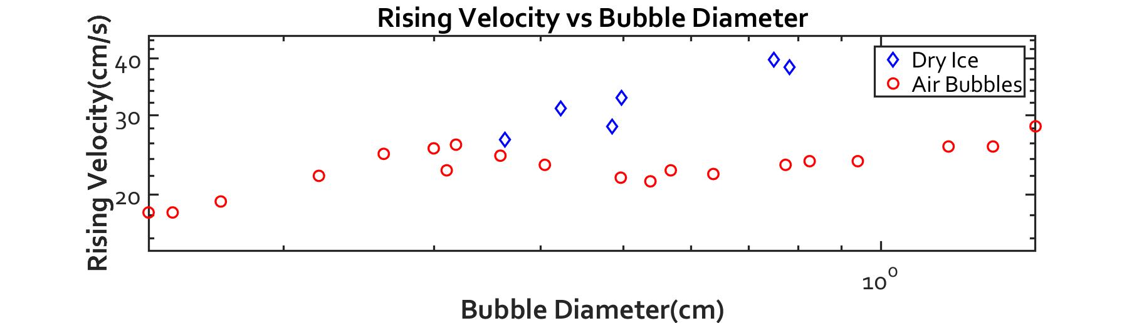

Figure F shows the rising velocity of dry ice bubbles and air bubbles for a given diameter. The dry ice bubbles had significantly higher rising velocities than the air bubbles of the same size gotten from the earlier work of Mario Talaia (Talaia, 2007). Just to ensure the validity and consistency of the findings, the experiment was repeated with air bubbles and compared with Mario Talaia’s air bubble samples. The air bubbles tested had similar dynamics to the one from Mario Talaia’s research and thus ensuring that the results are consistent. Evidently, the findings indicate that interfacial mass transfer may affect bubble dynamics by increasing the rising velocities of such bubbles.

**Conclusion**

The findings of the research show the way interfacial mass transfer affects the dynamics of the bubbles, which ultimately adds to the current knowledge of bubble dynamics. The findings also open the door for further research on bubble dynamics in presence of interfacial mass transfer, especially regarding wake instability and momentum coupling. The results from these experiments also provokes more research on interfacial mass transfer, particularly, research on the reason interfacial mass transfer alters the rising velocities and path of these bubbles and the meaning of potential findings in fields of nuclear and chemical engineering.

**References**

Brennen, Christopher E. “Spherical Bubble Dynamics.” Cavitation and Bubble Dynamics, pp. 168., doi:10.1017/cbo9781107338760.003.

Haga, D., and M. E. Weber. “Bubbles in Viscous Liquids: Shapes, Wakes and Velocities.” *Journal of Fluid Mechanics*, vol. 105, no. -1, 1981, p. 61., doi:10.1017/s002211208100311x.

Tripathi, Manoj Kumar, et al. “Dynamics of an Initially Spherical Bubble Rising in Quiescent Liquid.” *Nature Communications*, vol. 6, no. 1, 2015, doi:10.1038/ncomms7268.

Talaia, Mario. (2007). Terminal Velocity of a Bubble Rise in a Liquid. World Acad. Sci. Eng. Technol.. 28.

Larachi, F., et al. “Gasâ Liquid Interfacial Mass Transfer in Trickle-Bed Reactors at Elevated Pressures.” *Industrial & Engineering Chemistry Research*, vol. 37, no. 3, 1998, pp. 718–733., doi:10.1021/ie960903u.