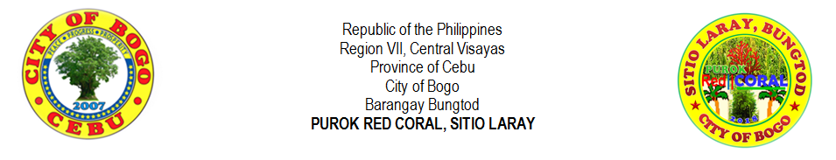
OFFICE OF THE PUROK PRESIDENT
________________________________________________________________________________________________________________________________________________________________________________________________

PUROK CERTIFICATION
TO WHOM IT MAY CONCERN:

This is to certify that ______________________________________________________, _________ years old, born on ____________________________ a Filipino citizen, and a bona fide resident of Purok Red Coral of Sitio Laray, Bungtod, Bogo City, Cebu. He or she is a registered voter in Barangay _________________________ and hereby certify that he or she is an

 | ACTIVE | (duly met the required expected amount of payment and the number of times in the participation in the purok community service (Pentakasi) or any activities in the purok)
 | INACTIVE | (with pending or unpaid monthly contribution and negligence in the responsibility during the community service (Pentakasi) or unattending of any social welfare development activities)

This certification is issued in support of the evaluation or processing of the application of the above-mentioned for the grant of __________________________________________ and for the pursuance of his or her other requirements therewith. This is to certify further, that the aforementioned resident has no derogatory record on file and has not violated any of our purok rules and regulations.

This is also to certify that he or she is giving a correct information regarding his or her name, age, date of birth and place of voter’s registration. Any incorrect information stated above is not valid and hereby testify with documents such as NSO Live Birth Certificate and Voter’s ID or Voter’s Certification.

Given this ________ day of _______________________________, 20____ at Purok Red Coral, Laray, Bungtod, Bogo City, Cebu 6010 Philippines.

Prepared by:
 | MIRASOL S. TAÑARA |  |  |  | ROWENA V. DADUL
 | Purok Secretary |  |  |  | Purok Treasurer
 |  |  |  |  | 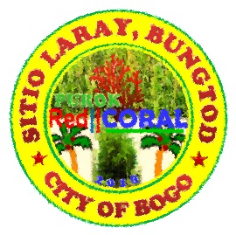
Certified by:

 |  |  | RIFE D. AVENIDO
 | Committee Chair |  | Purok President |  | Not Valid Without Seal

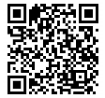 | Official Website: | https://purokredcoralaraybungtod2018.site123.me | 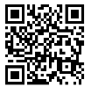 | Magazine Website: | 6013aa6622a5d.site123.me
 | Email: | purokredcoral2018@gmail.com | Control No:

