Republic of the Philippines
Region VII, Central Visayas
Province of Cebu
City of Bogo
Barangay Bungtod
Purok |  | , | Sitio

Date Conducted: |  |  | Conducted by:

SEASONAL CALENDAR

INDICATORS |  | JAN | FEB | MAR | APR | MAY | JUN | JUL | AUG | SEP | OCT | NOV | DEC
Climate | PRESENT
 | PAST
Hazards | PRESENT
 | PAST
Health Problems | PRESENT
 | PAST
INDICATORS |  | JAN | FEB | MAR | APR | MAY | JUN | JUL | AUG | SEP | OCT | NOV | DEC
Livelihood Activities | PRESENT
 | PAST
Health  Activities | PRESENT
 | PAST
Social  Activities | PRESENT
 | PAST
Religious Activities | PRESENT
 | PAST
Household  Income | PRESENT
 | PAST
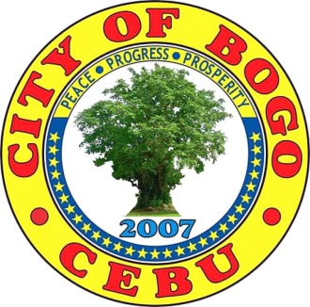
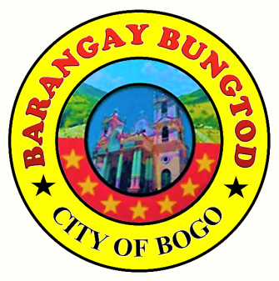
Republic of the Philippines
Region VII, Central Visayas
Province of Cebu
City of Bogo
Barangay Bungtod
Current Year: | 2019

Name of Barangay: | BARANGAY BUNGTOD |  | Date Accomplished: | SEPTEMBER 22, 2019

HISTORICAL TIMELINE
DATE | EVENT | IMPACTS | ORGANIZATION | REMARKS
8 November 2013  10–30 November 2013  December 2013  4 July 2014  July 2015  25 April 2016 | Massive Destruction of the Typhoon “Yolanda”  Relief goods distribution by different organizations or institutions  Relief goods distribution  Ground – breaking Ceremony  International Society of Automation (ISA) cash Assistance Distribution  Turn – over of houses | A percentage of 90 % of houses and many trees were destroyed by the typhoon even livelihood such as farming and livestock.  Helped in recovering the victims’ situation.  Helped in lessening the victims’ experience.  Met the agreement between LGU – Bogo and CBCP, NASSA, CARITAS Philippines to give its ground title.  Gave a financial assistance to the victims in order to build a house.  Helped to provide shelter to the victims. | NONE  LGU – Bogo and St. Louise de Marillac College of Bogo  MAGDALO  LGU – Bogo  CBCP, NASSA and CARITAS Philippines  International Governments through LGU – Bogo / ISA  LGU – Bogo  CARITAS Philippines | The victims were in the process of experiencing the impact of the strong typhoon.  They gave hope to the victims through welfare activities.  They gave a social welfare activity to help others.  They gave a great help to the victims of the disaster.  They gave a great help to the victims.  They gave a great help to the victims.
DATE | EVENT | IMPACTS | ORGANIZATION | REMARKS
4 June 2016  8 April 2018  July 2018  11 August 2018  December 2018  20 January 2019  11, 14, 17 – 21 June 2019  9 -11 July 2019 | Midterm Planning Review  Fourth Inter – Barangay and Commercial Fire Olympics  Creation of the Purok System and Purok Centers  Turn – over of houses to home partners  Christmas Party Celebration of different Puroks  Sitio Laray Sinulog Festival  Philippine Red Cross Baseline Survey  Community – based Disaster Risk Reduction and Management Training | Helped the residents rebuild their lives such as alternative water source, rainwater containers(drums), footpaths, livelihood such as animal – raising, gardening, fashion accessories – making and soap – making.  Participants were provided with knowledge and skills on rescue and transfer relay, combination of busted hose and ladder and bucket relay and fire extinguishment.  Developed the spirit of “bayanihan” or solidarity among the residents.  Provided with housing to the typhoon victims.  Developed the spirit of unity and build strong relationship.  Developed the spirit of unity developed one’s talent especially the youth.  Gained information from residents regarding disaster experience and outcome.  Gained knowledge and skills on how to respond to disaster and on VCA conduction. | Pollution Central Association of the Philippines Region 7 (PCAPI – 7) and  PCAPI – 7 Foundation  Bogo City Fire Station Department and  LGU – Bogo  LGU – Bogo / Barangay Affairs / Liga ng mga Barangay  CFC – ANCOP UAE Bogo and Homeowners’ Association  Purok Community  Mrs. Belen Gulane and Rev. Fr. Patricio Ornopia  Philippine Red Cross – Northern Cebu Chapter  Philippine Red Cross – Northern Cebu Chapter | The plans gave a great help to the victims and need to continue in order to develop the life – changing perspective.  They gave a preparation to respond to fire situations.  It helped to build strong relationship among residents but it made the residents found a hard time for the responsibilities between the family and the community.  The housing program gave a great help to the beneficiaries.  It gave the community the goals of peace, progress and prosperity.  It gave the community the goals of promoting culture and peace.  It gave data on disaster and future plans or programs.  It helped the participants or volunteers to a proper conduction of the VCA.
DATE | EVENT | IMPACTS | ORGANIZATION | REMARKS
12 July 2019  11 August 2019  19 - 20 August 2019  23 August 2019  3 – 6 September 2019 | Barangay – based Disaster Risk Reduction and Management Planning and Workshop  Last awarding of 8 house duplex  Purok Evaluation  Purok Launching & Awarding Ceremony  Standard First – Aid Training | Helped how the barangay officials can effectively respond to the residents before, during, and after the disaster.  Thirty families were given certificate of occupancy for new houses and they were given a hope to live.  The 13 puroks presented their accomplishments to the evaluators and evaluated their performance and were proud of their accomplishments.  Gave the different puroks their level of performance and recognition to officially start the governance system.  Gained knowledge and skills on first – aid and how to respond to emergency situations such as accidents. | Philippine Red Cross – Northern Cebu Chapter  CFC – ANCOP UAE Bogo and LGU - Bogo  LGU – Bogo / Barangay Affairs / Liga ng mga Barangay  Barangay Bungtod Officials / Barangay Affairs / Liga ng mga Barangay  Philippine Red Cross – Northern Cebu Chapter | It gave the barangay a corresponding plan of action when addressing to the residents’ safety.  It gave a great help for the beneficiaries with housing.  It gave the different puroks how they performed well.  It gave every individual to be part of the development and progress of the community.  It gave a possibility to apply the skills learned whenever accidents occurred especially to the family.

