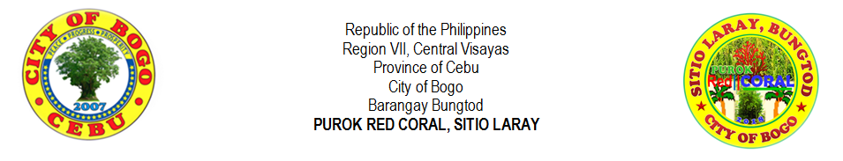
LIST OF VACCINATED DOGS

Name of Barangay | : | BUNGTOG |  | Municipality/City | : | BOGO CITY
Name of Purok | : | RED CORAL |  | Region | : | VII

No. | Date | DOG PROFILE |  |  |  |  |  | PET OWNER
 |  | Name of Dog | Species  (Specify ) | Sex  (M/F) | Age (yrs.) | Neutering  No./C/S | Color | Name | Complete Address
1 | AUGUST 2019 | AN-AN |  | F | 7 | NO | WHITE | KEN PELAYO | LARAY BUNGTOD BOGO CITY CEBU
2 |  | BERNAM |  | M | 6 | C | WHITE & BLACK | KEN PELAYO
3 |  | TIGER |  | F | 6 | NO | ASH BROWN | KEN PELAYO
4 |  | MARS |  | F | 5 | NO | BROWN | KEN PELAYO
5 |  | VINCE |  | M | 5 | C | BLACK | KEN PELAYO
6

7

8

9

10

No. | Date | DOG PROFILE |  |  |  |  |  |  | PET OWNER
 |  | Name of Dog |  | Species  (Specify ) | Sex  (M/F) | Age (yrs.) | Neutering  No./C/S | Color | Name | Complete Address
11

12

13

14

15

16

17

18

19

20

21

22

23

24

25

Total Number of Vaccinated Dog:
LIST OF NON - VACCINATED DOGS

Name of Barangay | : |  |  | Municipality/City | :
Name of Purok | : |  |  | Region | :

No. | Date | DOG PROFILE |  |  |  |  |  | PET OWNER
 |  | Name of Dog | Species  (Specify ) | Sex  (M/F) | Age (yrs.) | Neutering  No./C/S | Color | Name | Complete Address
1

2

3

4

5

6

7

8

9

10

No. | Date | DOG PROFILE |  |  |  |  |  |  | PET OWNER
 |  | Name of Dog |  | Species  (Specify ) | Sex  (M/F) | Age (yrs.) | Neutering  No./C/S | Color | Name | Complete Address
11

12

13

14

15

16

17

18

19

20

21

22

23

24

25

Total Number of Non-Vaccinated Dog:

