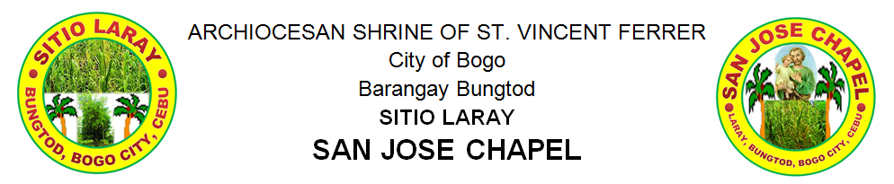
celebrates
Annual Fiesta of

SAINT JOSEPH

Theme:
“Treasure all the Gifts of God”
March 27 - 30, 2019

__________________________________
You are cordially invited
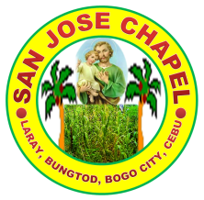
REMINISCING THE PAST
HISTORY OF SITIO LARAY
Sitio Laray formerly Sitio Tabayjo is located near and above the old municipal hall which was now the City of Bogo Science and Arts Academy and its way to visit was through the street at the façade of the school and the way where buses from Cebu City had always their turns. It was also at the façade of Carole residence now, the Carole Dy’s Nature Park and the land area was owned by Ybañez family and Madame Clomen Verallo which was her school named Felipe R. Verallo Memorial Foundation Inc. was built.

The sitio was named “Tabayjo” before which Agaton Ybañez owned a sugarcane farm that the area was named “Tres”, a Spanish term for third because this was the third farm in the place. In order to get the quota of the crops, Agaton asked the help of Angkay, the father of Irene (so lately, Agaton’s wife). There were no special historical events in the sitio aside from the World War II happened in the town of Bogo during on the year 1941 where the Americans had a battle against the Japanese. Both enemy forces started the war on the province of Cebu specially on the places within Cebu City until it came at the town. The Japanese troops camp was based at the place where the school named Northen Cebu Colleges (the first and oldest school in Northern part of Cebu which was built during 1932), while the Americans were based at Pulang Bato (now, Polambato). In the year 1936, another school named Escuela de la Sagrada Familia (now, St. Louise de Marillac College of Bogo) was built and ran by a nun from the Daughters of Charity which she was also a native in Bogo. She was Sister Dorotea Rubio, D.C. and asked from the assistance of her of her fervor missionary sister, Doña Raquel Rubio viuda de Sanchez which she also helped to build an elementary school for poor children in Bogo. The two schools were ran smoothly and peacefully until the war broke the silence during 1941 until 1944. Because of the delicate situation, the schools had no other choice, but they were temporarily closed.

Long ago in the mid-1920’s the land from Sitio Tabayjo going to the land where the location of Bogo Central School I in Barangay Cogon, was owned by the Mendoza family and years passed, the huge landmass was divided into portions as the family grew and relatives were given portions. The land from the corner of Sitio Laray until to the edge before the sugarcane plantation before was owned by Jose Sta. Teresa. Many years passed some portions of it were divided to Ybañez’s heirs and of course Sta. Teresa’s heirs. The portion of the land where the San Jose Chapel stood, was owned by one of the heir of Jose Sta. Teresa, his son Leo Sta. Teresa and the chapel was owned by him (Leo). The patron saint (San Jose) and the date of its fiesta celebration was also the day when Jose Sta. Teresa was born, and his name was derived from the name of the patron saint. Every fiesta, the Sta. Teresa family always lead the celebration and heirs, especially Madame Carmen, Leo and Dale were heartfully served the fiesta as they show their devotion to Saint Joseph.

After the war, Agaton Ybañez who was a farmer and a partner on the business with Angkay, ran the farm smoothly. Agaton, on the other side, worked hard in order the farm would not went down and because also of his loyalty, he was married to Angkay’s daughter named Irene. Until, the love that bloomed not only on the farm but also on the hearts of the two faithful lovers, bore into eight siblings (Editha, Vicente, Santiago, Antonio, Loly, Lita, Shirley and Mony). The family had settled at Barangay Bungtod, near the Archdicesan Shrine of San Vicenter Ferrer Parish and they continuously ran the

sugarcane farm. Another family from Cayang, Bogo came and settled their house at Sitio Tabayho whom the family was a peasant farmer of the Ybañez family. Some of the spaces of the land converted into farms and planted another crop, which was corn or “mais”. Because of loyalty and a trusted peasant, Fruto “Totong” Pega Tillor was given by Agaton a carabao in order to use for plowing the field. Several years of service and loyalty to the Ybañez family, and one of the remaining heirs of Agaton who owned the parcel of the land, still showing kindness to Totong’s family. The land area of sitio Tabayjo was huge and it was divided. Instead of being part of Barangay Dakit, the other half of the sitio was now part of Barangay Bungtod during the relocation. Some people have no idea about the place named “Lawis” which truly found in the map. The sitio that which part of Lawis was the Maharat and the other half of Sitio Tabayjo was renamed Maharat since it was nearer to it. Even though the sitio was renamed, there were no changes made from the side of few residents.

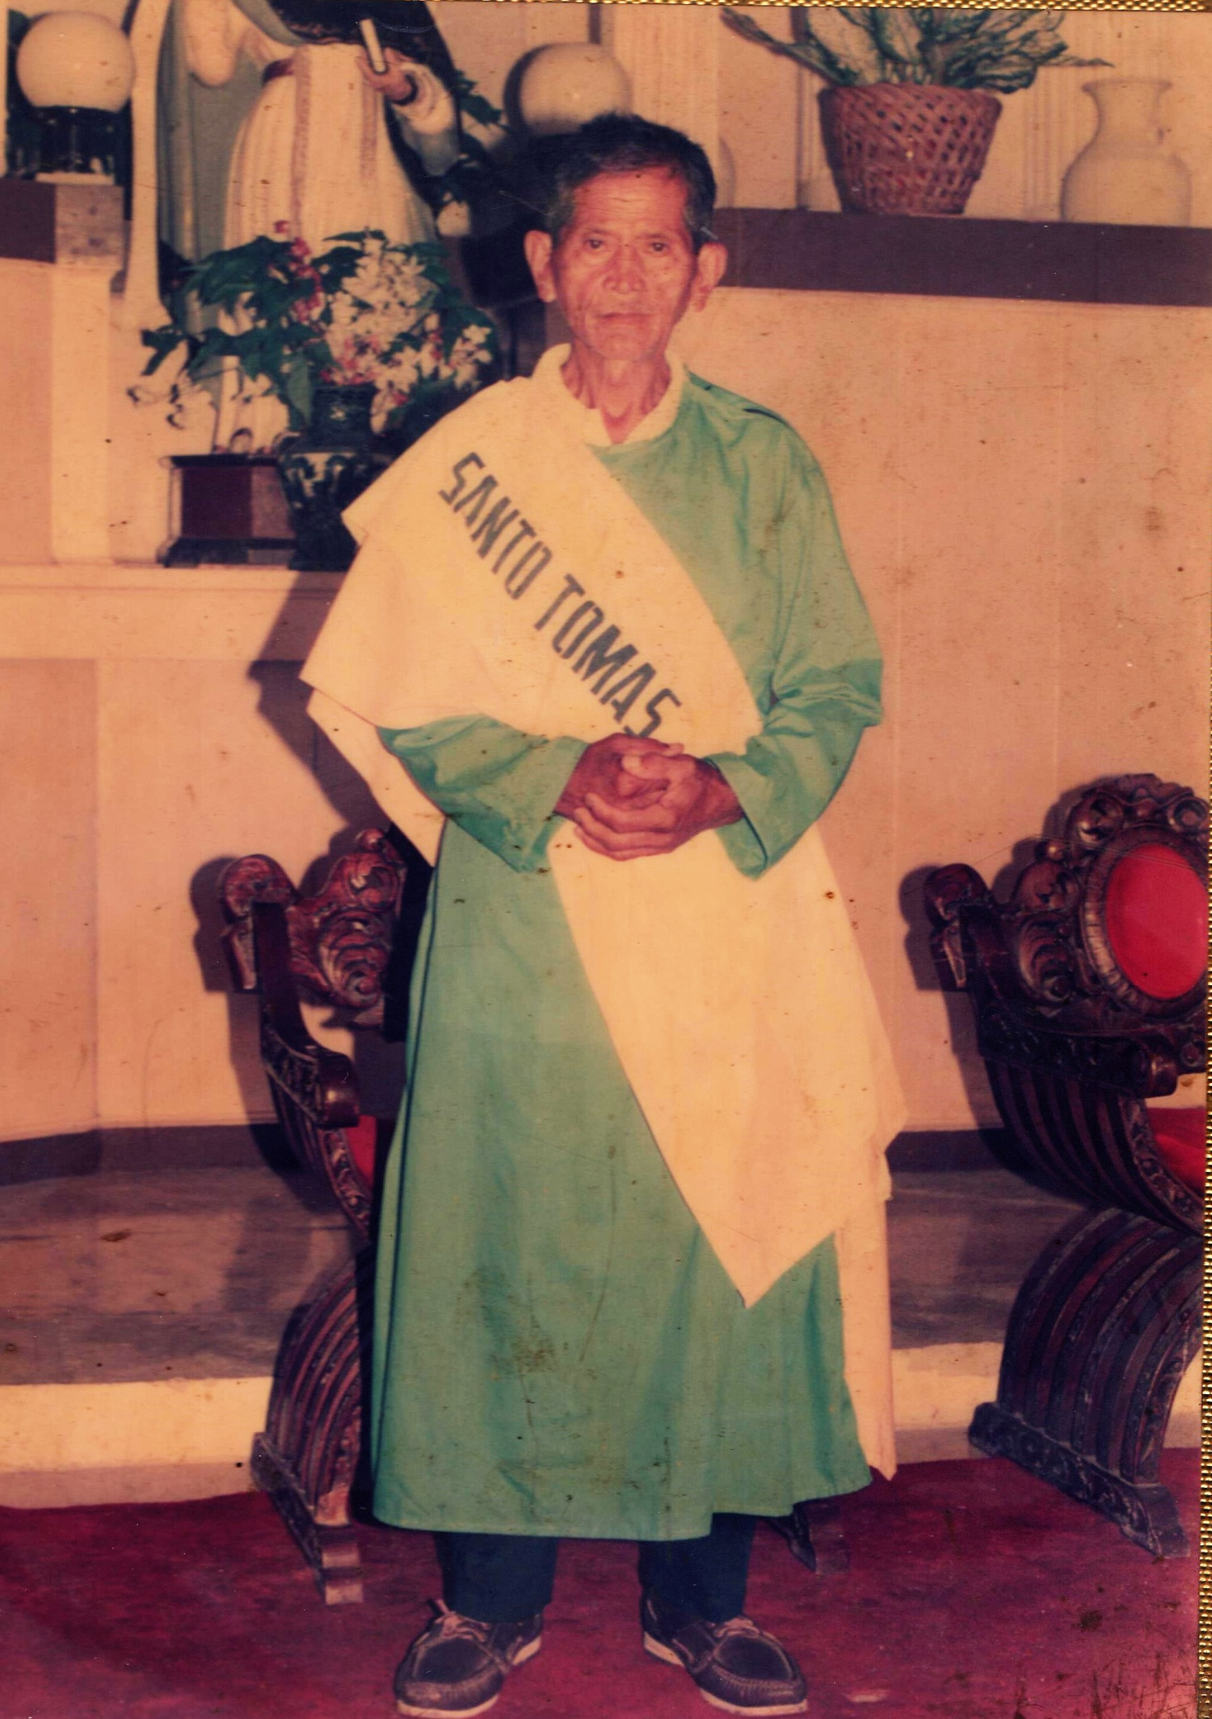
FRUTO “Totong” PEGA TILLOR SR.
BORN ON OCTOBER 25, 1921

“The Oldest Living Man of Sitio Laray”
Until, the sitio was added more people and built their houses on the same place, and another family had resided the small place and became a small community. Totong became a lay minister in the parish and his wife, Laurencia was also a servant in the parish. Both of the two were servants of God and they decided to have a dawn rosary in their small community. The activity had changed their lives to become more faithful to God, to the Son, Jesus Christ and to the Blessed Virgin Mary. Actually, the activity was always done during dawn and more on praying to God and giving honor to Mary. All of the family in the place had accepted Blessed Virgin Mary in their homes whenever there would be someone celebrating his or her birthday. Every home gave their heartfelt gratitude as the statue of Blessed Virgin Mary visited their houses. The activity exists until now and Ermielenda Ortega and other believers still bringing Mary to every home. She continues serving God despite of the death of Laurencia last January 2014. Not only they bringing Mary in their small community but they are visiting the nearest sitios such as Maharat and few houses in part of Barangay Cogon.

Then, the sitio was renamed Laray (means, “series”) because the place was planted by many coconut trees in which they were in series or in lined together. The parishioners from the Archdiocesan Shrine of St. Vincent Ferrer named it Laray as they observed the grown coconut in the place when they visited the place. The native in the place built their houses on the land of Ybañez and what they gave on return to the owner was to help particularly during the Holy Week activities as they help in beautifying the carousel, cooking and other way to assist in the preparation.

The source of living of the residents before was on farming as such the Villegas family which was the first family lived in the Sitio Tabayho (now sitio Laray) and had a corn farm but the land was owned property of Ybañez family. There was no corn mill on that time, and the way to process the
harvest was through the grains in a grinder which made of stone or wood. There are two types of the grinders, one made of wood and the other one was made of stone. There are no other differences of the two aside from the material they made but they have the same feature in which the form has two big circles which piled up and down and merely attached to each other, and the above circle has a small hole in the center in which the grains are placed in order to grind. The above circle has another hole on the side in which intended for the wood handle where it is placed. The way to grind is to push and pull the handle in order to turn the above circle and the broken grains will go outside from the cavity or space in the middle of the attached circles. There should be many sacks below the grinder to catch the grinded grains of corn. Until now, Pampela Villegas (an heir) preserved the grinders. At this modern society, the corn will be grinded in a corn mill to have a fine result and other material will be created from the grinded corn which is called as, “tahup”. “Tahup” will never been eaten by the people, instead, it will used in some of the ingredients to feed the pig. It has a strong odor and it somewhat like in a powdered form. To those farmers who don’t have poultry, they actually sell the “tahup” in kilo but the price is cheaper.

Eventhough lives were not easy but still the smiles of the residents were obsolete and the uniqueness in finding entertainment especially their sons and daughters. During the period of 1980’s to 1990’s, children or adolescents have the creativity in having an entertainment and that was on playing Filipino games such as patintero, luksong baka, luksong tinik, skipping rope, tumbang preso, buwan – buwan maliwanag ang buwan (this game is played best during nighttime under the moon), slipper game (the slipper is kicked by the foot and after, the player/s will have to run from the first base and turn until he reached the main base and it has a similarity with the baseball game), and slipper “manikin” up (played by throwing the slipper up and the direction of the slipper will go back from the one who throws it where the other players will have to catch the thrown slipper, and if not, the “taya” or “hago” , the loser will count for about ten counts decreasingly, and the other players will move and pause as the count down. If the count reaches one, one of the players will get the slipper from the ground and throws to the other player and the “taya” will touch the other player who catches or touches the slipper and whoever caught by the “taya”, he/she will be the loser.). There are many forms of entertainment in order to amuse themselves.

The most challenging and bitter experience happened in Sitio Laray was the strong typhoon Yolanda came where almost houses were destroyed and the livelihood of the residents was affected. The chapel was also destroyed by the typhoon and it was constructed again by the help of the Sta. Teresa family and another hope arose again because of their faith to God. November 8, 2013 is the unforgettable event in the history of Sitio Laray and other affected places.

CALENDAR OF ACTIVITIES
DATE | EVENT | TIME
March 21, 2019 | NOVENA | 3:00 PM
 | KASAULOGAN SA PULONG | 7:00 PM
March 22, 2019 | NOVENA | 3:00 PM
 | KASAULOGAN SA PULONG | 7:00 PM
March 23, 2019 | NOVENA | 3:00 PM
 | KASAULOGAN SA PULONG | 7:00 PM
March 24, 2019 | NOVENA | 3:00 PM
 | KASAULOGAN SA PULONG | 7:00 PM
March 25, 2019 | NOVENA | 3:00 PM
 | KASAULOGAN SA PULONG | 7:00 PM
March 26, 2019 | NOVENA | 3:00 PM
 | KASAULOGAN SA PULONG | 7:00 PM
March 27, 2019 | NOVENA | 3:00 PM
 | KASAULOGAN SA PULONG | 7:00 PM
 | DISCO | 8:00 PM
March 28, 2019 | NOVENA | 3:00 PM
 | KASAULOGAN SA PULONG | 7:00 PM
 | ZUMBA | 8:00 PM
 | DISCO | 9:30 PM
March 29, 2019 | NOVENA | 3:00 PM
 | KASAULOGAN SA PULONG | 7:00 PM
 | BATTLE OF THE CHAMPIONS SINGING CONTEST | 8:00 PM
 | DISCO | 10:30 PM
March 30, 2019 | MASS | 10:30 AM
 | LARO NG LAHI | 1:30 PM
 | NOVENA & PROCESSION | 5:00 PM
 | VARIETY SHOW | 8:00 PM
 | DISCO | 11:30 PM
LET’S HAVE FUN!

Move your hips and dance with good vibes!

Come and Dance!

Time: 8:00 PM
Date: March 28, 2019
Venue: Sitio Laray, Bungtod, Bogo City, Cebu
LET’S HAVE FUN!

Let’s hear the golden voices of the talented!

Come and Watch!

Time: 8:00 AM
Date: March 29, 2019
Venue: Sitio Laray, Bungtod, Bogo City, Cebu
LET’S HAVE FUN!

Let’s enjoy the showcase of different talents!

Come and Watch!

Time: 8:00 AM
Date: March 30, 2019
Venue: Sitio Laray, Bungtod, Bogo City, Cebu
LET’S HAVE FUN!

Go back to the original games of Pinoy!

Come and Enjoy!

This is open to all kids in Sitio Laray, Bungtod, Bogo City, Cebu who aged 6 to 12 years old and willing to enjoy and play the different “Laro ng Lahi Nating Mga Pilipino” or our national and traditional games of us Filipinos. This is a free tribute to the kids who want to enjoy and experience their life-being in their stage as a childhood.

Time: 1:30 AM
Date: March 30, 2019
Venue: Sitio Laray, Bungtod, Bogo City, Cebu
Fiesta Greetings from:
HON. LIZARDO Y. MIRAMBEL
& FAMILY

STA. TERESA FAMILY

FIESTA COMMITTEE

Snacks (by Date) | : | By Appointed Families
Food Servers (Fiesta) | : | Mrs. Nora Rosales
 | : | Mrs. Nimfa Bolambao
 | : | Mrs. Perlie Ysulan
 | : | Mr. Vicente D. Lepasana
 | : | Mrs. Amalia Ypil
Programme | : | Mr. Percilito C. Tillor, Over-all President, Sitio Laray Youth Organization
Stage Decoration | : | Purok Governance Team & Purok Youth Organization (Emerald & Red Coral)
Sound System Coordinator | : | Mr. Rene L. Bolambao
Physical Arrangement | : | Purok Emerald & Purok Red Coral Youth Officers & Members
Event Coordinators | : | Rene L. Bolambao & Henry Fernandez
After Care | : | Purok Emerald & Purok Red Coral PGT
Psalmist | : | Mrs. Amalia L. Ypil
Readers | : | Ms. Florimae L. Ypil
 | : | Mrs. Fe Yagon
Masters of Ceremony | : | Mr. Rene L. Bolambao
 | : | Mr. Henry Fernandez
PUROK GOVERNANCE TEAM
PUROK 1  EMERALD |  |  |  |  | 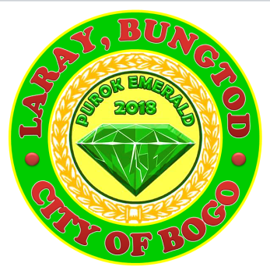
PUROK PRESIDENT |  |  | : | RENE L. BOLAMBAO
PUROK VICE – PRESIDENT |  |  | : | HENRY FERNANDEZ
PUROK SECRETARY |  |  | : | ANNABELLE A. BAJUYO
PUROK ASSISTANT SECRETARY |  |  | : | ROWELYN MALAIT
PUROK TREASURER |  |  | : | CELSA P. FERNANDEZ
PUROK AUDITOR |  |  | : | VIRGINTINA AWAYAN
COMMITTEES
HEALTH & NUTRITION |  |  | : | ELENA ANCERO
AGRICULTURE & LIVELIHOOD |  |  | : | JORENDA URSAL
EDUCATION |  |  | : | LIGAYA Y. JARAP
URBAN PLANNING & WASTE MANAGEMENT |  |  | : | JOHN PAUL SUMANTING
PEACE & ORDER & ENVIRONMENTAL PROTECTION |  |  | : | PABLO ANCERO
TOURISM |  |  | : | FE YAGON
WOMEN & CHILD PROTECTION |  |  | : | VIRGILIA MALAIT
YOUTH & SPORTS DEVELOPMENT |  |  | : | RONALD YNOC
INFRASTRUCTURE |  |  | : | ERMIE ROSALES
FINANCE, BUDGET, & APPROPRIATIONS |  |  | : | ANGEL SADIO
DISASTER RISK REDUCTION & MANAGEMENT |  |  | : | RYAN FERNANDEZ

VISION
Ang Purok 1 Emerald nga molambo, magmalinawon ug malig-on tungod sa mga tao nga nagkahiusa ug molambo usab dili lang ang purok hasta ang tanang pamilya nga nasakup dinhi sa Purok 1 Emerald.

MISSION
Alang sa kalamboan sa Purok 1 Emerald kinahanglan nga magtinabangay, mo-respeto sa usag-usa,mo-apil sa mga kalihokan nga mahitabo dinhi sa purok, ug magkahiusa pinaagi sa gugma ug pag-ampo sa atong Ginoong Hesukristo nga malamboon ang atong Purok hilabi na sa atong mga tagsa-tagsang panginabuhi.
PUROK YOUTH ORGANIZATION

PUROK 1
EMERALD
PUROK YOUTH PRESIDENT | : | SARAH JANE SUMANTING
PUROK YOUTH VICE – PRESIDENT | : | JUVY PEARL Y. JARAP
PUROK YOUTH SECRETARY | : | RIZA MAE DIAMANTE
PUROK YOUTH TREASURER | : | MARIE HOPE ARRIESGADO
PUROK YOUTH AUDITOR | : | KINETH FERNANDEZ
PUROK YOUTH PIO’S | : | JOAN ADRALES
 | : | JOAN OFTANA
PUROK YOUTH SERGEANT @ ARMS | : | CHRISTIAN ANTONIO

PUROK GOVERNANCE TEAM

PUROK 2  RED CORAL |  |  | 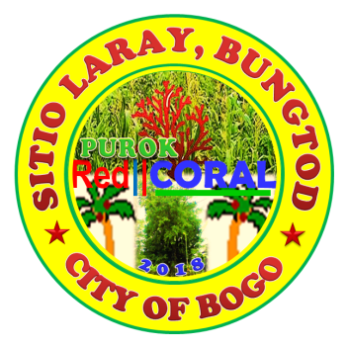
PUROK PRESIDENT | : | RIFE D. AVENIDO
PUROK VICE – PRESIDENT | : | AMALIA L. YPIL
PUROK SECRETARY | : | MIRASOL S. TAÑARA
PUROK TREASURER | : | ROWENA V. DADUL
PUROK AUDITOR | : | ELENITA V. URSABIA
COMMITTEES
HEALTH & NUTRITION | : | MIRALUNA A. URSABIA
AGRICULTURE & LIVELIHOOD | : | DOMINGO P. YSULAN
EDUCATION | : | PERLIE T. YSULAN
URBAN PLANNING & WASTE MANAGEMENT | : | MARIA G. ORTEGA
PEACE & ORDER & ENVIRONMENTAL PROTECTION | : | RUBEN D. BERNAL SR.
TOURISM | : | LORNA V. GESTA
WOMEN & CHILD PROTECTION | : | AMALIA L. YPIL
YOUTH & SPORTS DEVELOPMENT | : | GLEN V. ROMAGOS
INFRASTRUCTURE | : | DENNIS V. URSABIA
FINANCE, BUDGET, & APPROPRIATIONS | : | MARIFIL O. ABELLA
DISASTER RISK REDUCTION & MANAGEMENT | : | ERWIN C. VILLEGAS

VISION
We envisioned to offer better opportunities of our fellow residents by providing quality services that correspond to the demands of time and needs in our community.

MISSION
To improve the quality of life through varied services in health, agriculture, education, human risk reduction management, solid waste management, sports, environmental projects in our Purok Red Coral.
PUROK YOUTH ORGANIZATION

PUROK 2
RED CORAL
PUROK YOUTH PRESIDENT | : | JOSE WILLIAM V. ROMAGOS JR.
PUROK YOUTH VICE – PRESIDENT | : | PERCILITO C. TILLOR
PUROK YOUTH SECRETARY | : | FLORIMAE L. YPIL
PUROK YOUTH TREASURER | : | CHRISTIAN IAN S. TAÑARA
PUROK YOUTH AUDITOR | : | JOHN ELTON I. CODERA
PUROK YOUTH PIO’S | : | JOHN REIL C.LALANTACON
 | : | JERIC Y. MONTELLANO
PUROK YOUTH SERGEANT @ ARMS | : | RUBEN C. BERNAL JR.
 | : | JOHNROUE V. DADUL

PUROK RED CORAL
Website: https://purokredcorallaraybungtod.site123.me
Email Address: www.purokredcorallaraybungtod2018@gmail.com
Facebook: Purok Red Coral Facebook Page
Contact: 09359604284

NOVENA & MASS SPONSORS

MARCH 21 | -- | DALE STA. TERESA & FAMILY
MARCH 22 | -- | DIAMANTE FAMILY & BOLAMBAO FAMILY
MARCH 23 | -- | YAGON FAMILY, JARAP FAMILY, CUEVA FAMILY
MARCH 24 | -- | FERNANDEZ,MALAIT, PIAÑAR, & ANCERO FAMILIES
MARCH 25 | -- | LEPASANA, YPIL, CATAGBO, & CODERA FAMILIES
MARCH 26 | -- | AWAYAN, ATON, VERDIDA, DELA ROSA, & GORGONIA FAMILIES
MARCH 27 | -- | ORTEGA FAMILY, TILLOR FAMILY, & VILLEGAS FAMILY
MARCH 28 | -- | PUROK EMERALD &  PUROK RED CORAL, YNOC & ROSALES FAMILIES
MARCH 29 | -- | BARANGAY BUNGTOD OFFICIALS
MARCH 30 | -- | FIESTA

ACKNLOWLEDGEMENT

We, the Sitio Laray Committee would like to extend our sincerest and warmest gratitude to those people who extended their hearts in order these events made successful and possible for the residents in Sitio Laray. To those who give their full support in terms of financial matters, efforts, time and talent, you are the precious gift God gave unto us. We humbly acknowledge your great contribution for the success of these events.

PUBLIC APOLOGY

We, the Sitio Laray Committee would like to ask an apology to the public, to those printed names who have been misspelled in this program and we don’t have any intention for committing these kind of mistakes. Also, any contributing person whose name was not printed, we will just acknowledge your name during the evening programs. Yet, we are sincere to accept our mistakes and we are responsible to correct it.

