**THE PEOPLE AND THEIR BACKGROUND**





“Bogohanon” is term coined for a native living in Bogo, who is a bonafide resident and born in the same place. Bogohanons are the folks who always aspire for peace, progress and prosperity, perspire for dreams to come into reality, and inspire fellow Bogohanons for the achievements globally. A true Bogohanon knows how to look back from where he rooted and knows how to look forward into his future. Yes, truly indeed, Bogohanons always say, “Padayon Bogo” as how the Bogo hymn was made and the song tells how natives love and nurture the place. Looking from the past, Bogohanons were traders as their goods bartered to the other merchants and the business settled on a lone bogo tree (Garuga floribunda), where the place got its name.

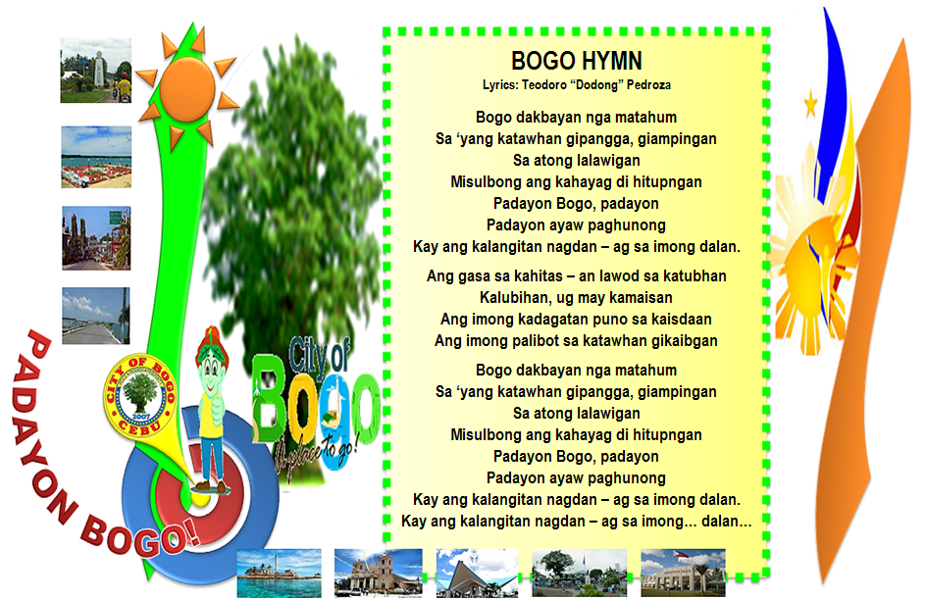

**Who are these natives in Sitio Laray?**

Every man and woman living in every place have something to call for them. People living in the province of Cebu, they called as Cebuanos or Bisaya which the dialect used is Sinugbuanong Binisaya. Bogo City is one of the towns in Cebu and the people are called as Bogohanons, and the natives living in Sitio Laray are called as Laraynons and they speak the same dialect as well. Laraynons are Bungturanons (residents in Barangay Bungtod, means “hill”) and the first people living in Sitio Laray formerly Sitio Tabayho are small – scale farmers of corn fields and until now, the heirs still run the farm. Some farmers don’t have their own land and the type of sharing is ½ in which half of the crops will go to the land owner and the other half will go to the farmers. They have different forms of livelihood such as farming, livestock and poultry and some of them are vendors or makers of one of the delicacies in Bogo known as, “pintos” which made from corn or “mais”.

The first family living in the sitio is the Villegas Family which they are farmers and the farm is transferred from one generation to another generation. The family owned a corn farm and they have the grinders which they used in grinding the corn into small pieces and they were made of wood and stone. There are two types of the grinders, one made of wood and the other one was made of stone. There are no other differences of the two aside from the material they made but they have the same feature in which the form has two big circles which piled up and down and merely attached to each other, and the above circle has a small hole in the center in which the grains are placed in order to grind. The above circle has another hole on the side in which intended for the wood handle where it is placed. The way to grind is to push and pull the handle in order to turn the above circle and the broken grains will go outside from the cavity or space in the middle of the attached circles. There should be many sacks below the grinder to catch the grinded grains of corn. Until now, Pampela Villegas (an heir) preserved the grinders. At this modern society, the corn will be grinded in a corn mill to have a fine result and other material will be created from the grinded corn which is called as, “tahup”. “Tahup” will never been eaten by the people, instead, it will used in some of the ingredients to feed the pig. It has a strong odor and it somewhat like in a powdered form. To those farmers who don’t have poultry, they actually sell the “tahup” in kilo but the price is cheaper.

During the period of 1980’s to 1990’s, children or adolescents have the creativity in having an entertainment and that was on playing Filipino games such as patintero, luksong baka, luksong tinik, skipping rope, tumbang preso, buwan – buwan maliwanag ang buwan (this game is played best during nighttime under the moon), slipper game (the slipper is kicked by the foot and after, the player/s will have to run from the first base and turn until he reached the main base and it has a similarity with the baseball game), and slipper “manikin” up (played by throwing the slipper up and the direction of the slipper will go back from the one who throws it where the other players will have to catch the thrown slipper, and if not, the “taya” or “hago” , the loser will count for about ten counts decreasingly, and the other players will move and pause as the count down. If the count reaches one, one of the players will get the slipper from the ground and throws to the other player and the “taya” will touch the other player who catches or touches the slipper and whoever caught by the “taya”, he/she will be the loser.). There are many forms of entertainment in order to amuse themselves.

The true Laraynons know how to give “utang na loob” to the people who show kindness to them especially, to the owner of the land where their houses built. Those families whose houses stood on the land property of Lita Ybañez and Monina Y. Wijt, give in return to the owners from the crops and other factors. Even though how hard life is for the residents, they will never stop to find a way for living. Mostly, they are from extended family and as their family grows, and the time goes on, they have to settle for their own. Still, they decided to settle their own houses nearer to each other. So, that’s why, most of the residents are blood – related. People in Sitio Laray had experienced the phenomenal, remarkable history and unforgettable ecological backlash last November 2013 where the super typhoon Yolanda broke the houses of the residents and few houses remain. Others lived temporarily and shortly with those families had still their houses. After the calamity, people stood again and built their houses with the help and assistance from the government and charity foundations.

**Padayon Bogo!**

A household consists of one or more people who live in the same dwelling and also share meals or living accommodation, and may consist of a single family or some other grouping of people.[1] A single dwelling will be considered to contain multiple households if either meals or living space are not shared. The household is the basic unit of analysis in many social, microeconomic and government models[2], and is important to the fields of economics and inheritance.[3] Household models include the family, varieties of blended families, share housing, group homes, boarding houses, houses in multiple occupation (UK), and a single room occupancy (US). In feudal societies, the royal household and medieval households of the wealthy would also have included servants and other retainers.

Government definitions

For statistical purposes in the United Kingdom, a household is defined as "one person or a group of people who have the accommodation as their only or main residence and for a group, either share at least one meal a day or share the living accommodation, that is, a living room or sitting room".[4]

The United States Census definition similarly turns on "separate living quarters", i.e. "those in which the occupants live and eat separately from any other persons in the building"[5] A householder in the U.S. census is the "person (or one of the people) in whose name the housing unit is owned or rented (maintained);" if no person qualifies, any adult resident of a housing unit is a householder. The U.S. government formerly used the terms "head of the household" and "head of the family" to describe householders; beginning in 1980, these terms were officially dropped from the census and replaced with "householder".[6]

A household is officially defined as follows:[7]

A household includes all the persons who occupy a housing unit. A housing unit is a house, an apartment, a mobile home, a group of rooms, or a single room that is occupied (or if vacant, is intended for occupancy) as separate living quarters. Separate living quarters are those in which the occupants live and eat separately from any other persons in the building and which have direct access from the outside of the building or through a common hall. The occupants may be a single family, one person living alone, two or more families living together, or any other group of related or unrelated persons who share living arrangements. (People not living in households are classified as living in group quarters.)

Economic theories

Most economic theories assume there is only one income stream to a household[citation needed]; this a useful simplification for modeling, but does not necessarily reflect reality. Many households now include multiple income-earning members.

Most economic models do not address whether the members of a household are a family in the traditional sense. Government and policy discussions often treat the terms household and family as synonymous,[citation needed] especially in western societies where the nuclear family has become the most common family structure.[dubious – discuss] In reality, there is not always a one-to-one relationship between households and families.

Social

In social work the household is a residential grouping defined similarly to the above in which housework is divided and performed by householders. Care may be delivered by one householder to another, depending upon their respective needs, abilities, and perhaps disabilities. Different household compositions may lead to differential life and health expectations and outcomes for household members.[9][10] Eligibility for certain community services and welfare benefits may depend upon household composition.[11]

In sociology 'household work strategy', a term coined by Ray Pahl,[12][13] is the division of labour between members of a household, whether implicit or the result of explicit decision–making, with the alternatives weighed up in a simplified type of cost-benefit analysis. It is a plan for the relative deployment of household members' time between the three domains of employment: i) in the market economy, including home-based self-employment second jobs, in order to obtain money to buy goods and services in the market; ii) domestic production work, such as cultivating a vegetable patch or raising chickens, purely to supply food to the household; and iii) domestic consumption work to provide goods and services directly within the household, such as cooking meals, child–care, household repairs, or the manufacture of clothes and gifts. Household work strategies may vary over the life-cycle, as household members age, or with the economic environment; they may be imposed by one person or be decided collectively.[14]

Feminism examines the ways that gender roles affect the division of labour within households. Sociologist Arlie Russell Hochschild in The Second Shift and The Time Bind presents evidence that in two-career couples, men and women, on average, spend about equal amounts of time working, but women still spend more time on housework.[15][16] Cathy Young, another feminist writer, responds to Hochschild's assertions by arguing that in some cases, women may prevent the equal participation of men in housework and parenting.[17]

Household models

Household models in anglophone culture include the family and varieties of blended families, share housing, and group homes for people with support needs. Other models of living situations which may meet definitions of a household include boarding houses, a house in multiple occupation (UK), and a single room occupancy (US).

In feudal or aristocratic societies, a household may include servants or retainers, whether or not they are explicitly so named. Their roles may blur the line between a family member and an employee. In such cases, they ultimately derive their income from the household's principal income.