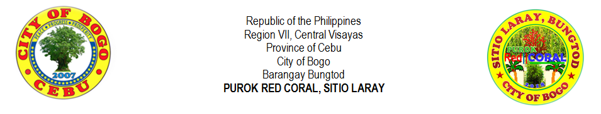
THE TAMARIND TREE: OUR PRIDE
by: Percilito C. Tillor

Every people all over the world have an own pride. Here, in a small community of Purok Red Coral, we have our own pride and we are proud to present it all over the world. In a simple way and manner, we would like to introduce, the biggest tamarind tree. This tree is planted by Fruto “Totong” Pega Tillor Sr., the oldest living man in our purok. He was born on October 25, 1921 and he is a native of Bogo and all throughout his life, only he could always think is his family. Despite of his age, he could always exactly remember about his past during the time of the World War II happened in the history of Bogo. There are many things he could not forget and one of those is the tamarind tree. There is an instance that the planted tree was claimed by his neighbor himself but if he would be the one to say, “Ako ang nagtanom ning sambag. Kung sila ang nagtanom og ilang angkonon, nganong tua man sila dapit namuyo layo sa sambag.” According to him, Pedro Aton claimed that he himself was the one who panted the tree and Totong did not remember when he planted it. After Totong was married to Laurencia Caayon on October 17, 1973 and they had already settled at the land owned by Monita Ybañez Wijt. The tree as being estimated, it lasts between 30 to 40 years from 2018 as forward.
Based on the environmental principle 3, “Everything is connected to everything else.” It means that all the things in this world are connected, both things with life and without life. For example, a fish has a life and this animal live in the water which does not have life. Whenever you will get the fish out from the water, the fish will die. The fish is connected to the water which gives life to the fish. As the tree is planted and grew, anyone can benefit from the tree. The tamarind tree has an important value to the person who planted it. As for Totong, the tree matters him most. There was such thing that this tree made special for him and to his family. He and his family built their house on this place and he planted the tree near from their house. As the tree grow taller and bigger for many years, then, it gives relaxation as anyone can take a rest or nap under the tree as it gives a wide shade because of its large in size. Here, under the tree, where the little children play and climb above it. This is also the spot where the family placed their pig before. Others said that this large tree was a home of an unidentified mythical creature but for the family, they didn’t believe on some told stories. Even the youngest son tried to prove that it was not true. The son slept under the tree many nights alone but there was no such thing happened to him even feelings.
The family transferred and built a new house still near at the tree. Until, the darkest time experienced by the people in Bogo last November 8, 2013, the super typhoon Yolanda destroyed some establishments, houses and trees. In the place only four houses and two dormitories of Felipe R. Verallo Memorial Foundation College, Inc. remained. Luckily, the house of Totong had only a partial damage and some neighbors temporarily occupied on their house and others occupied in the house of late, Lita Ybañez. As of the condition of the tree, a partial damage as well, and some branches were destroyed by the typhoon. The tree remained strong as well as Totong and his family.
The fruits taste sour and people liked to eat especially the children or even made into a “tamarindo”. It’s very simple to cook by adding sugar and cooked in a pan. The people before liked to eat “tamarindo” and as the time changes, no one tried to make it. The tree today is lonely until its body is gradually destroyed by the “bunlod”, a creature who likes to eat organic matters like wood. Its fruit is also used in cooking made by Filipinos known as “tinola” or in the locality, “tinowa” which can add sourness. The small leaves can also be eaten by the goats. The leaves easily fallen as the strong wind blows and the major branches, pave their ways into an up-straight or curved-like structure. The up-straight structures of the major branches behave until to the highest level where it could reach into 50 – 60 meters and in the middle of it, another minor branches sprouted. Also, in the minor branches sprouted minute branches that never should grasp by the hand as it never lasts the weight of the person. The sub-minor branches can grasp by a hand but only the nearest extension from its minor branch should be held. The minor branches have the ability to bend back and forth and it never survive when the strong wind strikes and the tip dances with the wind where it starts the major tension until into the minor branches, and a little tension will happen in the major branches. The dried fallen leaves make the land rich in nutrients and can also be used as organic fertilizer. The minute branches extend another thinner minute branch and it is the last branch to make the spine of the leaves. Then, the 24 leaves sprouted from the main spine which they are parallel to each other that every side will have 12 leaves. The trunk’s circumference measured for about 4 meters and 72 centimeters.
The tamarind tree symbolizes courage which in times of hardships and trials in life, the natives will never stop to stand again and to survive with all their strength. As its roots hold strong from the riches of the land and the strength is abound with another strong roots. That, in our life, in those fallen times, the little strength remains in ourselves can pull us to make another new day and new hope.
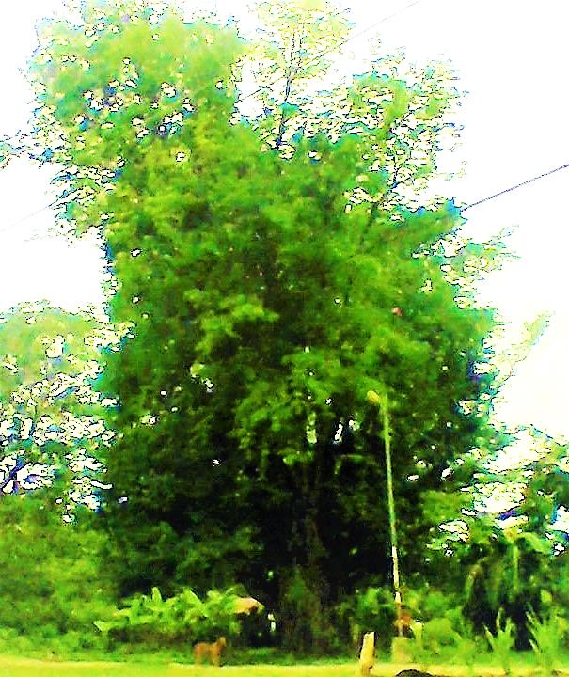
THE TAMARIND TREE
Location: Purok Red Coral, Laray, Bungtod, Bogo City, Cebu

The encircled part is the spot where the old house made of wood by the Tillor family is located and now was made into a piggery owned by Mr. Domingo P. Ysulan, the son-in-law of Totong and his family..

