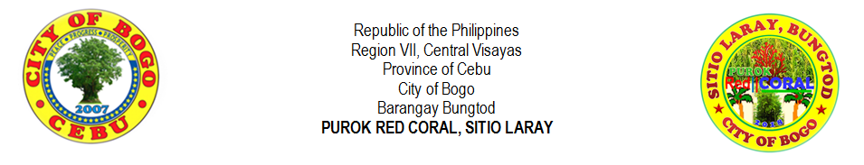
PUROK RED CORAL YOUTH ORGANIZATION
PUROK YOUTH MONTHLY CONTRIBUTION

 | NAME |  |  |  |  |  |  | MONTH AND YEAR
 |  |  |  |  |  |  |  | NOV. 2018 | DEC. 2018 | JAN. 2019 | FEB. 2019 | MAR. 2019 | APR. 2019 | MAY 2019 | JUN. 2019 | JUL. 2019
1 | ALBURO | , |  | JINIEBEB |  | TUMULAK
2 | ARNOZA | , |  | JOHN BRYLE |  | TILLOR
3 | ARPON | , |  | CHARLIE BON |  | YNOC
4 | ARPON | , |  | JOHN MICHAEL |  | YNOC
5 | ARPON | , |  | SHAINA MAE |  | YNOC
6 | ATON | , |  | CHRISTINA MAYSSA |  | CODERA
7 | ATON | , |  | CHRISTINE MAE |  | CODERA
8 | ATON | , |  | CHRISTY ANN |  | CODERA
9 | ATON | , |  | FELIX JR. |  | LOPEZ
10 | ATON | , |  | MARJUN |  | CODERA
11 | AVENIDO | , |  | JIRAH |  | RECLA
12 | AWAYAN | , |  | GENALYN |  | VILLEGAS
13 | BERNAL | , |  | JULIE ANN |  | DOONG
14 | BERNAL | , |  | MARIE RUAN |  | CANAMA
 | NAME |  |  |  |  |  |  | MONTH AND YEAR
 |  |  |  |  |  |  |  | NOV. 2018 | DEC. 2018 | JAN. 2019 | FEB. 2019 | MAR. 2019 | APR. 2019 | MAY 2019 | JUN. 2019 | JUL. 2019
15 | BERNAL |  | , |  | RUBANIE | DOONG
16 | BERNAL |  | , |  | RUBEN JR. | DOONG
17 | CAMBAL |  | , |  | JORIE | VILLEGAS
18 | CAMBAL |  | , |  | JORILYN | VILLEGAS
19 | CODERA |  | , |  | JOHN ELTON | ILLUSTRISIMO
20 | CODERA |  | , |  | MARILYN | LEPASANA
21 | DADUL |  | , |  | JHONROUE | VILLEGAS
22 | DADUL |  | , |  | ROSE ANTHONETTE | VILLEGAS
23 | EHEM |  | , |  | CHRISTOPHER | PABROA
24 | EJARA |  | , |  | REMAR | APILANIO
25 | LALANTACON |  | , |  | JHON REIL | CODERA
26 | LALANTACON |  | , |  | JOHNREY | CODERA
27 | LEPASANA |  | , |  | MARY JANE | DIAMANTE
28 | MALAIT |  | , |  | WALTER | MOMONGAN
29 | MONTELLANO |  | , |  | JERIC | YNOC
30 | MONTELLANO |  | , |  | JOHN PAUL | YNOC
31 | ORTEGA |  | , |  | JAKE AUGUSTINE | MONSALES
32 | ORTEGA |  | , |  | JESSIE VINCENT | MONSALES
33 | ORTEGA |  | , |  | JOSEPH | CANAMA
34 | ORTEGA |  | , |  | NIÑA | CANAMA
 | NAME |  |  |  |  |  |  | MONTH AND YEAR
 |  |  |  |  |  |  |  | NOV. 2018 | DEC. 2018 | JAN. 2019 | FEB. 2019 | MAR. 2019 | APR. 2019 | MAY 2019 | JUN. 2019 | JUL. 2019
35 | ROMAGOS |  | , |  | GLENDOLEN |  | VILLEGAS
36 | ROMAGOS |  | , |  | JOSE WILLIAM JR. |  | VILLEGAS
37 | SERVILLA |  | , |  | ANGEL MAE |  | ATON
38 | TAÑARA |  | , |  | CHRISTIAN IAN |  | SAYSON
39 | TILLOR |  | , |  | PERCILITO |  | CAAYON
40 | TILLOR JR. |  | , |  | PRUTO |  | CAAYON
41 | URSABIA |  | , |  | DEN MARIE |  | ALBURO
42 | YNOC |  | , |  | CATHLEEN MAE |  | ATON
43 | YNOC |  | , |  | NIÑO ROQUE |  | ATON
44 | YNOC |  | , |  | RENEL JAY |  | ATON
45 | YNOC |  | , |  | RONELDA |  | ATON
46 | YPIL |  | , |  | FLORIMAE |  | LEPASANA
47 | YPIL |  | , |  | JESTER PAUL |  | LEPASANA
48 | YPIL |  | , |  | VINCENT PAUL |  | LEPASANA
49 | YSULAN |  | , |  | VINCENT DOMINIC |  | LEPASANA

Prepared by: |  |  | Approved by:
 | CHRISTIAN IAN S. TAÑARA |  |  | JOSE WILLIAM V. ROMAGOS
 | Treasurer, Purok Red Coral Youth Organization |  |  | President, Purok Red Coral Youth Organization

