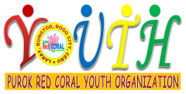
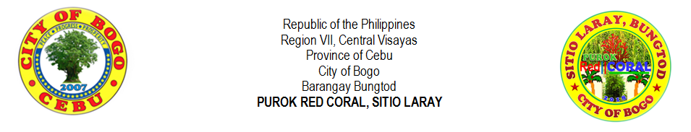
PUROK RED CORAL YOUTH ORGANIZATION
in coordination with
FELIPE R. VERALLO MEMORIAL FOUNDATION COLLEGE, INC.
award this
YOUTH OF THE YEAR AWARD
to
FLORIMAE L. YPIL

In recognition of her outstanding community service and active participation in the activities
of the youth organization. She has the ability to comprehend instructions, organized
and build society through community projects for sustainable development.

Her smoother interpersonal relationship, comradeship and candor with her colleagues would
articulate the warmth of a real leader, thereby, a good example to everyone.

Given this 30th of March, 2019 at Felipe R. Verallo Memorial Foundation College, Inc.,
Clotilde Hills, Dakit, Bogo City, Cebu.

JOSE WILLIAM V. ROMAGOS JR. |  | GLEN V. ROMAGOS |  | RIFE D. AVENIDO
Purok Youth President |  | Chairman, Sports and Youth Development |  | Purok President

in coordination with
FELIPE R. VERALLO MEMORIAL FOUNDATION COLLEGE, INC.
award this
CERTIFICATE OF APPRECIATION
to
FLORIMAE L. YPIL

In recognition of her outstanding community service and active participation in the activities
of the youth organization. She has the ability to comprehend instructions, organized
and build society through community projects for sustainable development.

Her smoother interpersonal relationship, comradeship and candor with her colleagues would
articulate the warmth of a real leader, thereby, a good example to everyone.

Given this 30th of March, 2019 at Felipe R. Verallo Memorial Foundation College, Inc.,
Clotilde Hills, Dakit, Bogo City, Cebu.

JOSE WILLIAM V. ROMAGOS JR. |  | GLEN V. ROMAGOS |  | RIFE D. AVENIDO
Purok Youth President |  | Chairman, Sports and Youth Development |  | Purok President

