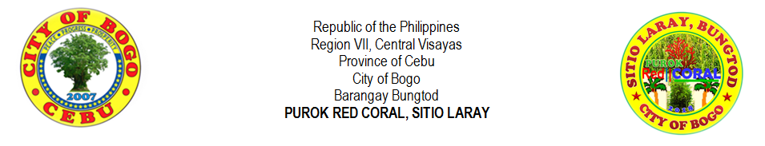
PUROK MEMORANDUM

October 24, 2018
PRCM001

Memorandum No. ,s. 2018

MEMORANDUM TO ORDINANCE NO. 001 – 2018

TO: Residents
Outsiders
Visitors
Professionals
Students
Children

- Attention is hereby informed the constituents regarding the Purok Ordinance No. 001 – 2018, An Ordinance Adopting the Proper Solid Waste Management in Purok Red Coral and prescribing its Rules, Regulations and Functions which entitled, “Proper Waste Management in Purok Red Coral”.

- Please be informed of the rules and regulations posted in tarpaulin and flyers. Everyone shall abide this ordinance and avoid any penalty as govern by the Purok Council.

- The said ordinance shall be respected and shall be given an importance as what the Purok mandated to do so.

- The decision of the Purok Council is final and unappealable.

- Immediate dissemination of this memorandum is desired.

RIFE D. AVENIDO
Purok President

