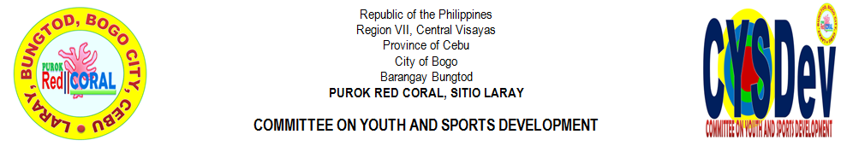
YOUTH & SPORTS DEVELOPMENT

CHAIRMAN | : | GLEN V. ROMAGOS
VICE-CHAIRMAN | : | JOSE WILLIAM V. ROMAGOS JR.
MEMBERS
 | 1 | FLORIMAE L. YPIL
 | 2 | CHRISTIAN IAN S. TAÑARA
 | 3 | JOHN ELTON I. CODERA
 | 4 | JHON REIL C. LALANTACON
 | 5 | JERIC Y. MONTELLANO
 | 6 | JOHNROUE V. DADUL
 | 7 | RUBEN C. BERNAL JR.
 | 8 | JAKE AUGUSTINE M. ORTEGA
 | 9 | CHRISTY ANN C. ATON
 | 10 | PERCILITO C. TILLOR
ADVISER | : | RIFE D. AVENIDO
RECORD KEEPER | : | MIRASOL S. TAÑARA
LAY-OUT DESIGNER | : | PERCILITO C. TILLOR

The Committee on Youth and Sports Development shall assist the barangay and the city government on matters pertaining to the youth welfare and development and active participation to sports and other matters related to youth and sports development.

