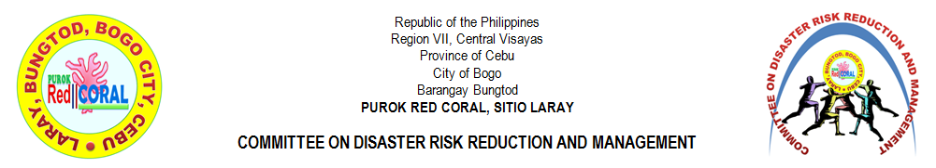
DISASTER RISK REDUCTION & MANAGEMENT

CHAIRMAN | : | ERWIN C. VILLEGAS
VICE-CHAIRMAN | : | CIRILO L. TAÑARA JR.
MEMBERS
 | 1 | JOSE WILLIAM V. ROMAGOS JR.
 | 2 | RUBANIE C. BERNAL
 | 3 | GLENN L. VERAQUE
 | 4 | NIÑO ROQUE A. YNOC
 | 5 | RUBEN C. BERNAL JR.
 | 6 | RENEL JAY Y. YNOC
 | 7 | JEROME V. AWAYAN
 | 8 | JOHN MICHAEL Y. ARPON
 | 9 | JOHN PAUL Y. MONTELLANO
 | 10 | JOHNROUE V. DADUL
ADVISER | : | RIFE D. AVENIDO
RECORD KEEPER | : | MIRASOL S. TAÑARA
LAY-OUT DESIGNER | : | PERCILITO C. TILLOR

The Committee on Disaster Risk Reduction and Management shall assist the barangay and the city government on matters pertaining to the adoption of principles and guidelines of disaster risk management and preparation from the calamities.

