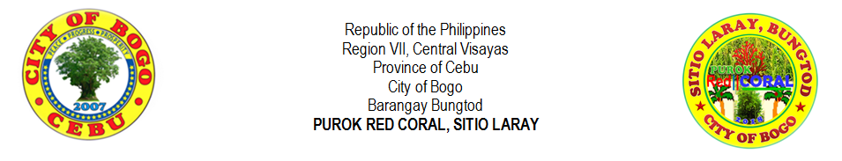
THE PEOPLE AND THEIR BACKGROUND
“Bogohanon” is term coined for a native living in Bogo, who is a bonafide resident and born in the same place. Bogohanons are the folks who always aspire for peace, progress and prosperity, perspire for dreams to come into reality, and inspire fellow Bogohanons for the achievements globally. A true Bogohanon knows how to look back from where he rooted and knows how to look forward into his future. Yes, truly indeed, Bogohanons always say, “Padayon Bogo” as how the Bogo hymn was made and the song tells how natives love and nurture the place. Looking from the past, Bogohanons were traders as their goods bartered to the other merchants and the business settled on a lone bogo tree (Garuga floribunda), where the place got its name.
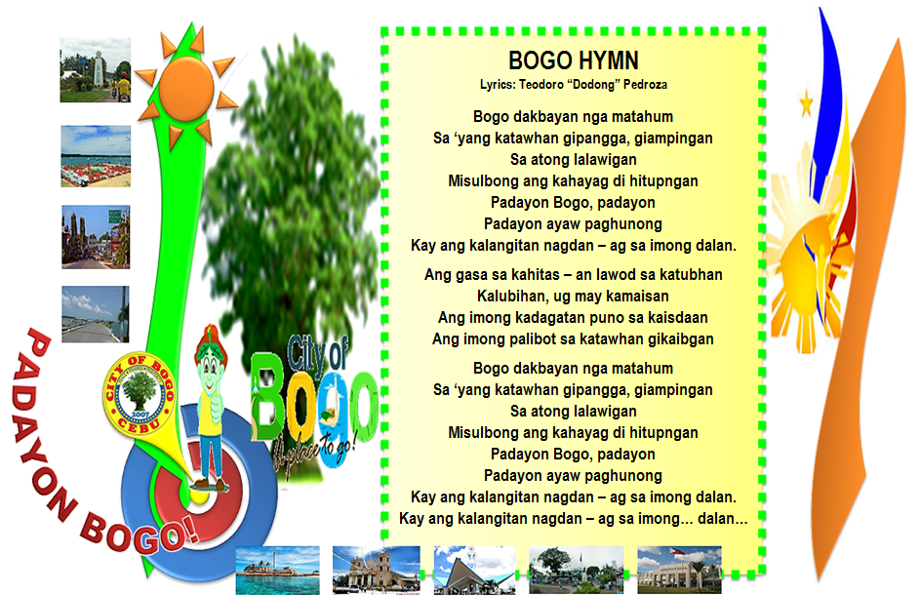
Who are these natives in Sitio Laray?

Every man and woman living in every place have something to call for them. People living in the province of Cebu, they called as Cebuanos or Bisaya which the dialect used is Sinugbuanong Binisaya. Bogo City is one of the towns in Cebu and the people are called as Bogohanons, and the natives living in Sitio Laray are called as Laraynons and they speak the same dialect as well. Laraynons are Bungturanons (residents in Barangay Bungtod, means “hill”) and the first people living in Sitio Laray formerly Sitio Tabayjo are small – scale farmers of corn fields and until now, the heirs still run the farm. Some farmers don’t have their own land and the type of sharing is ½ in which half of the crops will go to the land owner and the other half will go to the farmers. They have different forms of livelihood such as farming, livestock and poultry and some of them are vendors or makers of one of the delicacies in Bogo known as, “pintos” which made from corn or “mais”.
The first family living in the sitio is the Villegas Family which they are farmers and the farm is transferred from one generation to another generation. The family owned a corn farm and they have the grinders which they used in grinding the corn into small pieces and they were made of wood and stone. There are two types of the grinders, one made of wood and the other one was made of stone. There are no other differences of the two aside from the material they made but they have the same feature in which the form has two big circles which piled up and down and merely attached to each other, and the above circle has a small hole in the center in which the grains are placed in order to grind. The above circle has another hole on the side in which intended for the wood handle where it is placed. The way to grind is to push and pull the handle in order to turn the above circle and the broken grains will go outside from the cavity or space in the middle of the attached circles. There should be many sacks below the grinder to catch the grinded grains of corn. Until now, Pampela Villegas (an heir) preserved the grinders. At this modern society, the corn will be grinded in a corn mill to have a fine result and other material will be created from the grinded corn which is called as, “tahup”. “Tahup” will never been eaten by the people, instead, it will used in some of the ingredients to feed the pig. It has a strong odor and it somewhat like in a powdered form. To those farmers who don’t have poultry, they actually sell the “tahup” in kilo but the price is cheaper.

During the period of 1980’s to 1990’s, children or adolescents have the creativity in having an entertainment and that was on playing Filipino games such as patintero, luksong baka, luksong tinik, skipping rope, tumbang preso, buwan – buwan maliwanag ang buwan (this game is played best during nighttime under the moon), slipper game (the slipper is kicked by the foot and after, the player/s will have to run from the first base and turn until he reached the main base and it has a similarity with the baseball game), and slipper “manikin” up (played by throwing the slipper up and the direction of the slipper will go back from the one who throws it where the other players will have to catch the thrown slipper, and if not, the “taya” or “hago” , the loser will count for about ten counts decreasingly, and the other players will move and pause as the count down. If the count reaches one, one of the players will get the slipper from the ground and throws to the other player and the “taya” will touch the other player who catches or touches the slipper and whoever caught by the “taya”, he/she will be the loser.). There are many forms of entertainment in order to amuse themselves.

The true Laraynons know how to give “utang na loob” to the people who show kindness to them especially, to the owner of the land where their houses built. Those families whose houses stood on the land property of Lita Ybañez and Monina Y. Wijt, give in return to the owners from the crops and other factors. Eventhough how hard life is for the residents, they will never stop to find a way for living. Mostly, they are from extended family and as their family grows, and the time goes on, they have to settle for their own. Still, they decided to settle their own houses nearer to each other. So, that’s why, most of the residents are blood – related. People in Sitio Laray had experienced the phenomenal, remarkable history and unforgettable ecological backlash last November 2013 where the super typhoon Yolanda broke the houses of the residents and few houses remain. Others lived temporarily and shortly with those families had still their houses. After the calamity, people stood again and built their houses with the help and assistance from the government and charity foundations.

Padayon Bogo!

