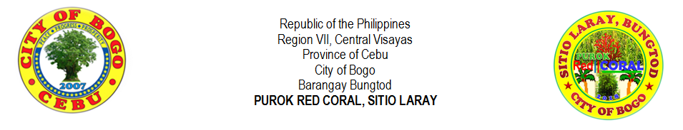
LIST OF BUSINESS ESTABLISHMENTS

Name of Barangay | : | Barangay Bungtod |  | Name of Purok | : | Purok Red Coral

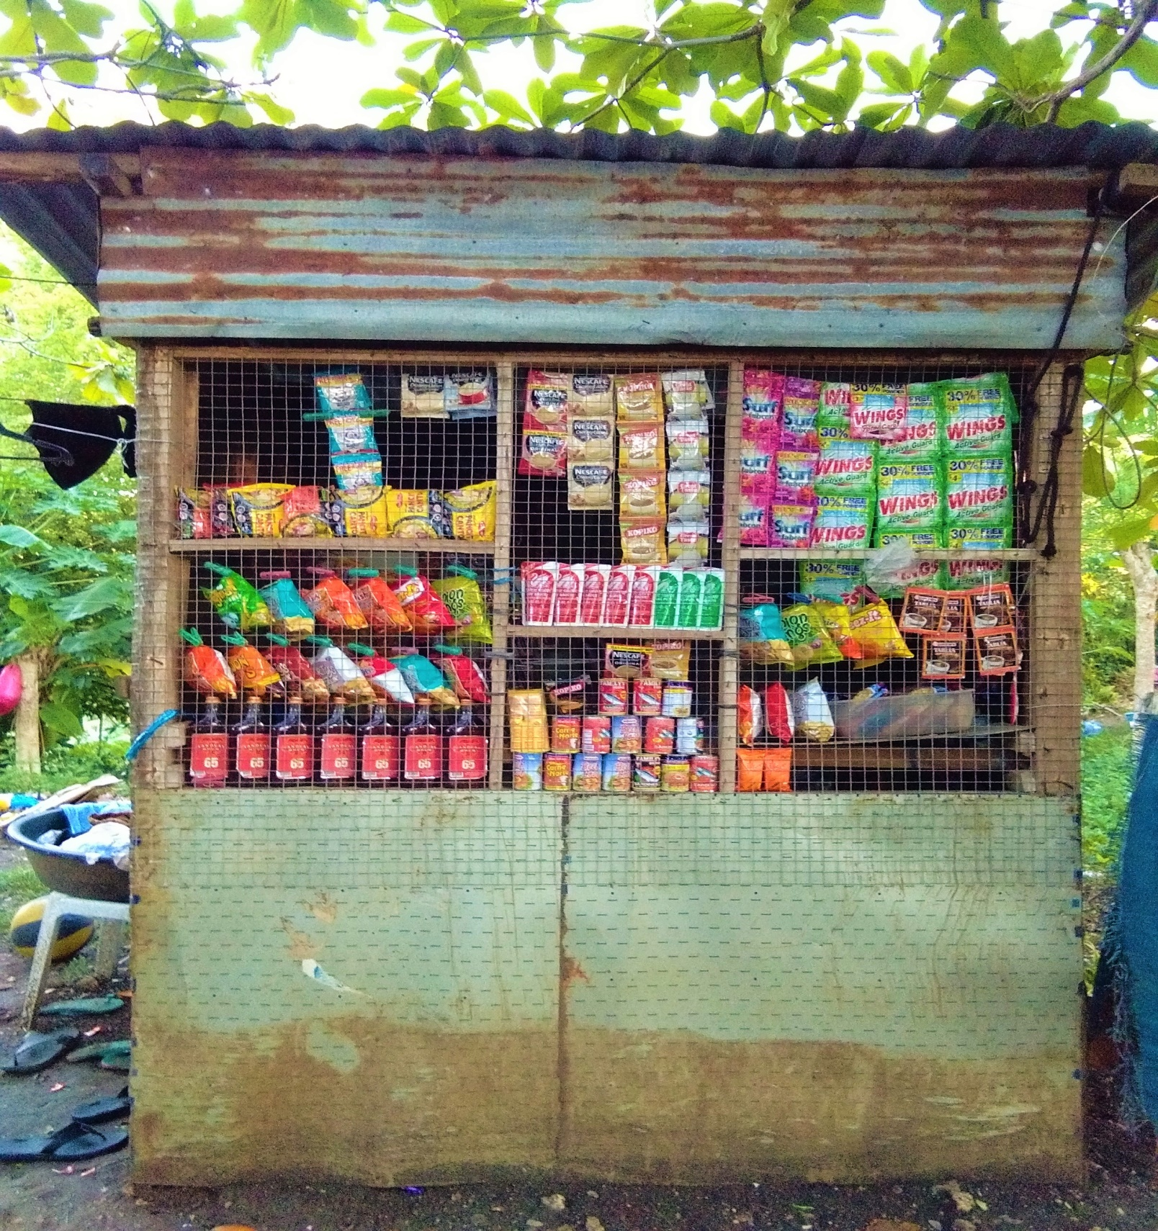
Business Proprietor | : | MARILYN L. CODERA
Type of Business | : | Sari-sari Store
Date Started | : | November 29, 2016
Estimated Capital | : | P 4, 000.00
Estimated Monthly Gross Income | : | P 5, 000.00
Another Source of Income | : | Ukay-ukay Selling

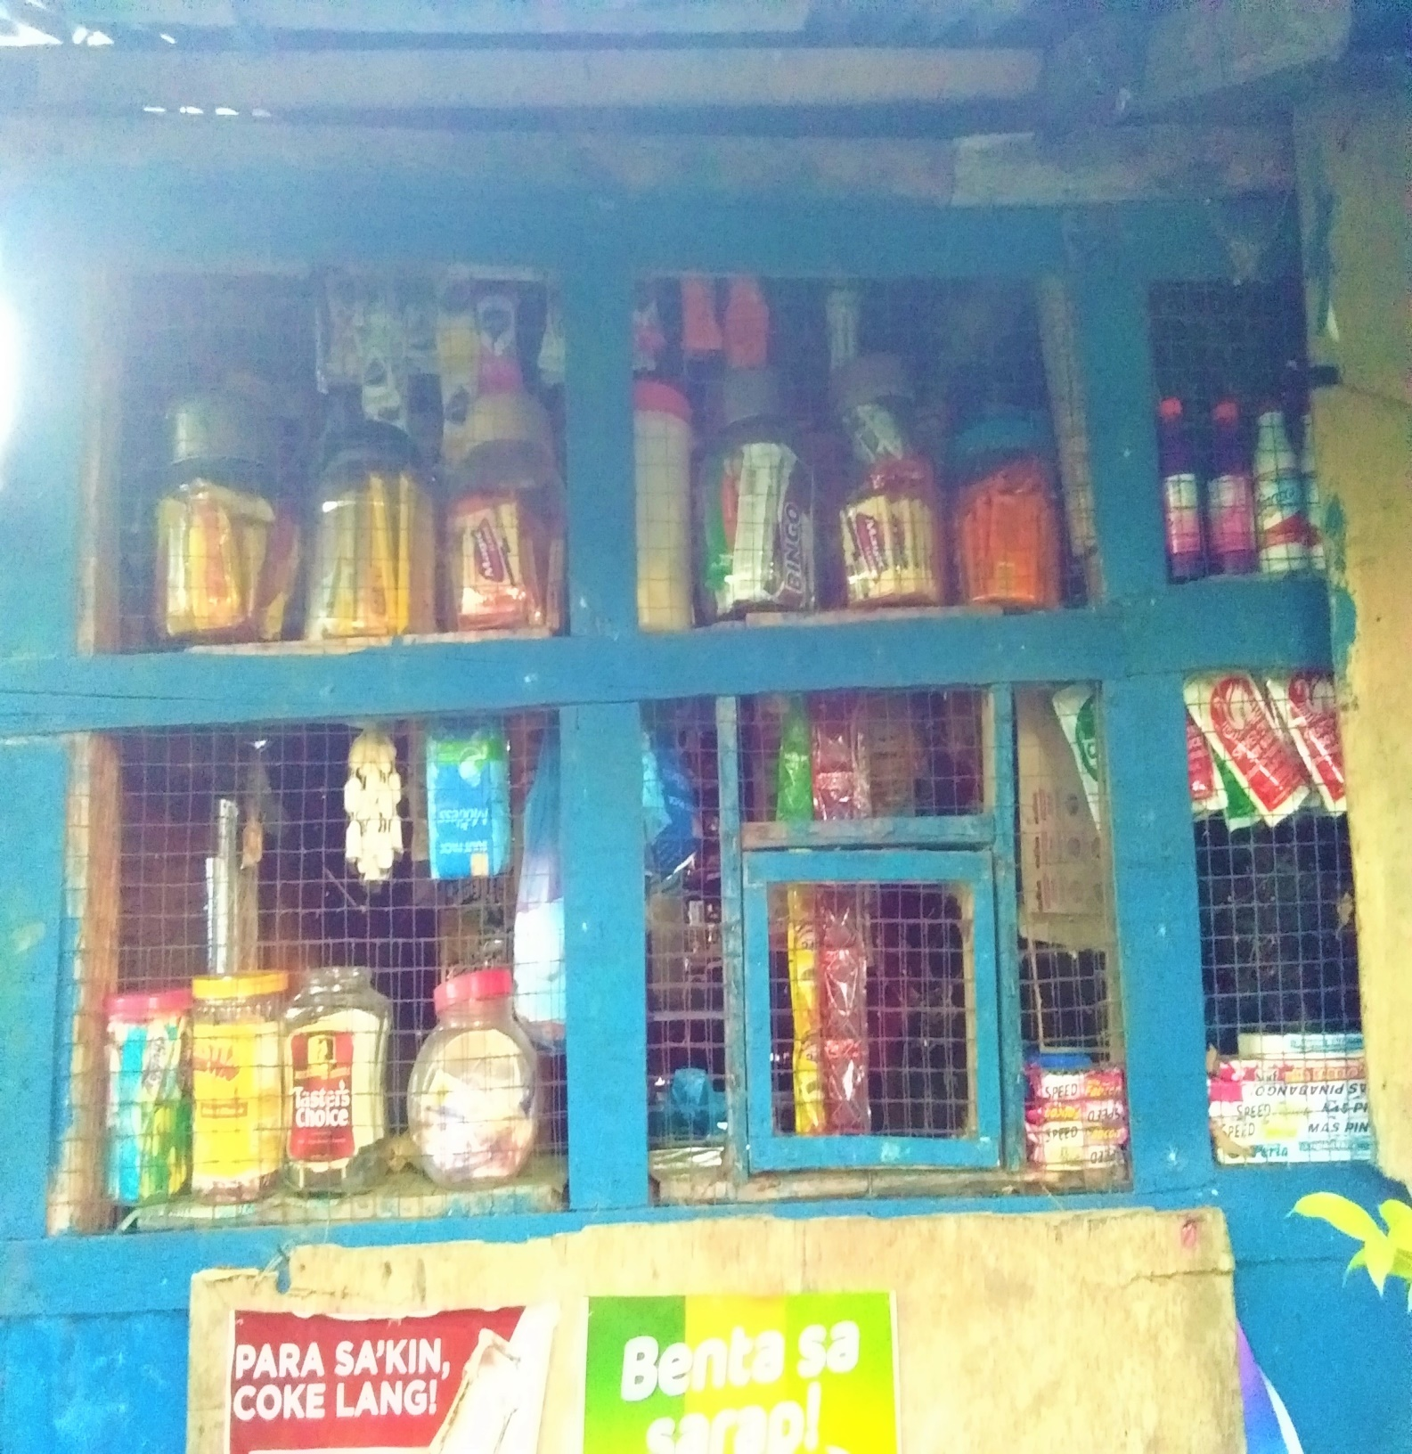
Business Proprietor | : | PAMPELA M. VILLEGAS
Type of Business | : | Sari-sari Store
Date Started | : | February 7, 1980
Estimated Capital | : | P 5, 000.00
Estimated Monthly Gross Income | : | P 10, 000.00
Another Source of Income | : | None

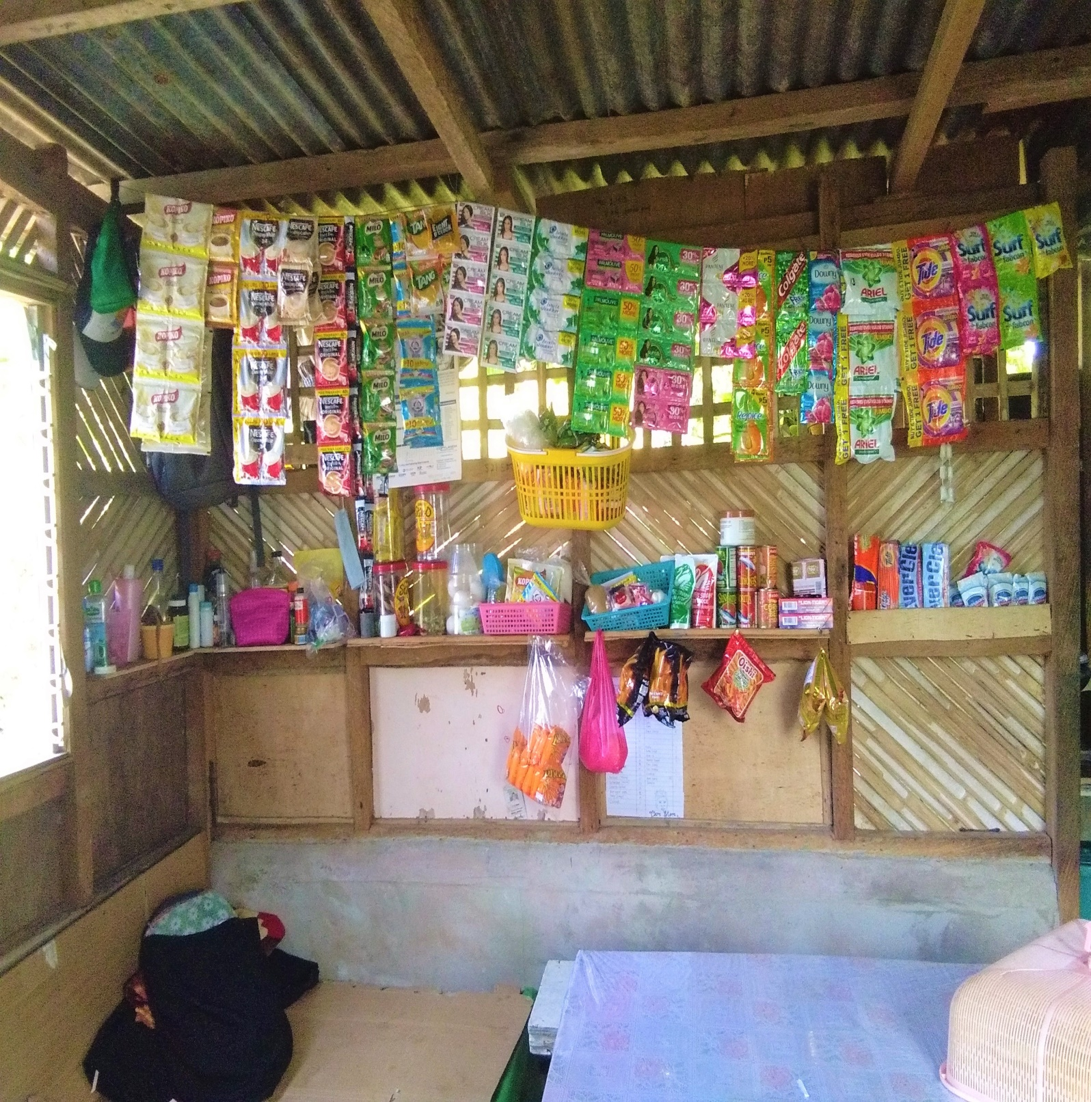
Business Proprietor | : | HANSEL L. GABOY
Type of Business | : | Sari-sari Store
Date Started | : | November 18, 2018
Estimated Capital | : | P 2, 000.00
Estimated Monthly Gross Income | : | P 3, 000.00
Another Source of Income | : | None

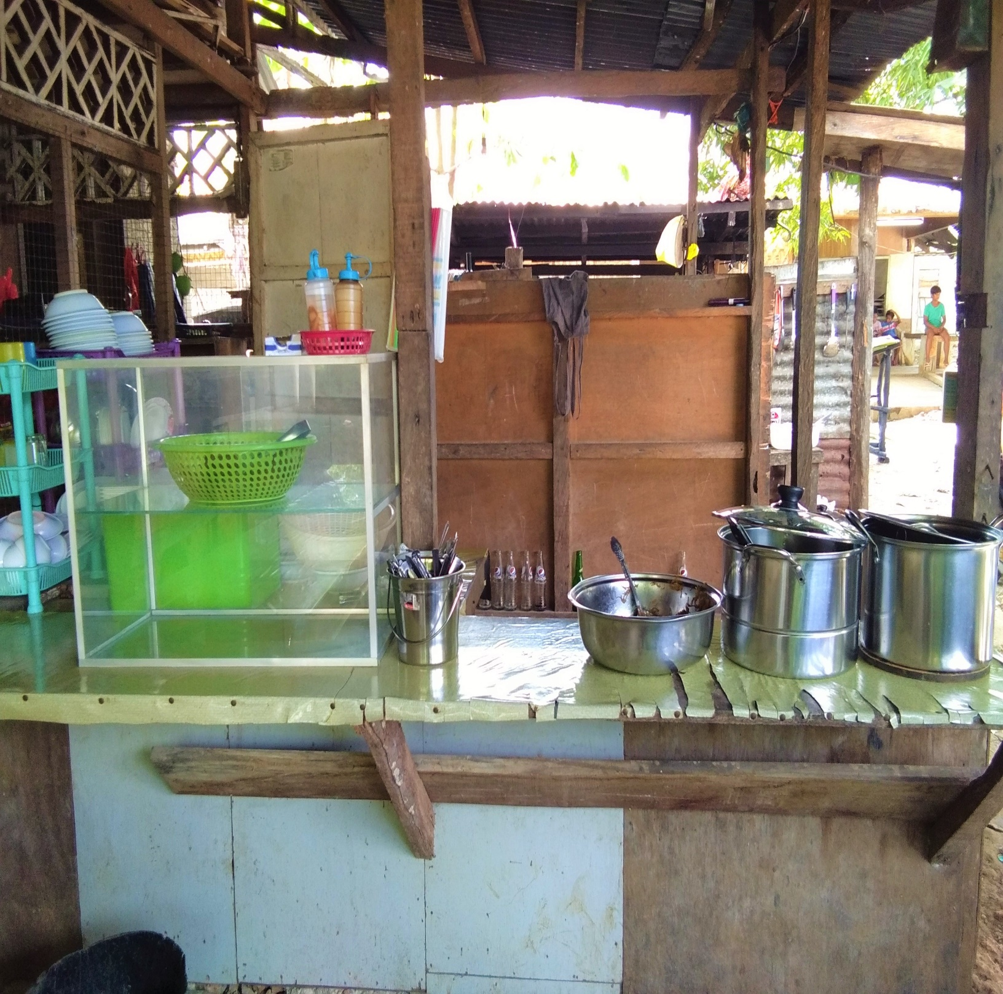
Business Proprietor | : | BONITA R. AVENIDO
Type of Business | : | Sari-sari Store
Date Started | : | February 14, 2014
Estimated Capital | : | P 5, 000.00
Estimated Monthly Gross Income | : | P 13, 000.00
Another Source of Income | : | None

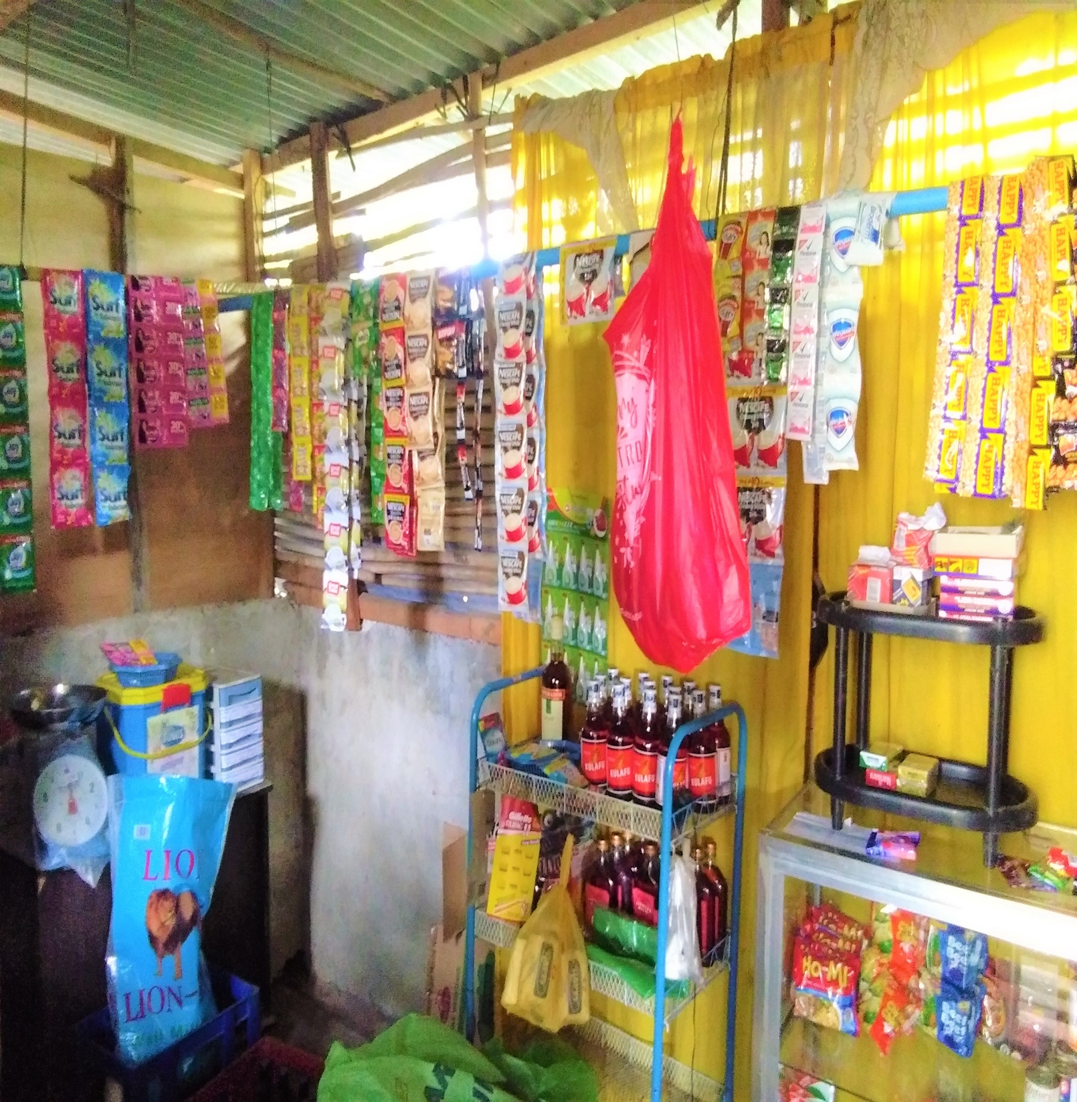
Business Proprietor | : | VICENTE L. LEPASANA JR.
Type of Business | : | Sari-sari Store
Date Started | : | February 8, 2016
Estimated Capital | : | P 5, 000.00
Estimated Monthly Gross Income | : | P 4, 000.00
Another Source of Income | : | School Admin, FRVMFI

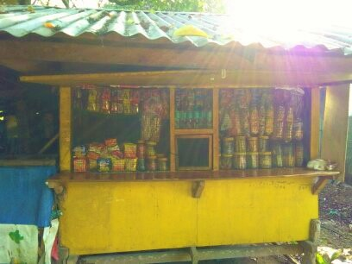
Business Proprietor | : | CLEMENCIA M. VILLEGAS
Type of Business | : | Sari-sari Store
Date Started | : | June 8, 1985
Estimated Capital | : | P 5, 000.00
Estimated Monthly Gross Income | : | P 12, 000.00
Another Source of Income | : | None

