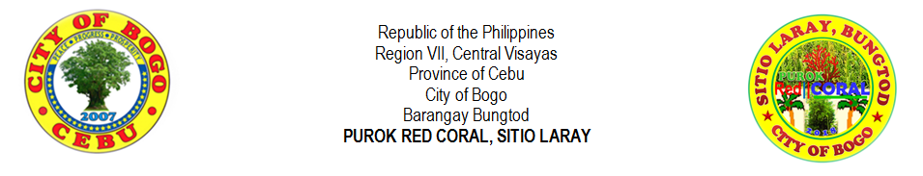
LIST OF WIDOW
NO. | LAST NAME |  | FIRST NAME | MIDDLE NAME | GENDER |  | AGE | DATE OF BIRTH | OCCUPATION | EDUCATIONAL STATUS
 |  |  |  |  | MALE | FEMALE
1
2
3
4
5
6
7
8
9
10
11
12
13
14
15
16
17
18
19
20

Prepared by: |  | Certified by:
MIRASOL S. TAÑARA |  | RIFE D. AVENIDO
Purok Secretary |  | Purok President

