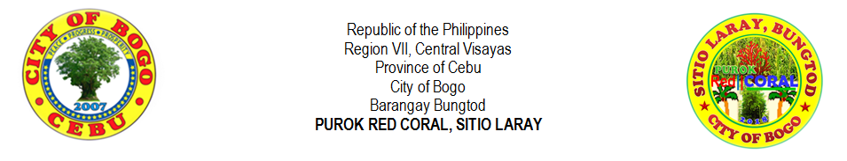
LIST OF SINGLE MALE 2018 (18 and above)
NO. | LAST NAME |  | FIRST NAME | MIDDLE NAME | AGE | DATE OF BIRTH
1 | ARPON | , | CHARLIE BON | YNOC | 23 | NOVEMBER 20, 1995
2 | ATON | , | FELIX JR. | LOPEZ | 29 | SEPTEMBER 30, 1989
3 | ATON | , | MARJUN | CODERA | 28 | AUGUST 30, 1990
4 | AWAYAN | , | JEROME | VILLEGAS | 26 | DECEMBER 28, 1992
5 | BERNAL | , | RUBANIE | CANAMA | 20 | AUGUST 15, 1998
6 | BERNAL | , | RUBEN JR. | CANAMA | 18 | MAY 7, 2000
7 | CAMBAL | , | JORIE | VILLEGAS | 24 | NOVEMBER 15, 1994
8 | EHEM | , | CHRISTOPHER | PABROA | 30 | OCTOBER 7, 1988
9 | EJARA | , | REMAR | APILANIO | 28 | AUGUST 15, 1990
10 | LALANTACON | , | JOHN REIL | CODERA | 24 | MAY 30, 1994
11 | MALAIT | , | WALTER | MOMONGAN | 25 | MARCH 25, 1993
12 | MONTELLANO | , | JERIC | YNOC | 18 | JULY 27, 2000
13 | ORTEGA | , | FREDIE | CANAMA | 33 | OCTOBER 6, 1985
14 | ORTEGA | , | JESSIE VINCENT | MONSALES | 19 | DECEMBER 16, 1999
15 | ORTEGA | , | JOMIE | CANAMA | 27 | JANUARY 6, 1991
16 | ORTEGA | , | JOSEPH | CANAMA | 30 | MARCH 14, 1988
17 | ROMAGOS | , | GLENDOLEN | VILLEGAS | 29 | JANUARY 18, 1989
18 | ROMAGOS | , | JOSE WILLIAM JR. | VILLEGAS | 25 | MARCH 18, 1993
19 | SASING | , | JONARD | PIANDONG | 29 | MAY 16, 1989
20 | SASING | , | MARVIN | PIANDONG | 35 | FEBRUARY 9, 1983
21 | SEBIAL | , | JENES | TAPAO | 43 | AUGUST 25, 1975
22 | TAÑARA | , | CHRISTIAN IAN | SAYSON | 19 | NOVEMBER 10, 1999
23 | TILLOR | , | PERCILITO | CAAYON | 26 | APRIL21, 1992
24 | TILLOR | , | PRUTO JR. | CAAYON | 29 | JUNE 4, 1989
25 | YNOC | , | RENEL JAY | ATON | 19 | FEBRUARY 5, 1999
26
27
28
29
30
31
32
33
34
35
36
37
38
39
40

Prepared by:
MIRASOL S. TAÑARA
Purok Secretary
Certified by:
RIFE D. AVENIDO
Purok President
LIST OF SINGLE FEMALE 2018 (18 and above)
NO. | LAST NAME |  | FIRST NAME | MIDDLE NAME | AGE | DATE OF BIRTH
1 | ALBURO | , | JINIEBEB | TUMULAK | 21 | SEPTEMBER 15, 1997
2 | AMORES | , | RIZA | MOMONGAN | 29 | OCTOBER 2, 1989
3 | ARPON | , | SHAINA MAE | YNOC | 18 | SEPTEMBER 24, 2000
4 | AVENIDO | , | JIRAH | RECLA | 24 | JUNE 2, 1994
5 | AWAYAN | , | GENALYN | VILLEGAS | 22 | MARCH 9, 1996
6 | BERNAL | , | MARIE RUAN | CANAMA | 23 | MAY 23, 1995
7 | CAMBAL | , | JORILYN | VILLEGAS | 22 | MARCH 16, 1996
8 | CODERA | , | DIANNE | ORTEGA | 43 | MAY 27, 1975
9 | CODERA | , | MARILYN | LEPASANA | 30 | NOVEMBER 24, 1988
10 | LALANTACON | , | CHARLIE | CODERA | 42 | MARCH 14, 1976
11 | LIPANGLIPANG | , | IRENEA | LAMPITAO | 62 | JULY 3, 1956
12 | ORTEGA | , | NIÑA | CANAMA | 26 | JANUARY 19, 1992
13 | ORTEGA | , | VICTORIA | PACLIPAN | 72 | DECEMBER 23, 1946
14 | SASING | , | RYCA JEAN | YNOC | 23 | OCTOBER 26, 1995
15 | URSABIA | , | ELENITA | VILLEGAS | 39 | JULY 22, 1979
16 | VILLEGAS | , | CLEMENCIA | MASUANGAT | 66 | NOVEMBER 9, 1952
17 | VILLEGAS | , | PAMPELA | MASUANGAT | 71 | APRIL 27, 1947
18 | VILLEGAS | , | VIOLETA | CODERA | 35 | JANUARY 8, 1983
19 | YNOC | , | RONELDA | ATON | 21 | OCTOBER 22, 1997
20
21
22
23
24
25
26
27
28
29
30
31
32
33
34
35
36
37
38
39
40

Prepared by:
MIRASOL S. TAÑARA
Purok Secretary
Certified by:
RIFE D. AVENIDO
Purok President

