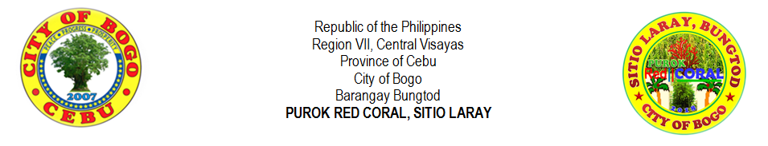
LIST OF SENIOR HIGH SCHOOL STUDENTS
NO. |  | LAST NAME |  | FIRST NAME | MIDDLE NAME |  | GENDER |  | AGE | DATE OF BIRTH | TYPE OF SCHOOL |  |  | NAME OF SCHOOL | NAME OF GUARDIAN | CONTACT NO.
 |  |  |  |  |  |  | MALE | FEMALE |  |  | PRIVATE | PUBLIC
1 |  | BERNAL | , | RUB EN JR. | CANAMA |  | √ |  | 18 |  | √ |  |  | FRVMFI | RUBEN BERNAL SR.
2 |  | CODERA | , | JOHN ELTON | ILLUSTRISMO |  | √ |  | 17 | 9/03/2001 | √ |  |  | FRVMFI | RICHARD CODERA | 0997723799
3 |  | MONTELLANO | , | JERIC | YNOC |  | √ |  | 18 | 7/27/2000 | √ |  |  | FRVMFI | MERLYN MONTELLANO | 09354191854
4 |  | TAÑARA |  | CHRISTIAN IAN | SAISON |  | √ |  | 19 | 11/10/1999 | √ |  |  | FRVMFI | MIRASOL TAÑARA | 09352318834
5
6
7
8
9
10
11
12
13
14
15
16
17
18
19
20
21
22
23
24
25
 | Prepared by: |  |  |  |  |  |  |  |  |  |  |  | Certified by:
 | MIRASOL S. TAÑARA |  |  |  |  |  |  |  |  |  |  |  | RIFE D. AVENIDO
 | Purok Secretary |  |  |  |  |  |  |  |  |  |  |  | Purok President

