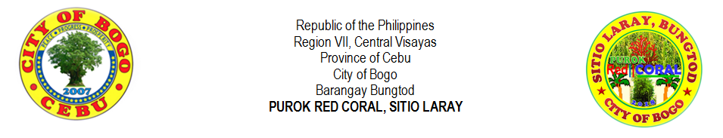
LIST OF LIVESTOCK
NO. | NAME | SITIO / PUROK | CHICKEN | GOAT | COW | PIG | CARABAO | DUCK | TURKEY
1 | ABELLA, RENE SAYSON | PUROK RED CORAL
2 | ARNOSA, PERLITA TILLOR | PUROK RED CORAL
3 | ARPON, BONIFACIO BUNGHANOY | PUROK RED CORAL
4 | ATON, FELIX LAMPITAO | PUROK RED CORAL
5 | ATON, JESUS URSAL | PUROK RED CORAL
6 | ATON, MAURA YAGON | PUROK RED CORAL
7 | ATON, RHODORA LOPEZ | PUROK RED CORAL
8 | AVENIDO, RIFE DUMASAPAL | PUROK RED CORAL
9 | AWAYAN, RAMON MAKIPID | PUROK RED CORAL
10 | BERNAL, RUBEN DOONG | PUROK RED CORAL
11 | CAMBAL, RICARDO DESUYO | PUROK RED CORAL
12 | CODERA, DIANNE ORTEGA | PUROK RED CORAL
13 | CODERA, MARILYN LEPASANA | PUROK RED CORAL
14 | CODERA, MIGUELA LEPASANA | PUROK RED CORAL
15 | DADUL, JONATHAN FABIERAN | PUROK RED CORAL
16 | EHEM, CHRISTOPHER PABROA | PUROK RED CORAL
17 | EJARA, REMAR APILANIO | PUROK RED CORAL
18 | EMOLLEN, ANDY LUMBO | PUROK RED CORAL
19 | GABOY, HANSEL LOZADA | PUROK RED CORAL
20 | GESTA, LORNA VERDIDA | PUROK RED CORAL
21 | GONZA, RYAN FELICES | PUROK RED CORAL
22 | GUTIEREZ, JUANITA ATON | PUROK RED CORAL
23 | LALANTACON, CHARLIE CODERA | PUROK RED CORAL
24 | LEPASANA, AMALIA DIAMANTE | PUROK RED CORAL
25 | LEPASANA, VICENTE DIAMANTE | PUROK RED CORAL
26 | LEPASANA, CRISPIN JR. DIAMANTE | PUROK RED CORAL
27 | LEPASANA, VICENTE JR. LAMPITAO | PUROK RED CORAL
28 | LIPANGLIPANG, IRENEA LAMPITAO | PUROK RED CORAL
29 | MONTELLANO, ERIC DIGNOS | PUROK RED CORAL
30 | ORTEGA, BONIFACIO PACLIPAN | PUROK RED CORAL
31 | ORTEGA, FELIX PACLIPAN | PUROK RED CORAL
32 | ORTEGA, RANILO CANAMA | PUROK RED CORAL
33 | ORTEGA, VICTORIA PACLIPAN | PUROK RED CORAL
34 | PELAYO, KEN MAGLASANG | PUROK RED CORAL
35 | PIAMONTE, ANTONIO JR. CUEVA | PUROK RED CORAL
36 | ROMAGOS, GLEN VILLEGAS | PUROK RED CORAL
37 | ROMAGOS, JOSE WILLIAM SR. BOOC | PUROK RED CORAL
38 | SASING, JONARD PIANDONG | PUROK RED CORAL
39 | SASING, MARVIN PIANDONG | PUROK RED CORAL
40 | SEBIAL, JENES TAPAO | PUROK RED CORAL
41 | SINANGOTE, BRENDO LANGUIDO | PUROK RED CORAL
42 | SERVILA, ARCHIE ROLLOQUE | PUROK RED CORAL
43 | TAÑARA, CIRILO JR. LAGOS | PUROK RED CORAL
44 | TILLOR, FRUTO SR. PEGA | PUROK RED CORAL
45 | URSABIA, DENNIS VILLEGAS | PUROK RED CORAL
46 | VERAQUE, GLENN LUBON | PUROK RED CORAL
47 | VILLEGAS, ANTONIO MASUANGAT | PUROK RED CORAL
48 | VILLEGAS, CLEMENCIA MASUANGAT | PUROK RED CORAL
49 | VILLEGAS, ERWIN CODERA | PUROK RED CORAL
50 | VILLEGAS, PAMPELA MASUANGAT | PUROK RED CORAL
51 | VILLEGAS, VICITACION CODERA | PUROK RED CORAL
52 | VILLEGAS, VIOLETA CODERA | PUROK RED CORAL
53 | WAGAS, DANTE PUNAY | PUROK RED CORAL
NO. | NAME | SITIO / PUROK | CHICKEN | GOAT | COW | PIG | CARABAO | DUCK | TURKEY
54 | YNOC, RONILLO VILLAMOR | PUROK RED CORAL
55 | YPIL, PACIANO LEPALAM | PUROK RED CORAL
56 | YSULAN, DOMIGO PASUKIN | PUROK RED CORAL
57
58
59
60
61
62
63
64
65
66
67
68
69
70

Prepared by:
MIRASOL S. TAÑARA
Purok Secretary
Certified by:

RIFE D. AVENIDO
Purok President

