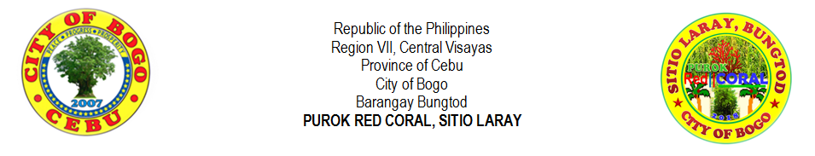
LIST OF JUNIOR HIGH SCHOOL STUDENTS
NO. |  | LAST NAME |  | FIRST NAME | MIDDLE NAME |  | GENDER |  | AGE | DATE OF BIRTH | TYPE OF SCHOOL |  |  | NAME OF SCHOOL | NAME OF GUARDIAN | CONTACT NO.
 |  |  |  |  |  |  | MALE | FEMALE |  |  | PRIVATE | PUBLIC
1 |  | ARPON | , | JOHN NIDEL | YNOC |  | √ |  | 14 | 5/24/2004 | √ |  |  | FRVMFI | BONIFACIO ARPON | 09364556920
2 |  | ARNOZA | , | JOHN BRYLE | TILLOR |  | √ |  | 14 | 10/20/2004 | √ |  |  | SLMCB | PERLITA ARNOZA | 09366226072
3 |  | BERNAL | , | JULIE ANN | CANAMA |  |  | √ | 14 | 7/12/2004 | √ |  |  | CRMC | RUBEN BERNAL | 09355049366
4 |  | DADUL | , | JHONROUE | VILLEGAS |  | √ |  | 16 | 5/02/2002 | √ |  |  | FRVMFI | ROWENA DADUL | 09352006514
5 |  | DADUL | , | ROSE ANTHONETTE | VILLEGAS |  |  | √ | 13 | 4/25/2005 | √ |  |  | FRVMFI | ROWENA DADUL | 09352006514
6 |  | GONZA | , | DIRK JAMES | VILLEGAS |  | √ |  | 12 | 5/23/2006 | √ |  |  | CRMC | RYAN GONZA | 09227535817
7 |  | LALANTACON | , | JHONRY | CODERA |  | √ |  | 15 | 11/07/2003 | √ |  |  | FRVMFI | CHARLIE LALANTACON | 09327186600
8 |  | MONTELLANO | , | JOHN PAUL | YNOC |  | √ |  | 16 | 6/24/2002 | √ |  |  | FRVMFI | MERLYN MONTELLANO | 09354191804
9 |  | ORTEGA | , | JAKE AGUSTINE | MONSALES |  | √ |  | 16 | 8/30/2002 | √ |  |  | SLMCB | RANILO ORTEGA
10 |  | URSABIA | , | DEN MARIE | ALBURO |  |  | √ | 14 | 7/30/2004 | √ |  |  | FRVMFI | DENNIS URSABIA | 0973655316
11 |  | YPIL | , | FLORIMAE | LEPASANA |  |  | √ | 14 | 5/26/2004 | √ |  |  | FRVMFI | PACIANO YPIL
12 |  | YPIL | , | JESTER PAUL | LEPASANA |  | √ |  | 13 | 1/28/2005 | √ |  |  | FRVMFI | PACIANO YPIL
13 |  | YSULAN | , | VINCENT DOMINIC | TILLOR |  | √ |  | 13 | 2/04/2006 | √ |  |  | CRMC | DOMINGO P. YSULAN | 09392919370
14
15
16
17
18
19
20
21
22
23
24
25
 | Prepared by: |  |  |  |  |  |  |  |  |  |  |  | Certified by:
 | MIRASOL S. TAÑARA |  |  |  |  |  |  |  |  |  |  |  | RIFE D. AVENIDO
 | Purok Secretary |  |  |  |  |  |  |  |  |  |  |  | Purok President

