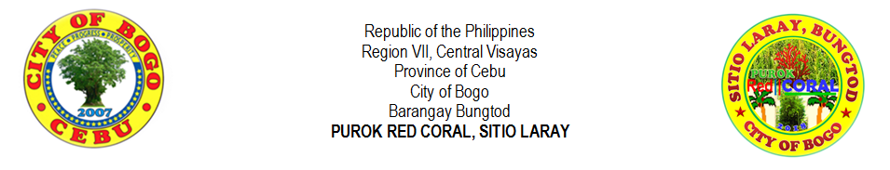
LIST OF HOUSEHOLDS AND TYPE OF HOUSE
NO. | LAST NAME |  | FIRST NAME | MIDDLE NAME | W1L | W3L | NL | CHBL | C1L | CWSL
1 | ABELLA | , | RENE | SAYSON |  |  |  |  |  | √
2 | ARNOSA | , | PERLITA | TILLOR
3 | ARPON | , | BONIFACIO | BUNGHANOY | √
4 | ATON | , | FELIX | LAMPITAO | √
5 | ATON | , | JESUS | URSAL |  |  |  |  |  | √
6 | ATON | , | MAURA | YAGON | √
7 | ATON | , | RHODORA | LOPEZ |  |  |  |  |  | √
8 | AVENIDO | , | RIFE | DUMASAPAL |  |  |  |  |  | √
9 | AWAYAN | , | RAMON | MAKIPID |  |  |  |  |  | √
10 | BERNAL | , | RUBEN SR. | DOONG | √
11 | CAMBAL | , | RICARDO | DESUYO
12 | CODERA | , | DIANNE | ORTEGA
13 | CODERA | , | MARILYN | LEPASANA
14 | CODERA | , | MIGUELA | LEPASANA
15 | DADUL | , | JONATHAN | FABIERAN
16 | EHEM | , | CHRISTOPHER | PABROA
17 | EJARA | , | REMAR | APILANIO
18 | EMOLLEN | , | ANDY | LUMBO
19 | GABOY | , | HANSEL | LOZADA
20 | GESTA | , | LORNA | VERDIDA
21 | GONZA | , | RYAN | FELICES
22 | GUTIEREZ | , | JUANITA | ATON
23 | LALANTACON | , | CHARLIE | CODERA
24 | LEPASANA | , | AMALIA | DIAMANTE
25 | LEPASANA | , | CRISPIN JR. | DIAMANTE
26 | LEPASANA | , | VICENTE | DIAMANTE
27 | LEPASANA | , | VICENTE JR. | LAMPITAO
28 | LIPANGLIPANG | , | IRENEA | LAMPITAO
29 | MONTELLANO | , | ERIC | DIGNOS
30 | ORTEGA | , | BONIFACIO | PACLIPAN
31 | ORTEGA | , | FELIX | PACLIPAN
32 | ORTEGA | , | RANILO | CANAMA
33 | ORTEGA | , | VICTORIA | PACLIPAN
34 | PELAYO | , | KEN | MAGLASANG
35 | PIAMONTE | , | ANTONIO JR. | CUEVA
36 | PIAMONTE | , | ANTONIO SR. | EDISAN
37 | ROMAGOS | , | GLEN | VILLEGAS
38 | ROMAGOS | , | JOSE WILLIAM SR. | BOOC
39 | SASING | , | JONARD | PIANDONG
40 | SASING | , | MARVIN | PIANDONG
41 | SEBIAL | , | JENES | TAPAO
42 | SERVILA | , | ARCHIE SR. | ROLLOQUE
43 | SINANGOTE | , | BRENDO | LANGUIDO
44 | TAÑARA | , | CIRILO JR. | LAGOS
45 | TILLOR | , | FRUTO SR. | PEGA
46 | URSABIA | , | DENNIS | VILLEGAS
47 | VERAQUE | , | GLENN | LUBON
48 | VILLEGAS | , | ANTONIO | MASUANGAT
49 | VILLEGAS | , | CLEMENCIA | MASUANGAT
50 | VILLEGAS | , | ERWIN | CODERA
51 | VILLEGAS | , | PAMPELA | MASUANGAT
52 | VILLEGAS | , | VICITACION | CODERA
53 | VILLEGAS | , | VIOLETA | CODERA
54 | YNOC | , | RONILLO | VILLAMOR
NO. | LAST NAME |  | FIRST NAME | MIDDLE NAME | W1L | W3L | NL | CHBL | C1L | CWSL
55 | YPIL | , | PACIANO | LEPALAM
56 | YSULAN | , | DOMINGO | PASUKIN
57
58
59
60
61
62
63
64
65
66
67
68
69
70
71
72
73
74
75
76
77
78
79
80

Prepared by:
MIRASOL S. TAÑARA
Purok Secretary
Certified by:

RIFE D. AVENIDO
Purok President

