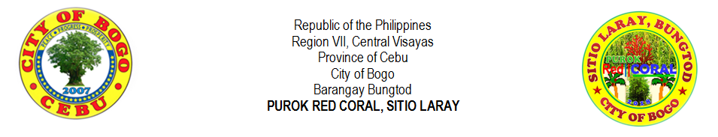

**LIST OF HOUSEHOLD WITH ELECTRICITY (2018)**

|  |  |  |  |  |  |
| --- | --- | --- | --- | --- | --- |
| **NO.** | **LAST NAME** |  | **FIRST NAME** | **MIDDLE NAME** | **ADDRESS** |
|
| **1** |  |  |  |  |  |
| **2** |  |  |  |  |  |
| **3** |  |  |  |  |  |
| **4** |  |  |  |  |  |
| **5** |  |  |  |  |  |
| **6** |  |  |  |  |  |
| **7** |  |  |  |  |  |
| **8** |  |  |  |  |  |
| **9** |  |  |  |  |  |
| **10** |  |  |  |  |  |
| **11** |  |  |  |  |  |
| **12** |  |  |  |  |  |
| **13** |  |  |  |  |  |
| **14** |  |  |  |  |  |
| **15** |  |  |  |  |  |
| **16** |  |  |  |  |  |
| **17** |  |  |  |  |  |
| **18** |  |  |  |  |  |
| **19** |  |  |  |  |  |
| **20** |  |  |  |  |  |
| **21** |  |  |  |  |  |
| **22** |  |  |  |  |  |
| **23** |  |  |  |  |  |
| **24** |  |  |  |  |  |
| **25** |  |  |  |  |  |
| **26** |  |  |  |  |  |
| **27** |  |  |  |  |  |
| **28** |  |  |  |  |  |
| **29** |  |  |  |  |  |
| **30** |  |  |  |  |  |
| **31** |  |  |  |  |  |
| **32** |  |  |  |  |  |
| **33** |  |  |  |  |  |
| **34** |  |  |  |  |  |
| **35** |  |  |  |  |  |
| **36** |  |  |  |  |  |
| **37** |  |  |  |  |  |
| **38** |  |  |  |  |  |
| **39** |  |  |  |  |  |
| **40** |  |  |  |  |  |

|  |  |
| --- | --- |
| Prepared by: |  |
|  |  |
|  | **MIRASOL S. TAÑARA** |
|  | Purok Secretary |

Certified by:

|  |
| --- |
| **RIFE D. AVENIDO** |
| Purok President |



**LIST OF HOUSEHOLD WITHOUT ELECTRICITY (2018)**

|  |  |  |  |  |  |
| --- | --- | --- | --- | --- | --- |
| **NO.** | **LAST NAME** |  | **FIRST NAME** | **MIDDLE NAME** | **ADDRESS** |
|
| **1** |  |  |  |  |  |
| **2** |  |  |  |  |  |
| **3** |  |  |  |  |  |
| **4** |  |  |  |  |  |
| **5** |  |  |  |  |  |
| **6** |  |  |  |  |  |
| **7** |  |  |  |  |  |
| **8** |  |  |  |  |  |
| **9** |  |  |  |  |  |
| **10** |  |  |  |  |  |
| **11** |  |  |  |  |  |
| **12** |  |  |  |  |  |
| **13** |  |  |  |  |  |
| **14** |  |  |  |  |  |
| **15** |  |  |  |  |  |
| **16** |  |  |  |  |  |
| **17** |  |  |  |  |  |
| **18** |  |  |  |  |  |
| **19** |  |  |  |  |  |
| **20** |  |  |  |  |  |
| **21** |  |  |  |  |  |
| **22** |  |  |  |  |  |
| **23** |  |  |  |  |  |
| **24** |  |  |  |  |  |
| **25** |  |  |  |  |  |
| **26** |  |  |  |  |  |
| **27** |  |  |  |  |  |
| **28** |  |  |  |  |  |
| **29** |  |  |  |  |  |
| **30** |  |  |  |  |  |
| **31** |  |  |  |  |  |
| **32** |  |  |  |  |  |
| **33** |  |  |  |  |  |
| **34** |  |  |  |  |  |
| **35** |  |  |  |  |  |
| **36** |  |  |  |  |  |
| **37** |  |  |  |  |  |
| **38** |  |  |  |  |  |
| **39** |  |  |  |  |  |
| **40** |  |  |  |  |  |

|  |  |
| --- | --- |
| Prepared by: |  |
|  |  |
|  | **MIRASOL S. TAÑARA** |
|  | Purok Secretary |

Certified by:

|  |
| --- |
| **RIFE D. AVENIDO** |
| Purok President |