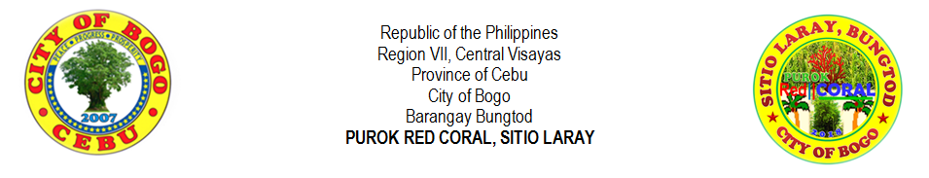
LIST OF ELEMENTARY STUDENTS
NO. |  | LAST NAME |  | FIRST NAME | MIDDLE NAME |  | GENDER |  | AGE | DATE OF BIRTH | TYPE OF SCHOOL |  |  | NAME OF SCHOOL | NAME OF GUARDIAN | CONTACT NO.
 |  |  |  |  |  |  | MALE | FEMALE |  |  | PRIVATE | PUBLIC
1 |  | ABELLA | , | BRANT SETH | ORTEGA |  | √ |  | 11 | 01/01/2008 | √ |  |  | FRVMFI | RENA ABELLA | 09324661908
2 |  | ARPON | , | FEONA MARIE | YNOC |  |  | √ | 11 | 05/242007 |  | √ |  | BCS-I | BONIFACIO ARPON | 09369556920
3 |  | ATON | , | CHRISTY ANN | CODERA |  |  | √ | 13 | 10/17/2003 |  | √ |  | BCS-I | DIANNE CODERA | 09655866279
4 |  | AVINEDO | ,
5 |  | AWAYAN | ,
6 |  |  | ,
7 |  |  | ,
8 |  |  | ,
9 |  |  | ,
10 |  |  | ,
11 |  |  | ,
12 |  |  | ,
13 |  |  | ,
14
15
16
17
18
19
20
21
22
23
24
25
26
27
28
NO. |  | LAST NAME |  | FIRST NAME | MIDDLE NAME |  | GENDER |  | AGE | DATE OF BIRTH | TYPE OF SCHOOL |  |  | NAME OF SCHOOL | NAME OF GUARDIAN | CONTACT NO.
 |  |  |  |  |  |  | MALE | FEMALE |  |  | PRIVATE | PUBLIC
29
30
31
32
33
34
35
36
37
38
39
40
41
42
43
44
45
46
47
48
49
50
51
52
53
54
55
56
57
58
59
60
 | Prepared by: |  |  |  |  |  |  |  |  |  |  |  | Certified by:
 | MIRASOL S. TAÑARA |  |  |  |  |  |  |  |  |  |  |  | RIFE D. AVENIDO
 | Purok Secretary |  |  |  |  |  |  |  |  |  |  |  | Purok President

