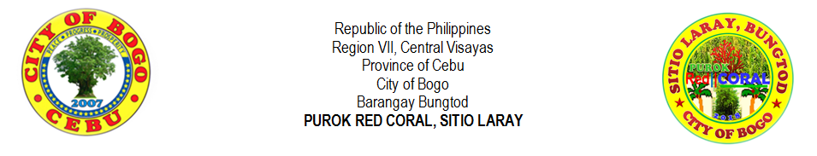
LIST OF COLLEGE STUDENTS
NO. |  | LAST NAME |  | FIRST NAME | MIDDLE NAME |  | GENDER |  | AGE | DATE OF BIRTH | TYPE OF SCHOOL |  |  | NAME OF SCHOOL | NAME OF GUARDIAN | CONTACT NO.
 |  |  |  |  |  |  | MALE | FEMALE |  |  | PRIVATE | PUBLIC
1 |  | ALBURO | , | JINNIEBEB | TUMULAK |  |  | F | 21 | 09/15/1997 | √ |  |  | FRVMFI | MIRALUMA URSABIA | 09173655314
2 |  | AVENIDO | , | JIRAH | RECLA |  |  | F | 24 | 06/02/1994 | √ |  |  | FRVMFI | RIFE D. AVENIDO | 09677246692
3 |  | LALANTACON | , | JOHN RIEL | CODERA |  | M |  | 24 | 06/30/1994 | √ |  |  | FRVMFI | CHARLIE LALANTACON | 09327186600
4 |  | ORTEGA | , | NIÑA | CANAMA |  | M |  | 27 | 01/19/1992 | √ |  |  | CRMC | BONIFACIO ORTEGA JR. | 09759845276
5
6
7
8
9
10
11
12
13
14
15
16
17
18
19
20
21
22
23
24
25
 | Prepared by: |  |  |  |  |  |  |  |  |  |  |  | Certified by:
 | MIRASOL S. TAÑARA |  |  |  |  |  |  |  |  |  |  |  | RIFE D. AVENIDO
 | Purok Secretary |  |  |  |  |  |  |  |  |  |  |  | Purok President

