Discover
PUROK RED CORAL

Have a wonderful visit to the humble place and progressive city in the northern part of Cebu, the astonishing Bogo City. Also, visit the one of the smallest communities in Barangay Bungtod, the Purok Red Coral, a home of life.

PROFILE
The topography of Purok Red Coral is near at the Carole Dy's Nature Park and partially at the back of Felipe R. Verallo Memorial Foundation, Inc. and its purok center is located 313.87 m (1,029.76 ft.) from corner to the center which is near the school and its school dormitory. The surface area is a hill and the way to visit from a highway facing the City of Bogo Science and Arts Academy which buses from Cebu City always have their right turn. Its narrow street is a one - way which made of lime or "anapog" and the corner has a two-story house on the right and on the left is a signpost. The area has an old big tamarind tree which is grown for about 40-50 years as estimated. The distance covered by the purok is 432.51 m (1,418.98 ft.) from corner to its boundary. The location is good in planting crops which some residents have corn crops and most of them are farmers and other source of livelihood is through livestock-raising and poultry. There are 55 total number of households in the purok and 202 total number of residents.

The topography of Purok Red Coral is near at the Carole Dy's Nature Park and partially at the back of Felipe R. Verallo Memorial Foundation, Inc. and its purok center is located 313.87 m (1,029.76 ft.) from corner to the center which is near the school and its school dormitory. The surface area is a hill and the way to visit from a highway facing the City of Bogo Science and Arts Academy which buses from Cebu City always have their right turn. Its narrow street is a one - way which made of lime or "anapog" and the corner has a two-story house on the right and on the left is a signpost. The area has an old big tamarind tree which is grown for about 40-50 years as estimated. The distance covered by the purok is 432.51 m (1,418.98 ft.) from corner to its boundary. The location is good in planting crops which some residents have corn crops and most of them are farmers and other source of livelihood is through livestock-raising and poultry. There are 55 total number of households in the purok and 202 total number of residents.

BOGO CITY TO CEBU CITY: 101 KM
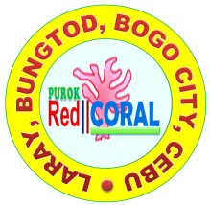

VISION
We envisioned to offer better opportunities of its fellow residents by providing quality services that correspond to the demands of time and needs in our community.

MISSION
To improve the quality of life through varied services in health, agriculture, education, human risk reduction management, solid waste management, sports, environmental projects in our Purok Red Coral.

OBJECTIVES:

Health and Nutrition
To address the health status and nutrition of the residents, community’s clean and green surrounding, beauty, and to render social services for the welfare of the people.

Agriculture and Livelihood
To enhance and improve the agricultural production through gardening, livestock raising and other decent way of finding source of income.

Education
To make alternatives in enhancing formal and non-formal education and promote culture and arts.

Urban Planning and Waste Management
To make innovations in reduction and segregation of waste and proper disposal of garbage.

Peace and Order and Environmental Protection
To make precautionary measures from disasters and maintain the essence of peacefulness and decency in the community and promote a place to visit.

Women and Child Protection
To promote safety and protection for women and children against abuses and develop the value of respect for human dignity.

Tourism
To show the value of hospitality and preserve the culture of Bogohanons and make proud to our beautiful and remarkable landmarks in our city.

Infrastructure
To develop projects with the access of 3 L’s: location, light and liquid.

Youth and Sports Development
To develop social awareness to the youth and build activities with regard in sports and other recreational activities.

Finance, Budget and Appropriations
To make usable of the funds and assistance in appropriate consumptions in the needs of the purok for project proposals and planned activities.

Disaster and Risk Reduction Management
To aware the residents on what are the measures to be done in times of calamities that will occur in the future.

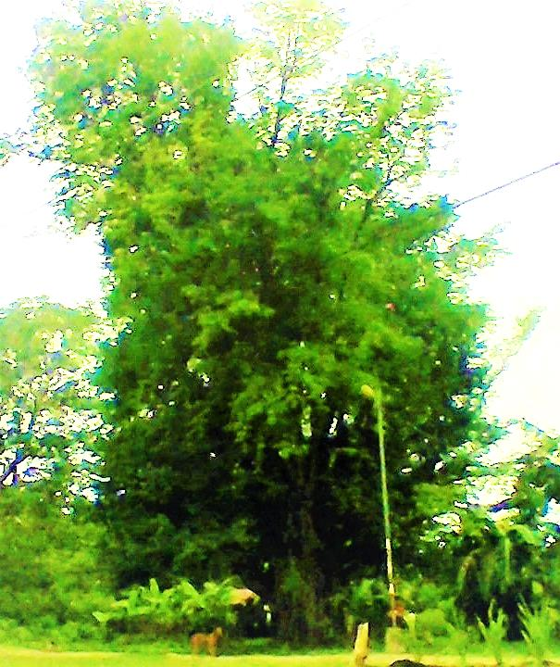
The tamarind tree symbolizes courage which in times of hardships and trials in life, the natives will never stop to stand again and to survive with all of their strength. As its roots hold strong from the riches of the land and the strength is abound with another strong roots. That, in our life, in those fallen times, the little strength remains in ourselves can pull us to make another new day and new hope.
“Encourage yourself to serve at your best and to look forward on what you can contribute for the betterment of the community.”

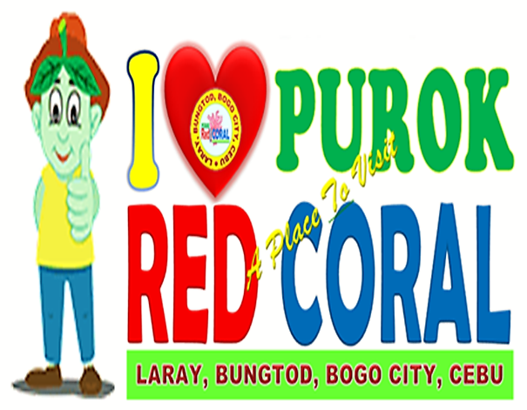
Percilito C. Tillor

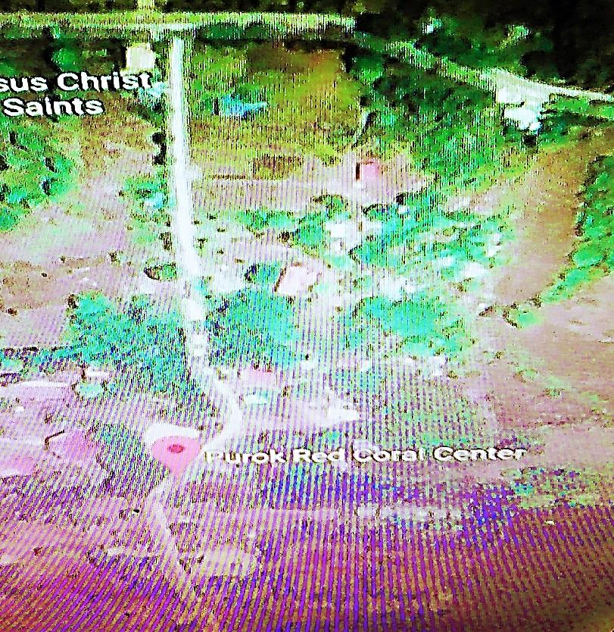

NAME OF PUROK | : | PUROK RED CORAL
LOCATION | : | LARAY, BUNGTOD, BOGO CITY, CEBU
TOTAL LAND AREA | : | 69, 073.16 m² ( 743, 497.33 ft² )
TOTAL DISTANCE | : | 1.16 km ( 3, 801.71 ft. )
DISTANCE FROM CORNER – CENTER | : | 313.87 m ( 1, 029.76 ft. )
TOTAL POPULATION | : | 202
NAME OF PUROK | : | PUROK RED CORAL
LOCATION | : | LARAY, BUNGTOD, BOGO CITY, CEBU
TOTAL LAND AREA | : | 69, 073.16 m² ( 743, 497.33 ft² )
TOTAL DISTANCE | : | 1.16 km ( 3, 801.71 ft. )
DISTANCE FROM CORNER TO CENTER | : | 313.87 m ( 1, 029.76 ft. )
TOTAL POPULATION | : | 202

FOOD FOR THOUGHT:
“MAKE EVERY MOMENT SPECIAL AND CHERISH LIFE FOREVER.”

THEMES
CURRENT | NEXT
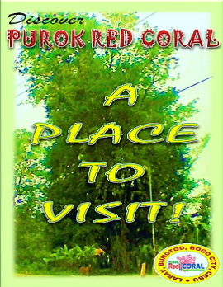 | 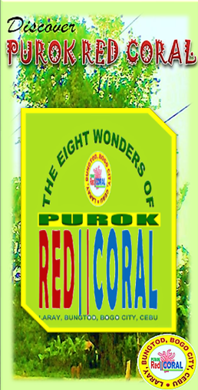

For more information and questions, you can send your message to our e-mail address at purokredcorallaray@gmail.com. Thank you!
PUROK RED CORAL OFFICIALS
HON. LIZARDO Y. MIRAMBEL
Purok Adviser

MR. RIFE D. AVENIDO
Purok President

MRS. AMALIA L. YPIL
Purok Vice – President

MRS. MIRASOL S. TAÑARA
Purok Secretary

MRS. ROWENA V. DADUL
Purok Treasurer

MS. ELENITA V. URSABIA
Purok Auditor

MRS. MARILUNA A. URSABIA
Committee Chair, Health and Education

MR. DOMINGO P. YSULAN
Committee Chair, Agriculture and Livelihood

MRS. PERLIE T. YSULAN
Committee Chair, Education

MRS. MARIA G. ORTEGA
Committee Chair, Urban Planning and Solid Waste Management

MR. RUBEN D. BERNAL
Committee Chair, Peace and Order and Environmental Protection

MRS. AMALIA L. YPIL
Committee Chair, Women and Child Protection

MS. LORNA V. GESTA
Committee Chair, Tourism

MR. DENNIS V. URSABIA
Committee Chair, Infrastructure

MR. GLEN V. ROMAGOS
Committee Chair, Sports and Youth Development

MRS. MARIFEL O. ABELLA
Committee Chair, Finance, Budget, and Appropriation

MR. ERWIN C. VILLEGAS
Committee Chair, Disaster Risk and Reduction Management

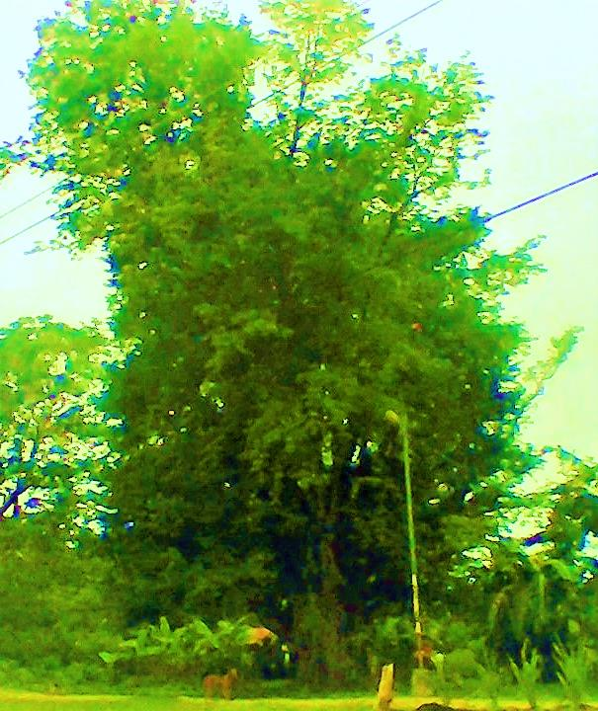
Discover
PUROK RED CORAL

A
PLACE
TO
VISIT!

Discover
PUROK RED CORAL

Converge your mind with inspiring thoughts that will make your heart a desirable action to speed up the sleeping soul within you. Yes! It’s you who is the spirit of making a remarkable history in our beloved purok.
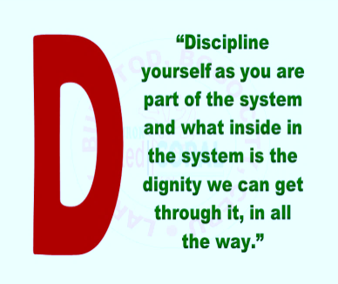
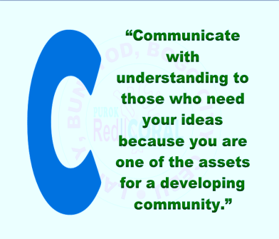
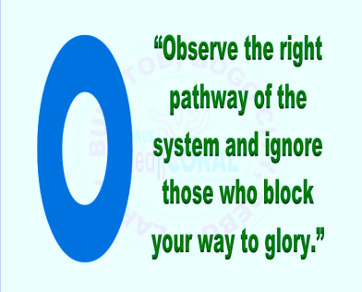
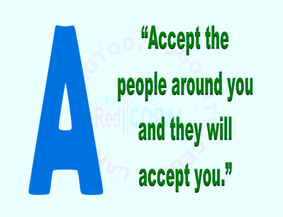
How to make a logo?
In making a logo, you must consider the following factors which are the people, place and its history, and the goal. Here are some tips to come up with a meaningful logo.
- See the people living on the place. Knowing the people and their common situation and their way of living are the keys to come up with a shape and color. The meaning of the color must agree with the background of the people.
- Discover the history of the place. Be acquainted with the things or events in the specific place that gave a sentimental value with the natives.
- Translate into words, figures, and vice versa. Words can be translated into shapes, for example, there are 29 important barangays in the City of Bogo and instead of writing them with the use of words, think for things or shapes that give significance. That’s why stars are used to represent the 29 barangays.
- Make it identical and exclusive. Some people are not knowledgeable with the history, and people’s background and place. To make it be known by all, put numbers that represent the year the organization was established but some can put years in the logo because not all are permanent. Then, put a place in order to be easily found by researchers and make it as your own.
- See the future goal. It is important to put the goal which can be identified easily by others of what the organization is all about and the future plans to set onward. For example, the three important goals in the logo of Bogo which are the peace, progress and prosperity.
- Organize all the subjects. The shapes, words, numbers, and colors should be in their proper and suited arrangement in order the result will be pleasant in the eyes. See to it that no something is missing.
The above statements are just an opinion of the designer who wrote it. Hope you can get something or learnt from it and it is based on the experience of the designer.

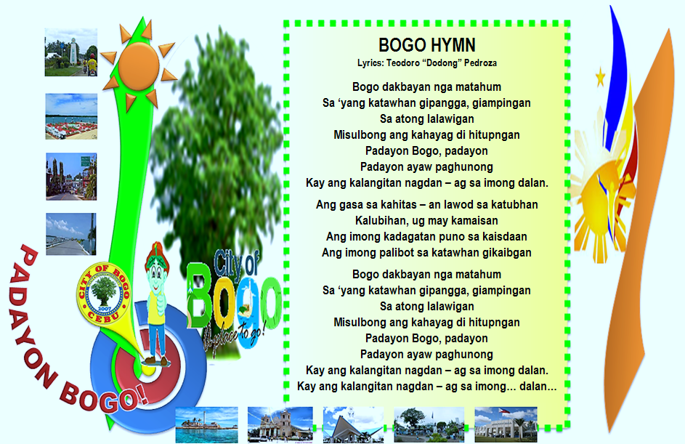
The song “Bogo Hymn” tells how Bogohanons really have the spirit of courage to continue living a life for the better as the line says, “Padayon Bogo” and how the people nurture the beloved hometown where the historical tree has grown on the place. The lone bogo tree signifies the people and the dream.
NAME OF PUROK | : | PUROK RED CORAL
LOCATION | : | LARAY, BUNGTOD, BOGO CITY, CEBU
TOTAL LAND AREA | : | 69, 073.16 m² ( 743, 497.33 ft² )
TOTAL DISTANCE | : | 1.16 km ( 3, 801.71 ft. )
DISTANCE FROM CORNER TO CENTER | : | 313.87 m ( 1, 029.76 ft. )
TOTAL POPULATION | : | 202

FOOD FOR THOUGHT:
“CHERISH THE GIFT THAT GOD GAVE UNTO US.”

THEMES
CURRENT | NEXT
 | 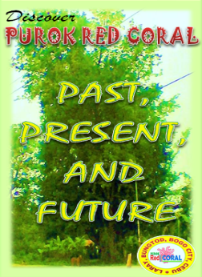

For more information and questions, you can send your message to our e-mail address at purokredcorallaray@gmail.com. Thank you!
THE LOGO AND ITS MEANING
THE CORAL
It is the habitat of the fish in which Bogo is abundant in marine resources; it means that we are living in a home with strong relationship to one another and its red color symbolizes courage and determination to progress in prosperity.

THE BLUE AND RED VERTICAL BARS
These are the two bars that signify the ups and downs in our life. The blue refers to the downs or frustrations, yet these will never hinder us to stand again and to continue living with progression and the movement needs courage (the red bar) with the guidance of the Almighty Father - as such, the goal to be experienced in reality.

THE GREEN HORIZONTAL BAR (beneath the word coral)
It is the marine life in which fishing is one of the livelihoods of the people in Bogo. The color also signifies the green surrounding within the purok which cleanliness and greenest are among
of the concerns of the residents to promote environmental stability.

THE YELLOW CIRCLE WITH GREEN BORDER
These are the colors of hope and prosperity. The circle symbolizes infinity and yellow symbolizes hope, in which our hope doesn’t stops and never ends in sharing the gift to one another. The green symbolizes prosperity that binds us to work as one, and with many hands, we can inspire ourselves and others to develop the spirit of bayanihan in a goal, the essence of PROGRESSIVE COMMUNITY.

THE PUROK RED CORAL
It is a name given to one of the group of households in smaller size at Sitio Laray, Barangay Bungtod. The word purok is written above the word red that signifies the goal of the people to reach it and to feel the essence of success along the way. The name of the purok doesn’t give meaning literally, but what’s behind of it, is the true service from within each heart.

Discover
PUROK RED CORAL

Converge your mind with inspiring thoughts that will make your heart a desirable action to speed up the sleeping soul within you. Yes! It’s you who is the spirit of making a remarkable history in our beloved purok.

Discover
PUROK RED CORAL

PAST,
PRESENT,
AND
FUTURE

