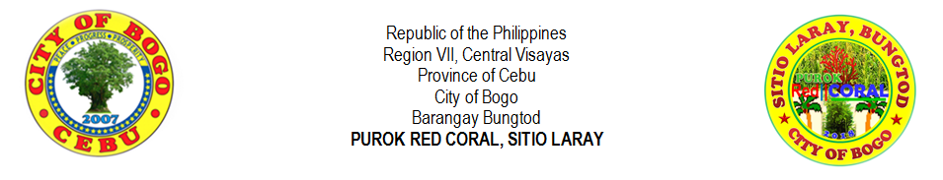
HISTORY OF SITIO LARAY
Sitio Laray formerly Sitio Tabayjo is located near and above the old municipal hall which was now the City of Bogo Science and Arts Academy and its way to visit was through the street at the façade of the school and the way where buses from Cebu City had always their turns. It was also at the façade of Carole residence now, the Carole Dy’s Nature Park and the land area was owned by Ybañez family and Madame Clomen Verallo which was her school named Felipe R. Verallo Memorial Foundation Inc. was built.

The sitio was named “Tabayjo” before which Agaton Ybañez owned a sugarcane farm that the area was named “Tres”, a Spanish term for third because this was the third farm in the place. In order to get the quota of the crops, Agaton asked the help of Angkay, the father of Irene (so lately, Agaton’s wife). There were no special historical events in the sitio aside from the World War II happened in the town of Bogo during on the year 1941 where the Americans had a battle against the Japanese. Both enemy forces started the war on the province of Cebu specially on the places within Cebu City until it came at the town. The Japanese troops camp was based at the place where the school named Northen Cebu Colleges (the first and oldest school in Northern part of Cebu which was built during 1932), while the Americans were based at Pulang Bato (now, Polambato). In the year 1936, another school named Escuela de la Sagrada Familia (now, St. Louise de Marillac College of Bogo) was built and ran by a nun from the Daughters of Charity which she was also a native in Bogo. She was Sister Dorotea Rubio, D.C. and asked from the assistance of her of her fervor missionary sister, Doña Raquel Rubio viuda de Sanchez which she also helped to build an elementary school for poor children in Bogo. The two schools were ran smoothly and peacefully until the war broke the silence during 1941 until 1944. Because of the delicate situation, the schools had no other choice, but they were temporarily closed.

After the war, Agaton Ybañez who was a farmer and a partner on the business with Angkay, ran the farm smoothly. Agaton, on the other side, worked hard in order the farm would not went down and because also of his loyalty, he was married to Angkay’s daughter named Irene. Until, the love that bloomed not only on the farm but also on the hearts of the two faithful lovers, bore into eight siblings (Editha, Vicente, Santiago, Antonio, Loly, Lita, Shirley and Mony). The family had settled at Barangay Bungtod, near the Archdicesan Shrine of San Vicenter Ferrer Parish and they continuously ran the sugarcane farm. Another family from Cayang, Bogo came and settled their house at Sitio Tabayho whom the family was a peasant farmer of the Ybañez family. Some of the spaces of the land converted into farms and planted another crop, which was corn or “mais”. Because of loyalty and a trusted peasant, Fruto “Totong” Pega Tillor was given by Agaton a carabao in order to use for plowing the field. Several years of service and loyalty to the Ybañez family, and one of the remaining heirs of Agaton who owned the parcel of the land, still showing kindness to Totong’s family. The land area of sitio Tabayjo was huge and it was divided. Instead of being part of Barangay Dakit, the other half of the sitio was now part of Barangay Bungtod during the relocation. Some people have no idea about the place named “Lawis” which truly found in the map. The sitio that which part of Lawis was the Maharat and the other half of Sitio Tabayjo was renamed Maharat since it was nearer to it. Even though the sitio was renamed, there were no changes made from the side of few residents.

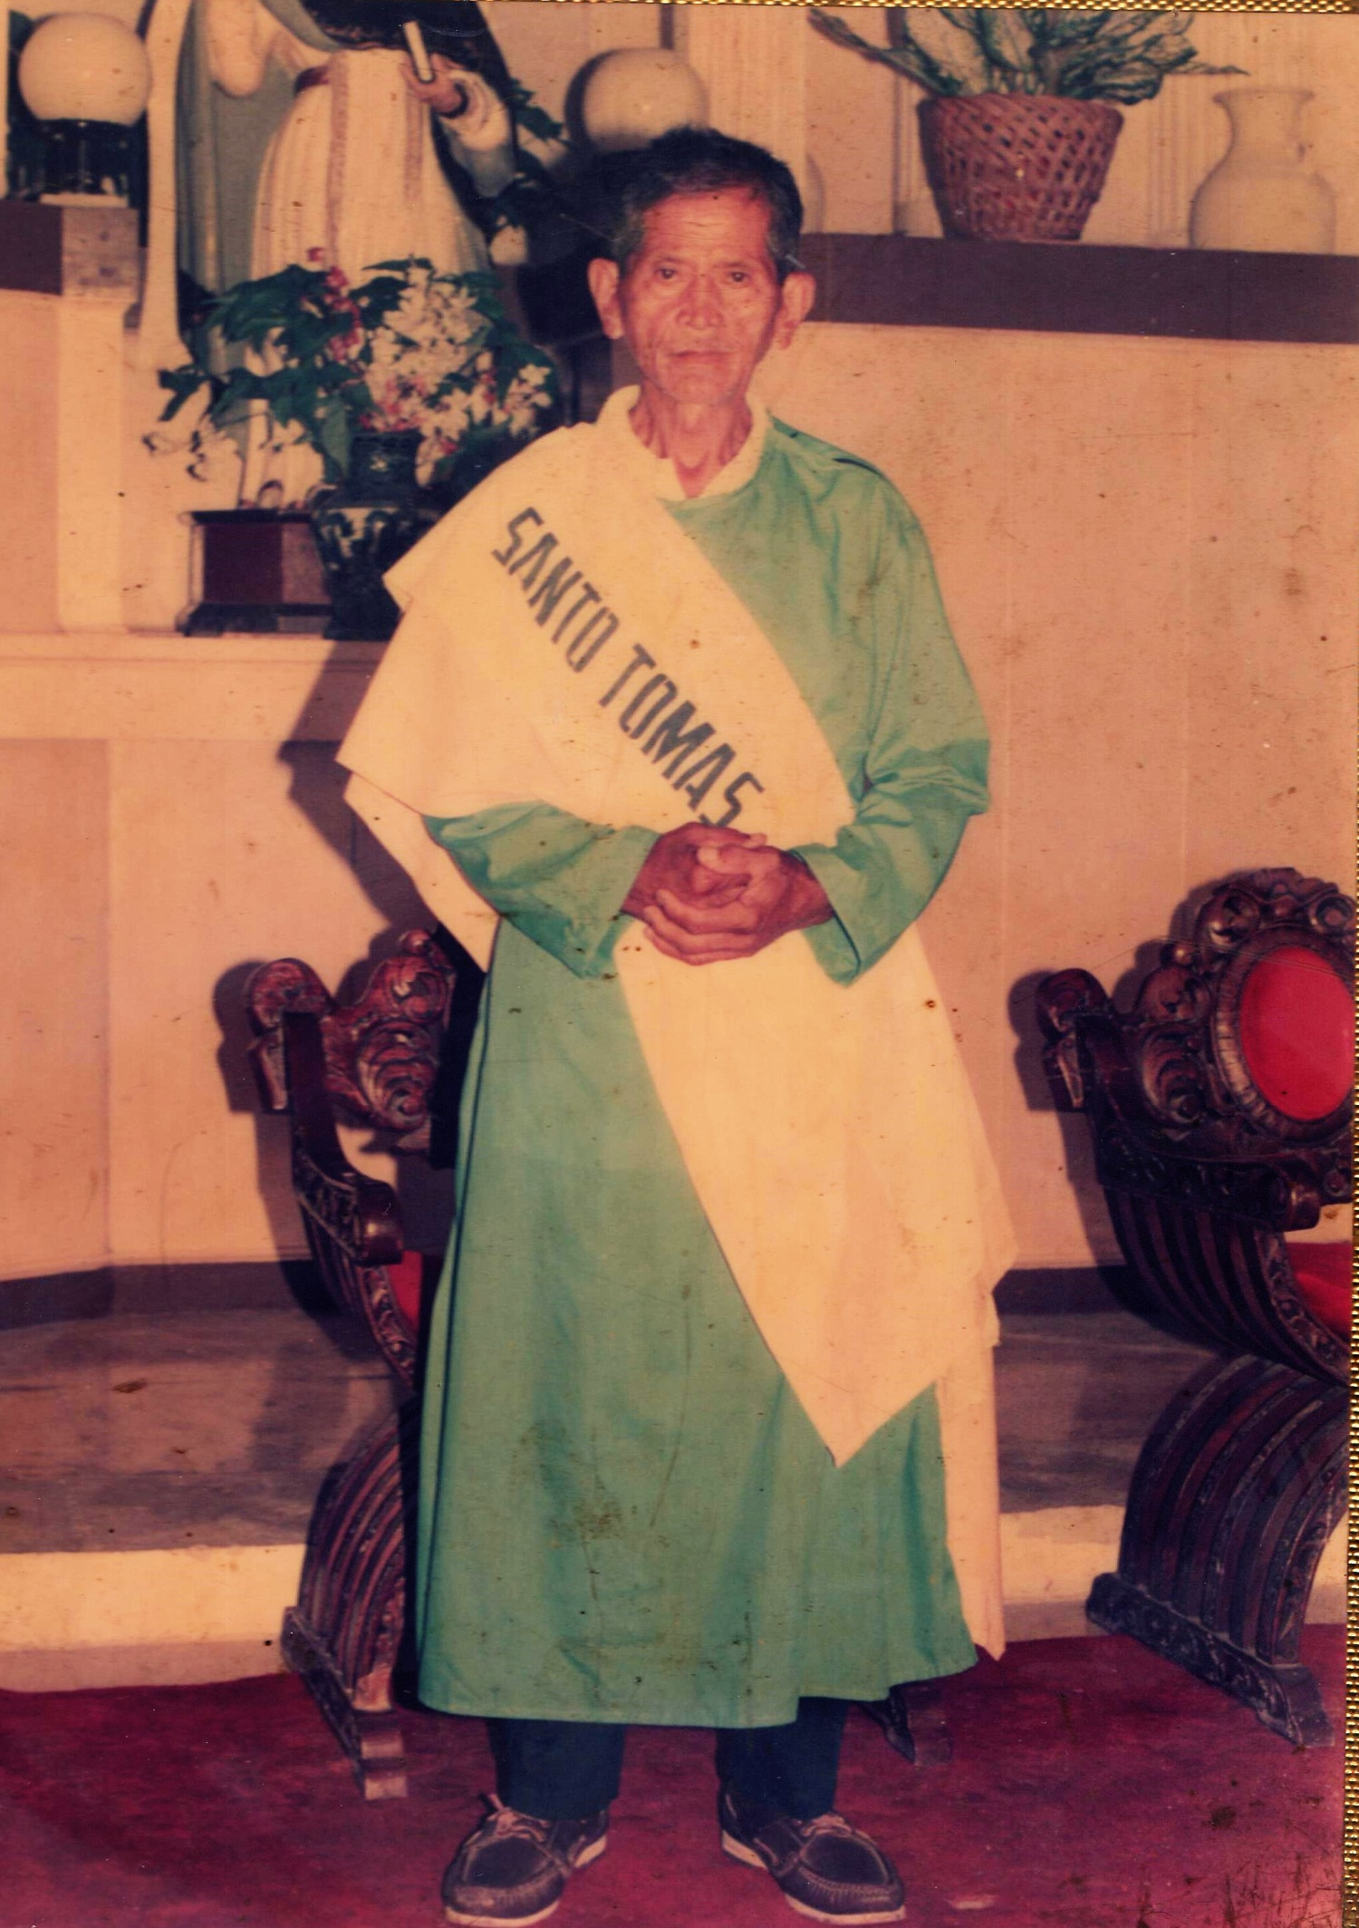
FRUTO “Totong” PEGA TILLOR SR.
BORN ON OCTOBER 25, 1921

“The Oldest Living Man of Sitio Laray”
Until, the sitio was added more people and built their houses on the same place, and another family had resided the small place and became a small community. Totong became a lay minister in the parish and his wife, Laurencia was also a servant in the parish. Both of the two were servants of God and they decided to have a dawn rosary in their small community. The activity had changed their lives to become more faithful to God, to the Son, Jesus Christ and to the Blessed Virgin Mary. Actually, the activity was always done during dawn and more on praying to God and giving honor to Mary. All of the family in the place had accepted Blessed Virgin Mary in their homes whenever there would be someone celebrating his or her birthday. Every home gave their heartfelt gratitude as the statue of Blessed Virgin Mary visited their houses. The activity exists until now and Ermielenda Ortega and other believers still bringing Mary to every home. She continues serving God despite of the death of Laurencia last January 2014. Not only they bringing Mary in their small community but they are visiting the nearest sitios such as Maharat and few houses in part of Barangay Cogon.

Then, the sitio was renamed Laray (means, “series”) because the place was planted by many coconut trees in which they were in series or in lined together. The parishioners from the Archdiocesan Shrine of St. Vincent Ferrer named it Laray as they observed the grown coconut in the place when they visited the place. The native in the place built their houses on the land of Ybañez and what they gave on return to the owner was to help particularly during the Holy Week activities as they help in beautifying the carousel, cooking and other way to assist in the preparation.

The source of living of the residents before was on farming as such the Villegas family which was the first family lived in the Sitio Tabayho (now sitio Laray) and had a corn farm but the land was owned property of Ybañez family. There was no corn mill on that time, and the way to process the harvest was through the grains in a grinder which made of stone or wood. There are two types of the grinders, one made of wood and the other one was made of stone. There are no other differences of the two aside from the material they made but they have the same feature in which the form has two big circles which piled up and down and merely attached to each other, and the above circle has a small hole in the center in which the grains are placed in order to grind. The above circle has another hole on the side in which intended for the wood handle where it is placed. The way to grind is to push and pull the handle in order to turn the above circle and the broken grains will go outside from the cavity or space in the middle of the attached circles. There should be many sacks below the grinder to catch the grinded grains of corn. Until now, Pampela Villegas (an heir) preserved the grinders. At this modern society, the corn will be grinded in a corn mill to have a fine result and other material will be created from the grinded corn which is called as, “tahup”. “Tahup” will never been eaten by the people, instead, it will used in some of the ingredients to feed the pig. It has a strong odor and it somewhat like in a powdered form. To those farmers who don’t have poultry, they actually sell the “tahup” in kilo but the price is cheaper.

Eventhough lives were not easy but still the smiles of the residents were obsolete and the uniqueness in finding entertainment especially their sons and daughters. During the period of 1980’s to 1990’s, children or adolescents have the creativity in having an entertainment and that was on playing Filipino games such as patintero, luksong baka, luksong tinik, skipping rope, tumbang preso, buwan – buwan maliwanag ang buwan (this game is played best during nighttime under the moon), slipper game (the slipper is kicked by the foot and after, the player/s will have to run from the first base and

turn until he reached the main base and it has a similarity with the baseball game), and slipper “manikin” up (played by throwing the slipper up and the direction of the slipper will go back from the one who throws it where the other players will have to catch the thrown slipper, and if not, the “taya” or “hago” , the loser will count for about ten counts decreasingly, and the other players will move and pause as the count down. If the count reaches one, one of the players will get the slipper from the ground and throws to the other player and the “taya” will touch the other player who catches or touches the slipper and whoever caught by the “taya”, he/she will be the loser.). There are many forms of entertainment in order to amuse themselves.

Authored by: Percilito C. Tillor

