
المملكة العربية السعودية
وزارة التعليم
مدرسة............
الفصل الدراسي الثاني

Kingdom of Saudi Arabia
Ministry of Education
....................... Int. school
Term : 2nd

Q1- Read the following passage then answer the questions below:
Ali is a good schoolboy . He is 13 years old . He lives in Al-Madina with his family. His father name is Bader . His father is a teacher . Ali and his family have a big house . It has four bed rooms, three bathrooms, a living-room and a dinning room . Ali loves his family . He likes English subject .
A- Answer the following questions :
- How old is Ali?
……………………………………………………………………………………………………….
- What is his father's name?
……………………………………………………………………………………………………..........................................….

B- Choose the correct words:
- He lives in [ Jeddah - Al-Madina – Makkah].
- His father is a [ doctor – policeman – teacher].
C- Put ( T ) or ( F )
- He likes Arabic subject . ( )
- His house has three bed rooms . ( )
Q2: a- Choose the correct answer:-
- your name is Ahmed , { isn’t it - are they } .
- he drove { slowly – slow } .
- she walked ( quickly – quick ) .
- A funny person is someone ( who – which ) makes you laugh.
- No,I haven’t done them (yet – just ) .
- if you put water in the freezer, it ( becomes- becoming) ice
B- Do as shown between brackets:-
1- Turn off the light . ( rewrite the sentence into two different ways )
a - ……………………………………........... b-……………………………………............
2- If you sleep early, you ………… wake up early. { complete }
3-He drives ( fastly) (correct the mistake)
……………………………………………………………………………………………………………..

Q3 : A- Match the phrases with the meaning :
1. up in the air ( ) to appear unexpectedly
2. at long last ( ) a way to show surprise
3. is that so ( ) finally

B- write the correct word under each picture:
No Passing / Saw / scissors / watch


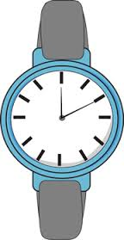
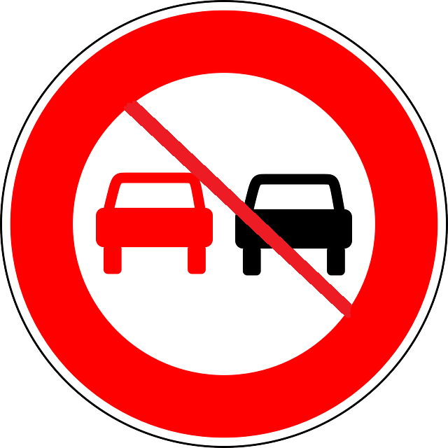
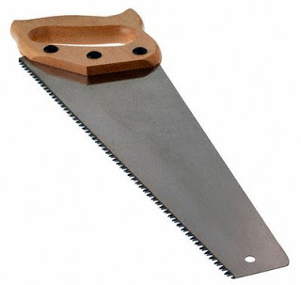

Q4- Choose the correct letter :

1- Speed limi….. ( t – b – e ) 2- p … ople ( o / i / e )
3- Tr….nk ( g – u – f ) 4- poli ... e ( h / c / g)

