Kingdom of Saudi Arabia  English language

24
Ministry of Education 3rd grade
Alsofairi 1436 / 1437 H
Intermediate School Time : 2 hours
المصحح
المراجع
اسم الطالب:- ....................................................................................الفصل :- .................الجلوس :..................... ..............

Q1: Read the following paragraph then answer the questions below:-

5

Town or country
In 1970 about 60% of saudis and 37% of the world's population lived in towns. 40% of saudis and 63% of the world's population lived outside towns or in the country. Now , about 85% of saudis and 55% of the world's population live outside towns and 15% of saudis and 45% of the world's population live outside towns or in the country .
(a) How many saudis lived in towns in 1970 ?
In 1970 about 60% of saudis lived in towns
(b) Choose:-
1- [ Now – in 1970 - ] about 85% of saudis and 55% of the world's population live outside towns.
2- [ 15% - 100% ] of saudis live outside towns or in the country.
(c) Put ( X ) or (√ ) :
1- In 1970 40% of saudis and 63% of the world's population lived outside towns or in the country. ( √ )
2- Now, 90% of saudis and 20% of the world's population live outside towns . ( X )

6
Q2: Choose the correct answer:-
1- They are going to { buying - buy – buys } a new car.
2- Ali likes { talk – talking – talked } about football .
3- We were ( watch – watching – watched ) TV.
4- She ( has – have ) started a new website.
5- You have known (fewer – less ) people than I do.
6- How ( much –many) books has she have?

5

Q3: write the correct preposition under each picture:-

along – below – into – out of – over

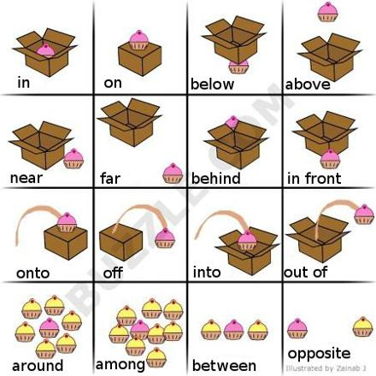
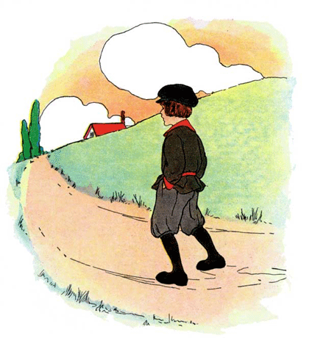


1- into 2- over 3- below 4- out of 5- along

Q4: Do as shown between the brackets:-

5
1- He / read a story. ( Use going to )
He is going to read a story
2- They \ study \ going to \ . \ English \ are \ (Rearrange)
They are going to study English .
3- Lesley did not ring the police in Brazil. ( make it affirmative )
Lesley rang the police in Brazil .
4- I have driven trucks for many years. ( change into negative)
I haven't driven trucks for many years.
5- He has drawn a beautiful cartoons. ( Ask yes,no question )
Has he drawn a beautiful cartoons ?

3
Q5: Write the past participil tense :-

eaten | 1- eat
swum | 2- swim
read | 3- read
written | 4- write
left | 5- leave
spent | 6- spend

GOOD LUCK

T. ABDULLRAHMAN M ALSHAMMARI

