Kingdom of Saudi Arabia  English language

24
Ministry of Education 3rd grade
Alsofairi 1436 / 1437 H
Intermediate School Time : 2 hours
المصحح
المراجع
اسم الطالب:- ....................................................................................الفصل :- .................الجلوس :..................... ..............

Q1: Read the following paragraph then answer the questions below:-

5

Town or country
In 1970 about 60% of saudis and 37% of the world's population lived in towns. 40% of saudis and 63% of the world's population lived outside towns or in the country. Now , about 85% of saudis and 55% of the world's population live outside towns and 15% of saudis and 45% of the world's population live outside towns or in the country .
(a) How many saudis lived in towns in 1970 ?
………………………………………………….
(b) Choose:-
1- [ Now – in 1970 - ] about 85% of saudis and 55% of the world's population live outside towns.
2- [ 15% - 100% ] of saudis live outside towns or in the country.
(c) Put ( X ) or (√ ) :
1- In 1970 40% of saudis and 63% of the world's population lived outside towns or in the country. ( )
2- Now, 90% of saudis and 20% of the world's population live outside towns . ( )

6
Q2: Choose the correct answer:-
1- They are going to { buying - buy – buys } a new car.
2- Ali likes { talk – talking – talked } about football .
3- We were ( watch – watching – watched ) TV.
4- She ( has – have ) started a new website.
5- You have known (fewer – less ) people than I do.
6- How ( much –many) books has she have?

5

Q3: write the correct preposition under each picture:-

along – below – into – out of – over

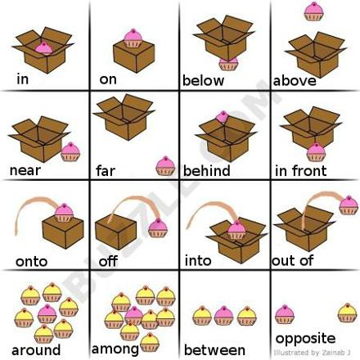
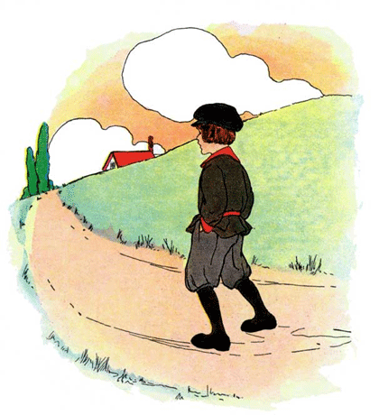
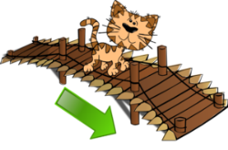

1- ……………. 2-……………… 3-………………… 4-………………. 5-……………

Q4: Do as shown between the brackets:-

5
1- He / read a story. ( Use going to )
……………………………………………………
2- They \ study \ going to \ . \ English \ are \ (Rearrange)
……………………………………………………
3- Lesley did not ring the police in Brazil. ( make it affirmative )
……………………………………………………
4- I have driven trucks for many years. ( change into negative)
……………………………………………………
5- He has drawn a beautiful cartoons. ( Ask yes,no question )
……………………………………………………

3
Q5: Write the past participil tense :-

1- eat

2- swim
3- read
4- write
5- leave
6- spend

GOOD LUCK

T. ABDULLRAHMAN M ALSHAMMARI

