30

Kingdom of Saudi Arabia
Ministry of Education
اسم المدرسة Inter. School
1434 – 1435 H

English Language
Final Exam 2nd Term
Time : 2 Hours
1st session

Name : …………………………………………………….

Seat Number: ( )

المصحح: أ.اسم المعلم. التوقيع : ( )

المراجع : أ. اسم المعلم. التوقيع : ( )

A] Read the Following Passage Then Answer the Questions :

"Majed Abdullah"
The Saudi National Team best player ever was Majed Abdullah. He was born in 1959 in Jeddahand achieved great success during his career as a football player. The ex-Saudi Arabian football player has turned into a hero for his country. His nickname was the Arabian Pele and he is the country to scorer with 89 goals from 1977 to 1994. Majed also scored the first goal in an official match at King Fahd International Stadium.

I) Answer the questions:
- Where was Majed Abdullah born?
……………………………………………………………………………………………………………………………………………
- Was he a Saudi player?
……………………………………………………………………………………………………………………………………………
II) Choose the correct answer:
- Majed Abdullah was nicknamed the ………………. [ Arabian Pele – Brazilian Pele – Saudi Pele ]
- Majed Abdullah scored ………………. Goals. [ 100 – 95 – 89 ]

III) Put True ( √ ) or False ( X ):
- Majed Abdullah was born in 1966. [ ].
- Majed scored the first goal in an official match at King Fahd Stadium. [ ].

B] Answer the Following Questions:
- What is your name?
……………………………………………………………………………………………………………………………………………
- What is your favourite sport ?
……………………………………………………………………………………………………………………………………………
- Have you ever been to Spain?
……………………………………………………………………………………………………………………………………………

6

3

1- Rhino.

2- Firefighter.

3- Water polo.

4- Headache.

5-Fox.

6- Keyboard.

6
C] Match:







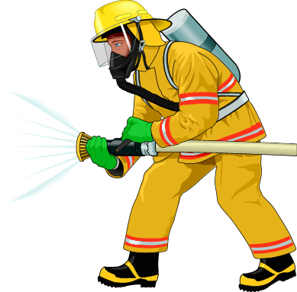

7
D] Choose the correct answer:

- …………………… milk do you have? [ How much – How many ]
- Where is Ali ? Has he ………………… to the airport ? [ gone - been ]
- He has got a sore throat. He …………… drink cold water. [ shouldn't - should ]
- This is Ahmed ……………… won the race. [ who - which ]
- They are ………………… play football tomorrow. [ will - going to ]
- Have you …………….. visited Jeddah? [ never - ever ]
- I haven't spoken to my brother …………. 5 years. [ since - for ]

4
E] Give the Past Participle of the Following Verbs:

- Drive : ………………………………………………………. 2) Sleep:…………………………………………………………
3) Be : ……………………………………………………………. 4) Drink: ……………………………………………….....

4
F] Copy the Following Sentence [ Twice ]:

"Sea Lions are really clever and talented animals"

"GOOD LUCK"

