24

Kingdom of Saudi Arabia English Language
Ministry of Education second Grade
…………..Intermediate school Time :2 hours
Final Exam 2nd term - 1st session ( 1434- 1435)
Name:………………………………………………………………………………………
Total | VII | VI | V | IV | III | II | I | Q. NO.
 |  |  |  |  |  |  |  | Mark N.
 |  |  |  |  |  |  |  | Mark L.
 |  |  |  | Reviser |  |  |  | Corrector
Composition

5
.

Write a short paragraph about YOURSELF and your plans for future:
……………………………………………………………………………………………………………………………………………….……………………………………………………………………………………………………………………….……………………………….….
………………………………………………………………………………………………………..…………………………………………….…
…………………………………………………………………………………………………………………………………………….…….….…
……………………………………………………………………………………………………………..…………………………………….……
…………………………………………………………………………………………………………………………………………….…………
Comprehension:

5

1- Read the following passage then answer the questions :
Hamsters are animals. They are rodents. Hamsters are furry. Their fur can be black, white, brown, red, or a mix of those colors. Hamsters have short tails.
Hamsters make good pets because they are easy to take care of. They do not need a lot of space. Hamsters usually live in cages that have lots of rooms and things to help the hamster exercise.
Hamsters eat mostly fruit and nuts. Some people buy hamster mix at the pet store, which is a healthy mix of food for hamsters. Hamsters can carry food in their cheeks. Hamsters are usually active in the early morning and in the evening.

2

1- Why do hamsters make good pets?
…………………………………………………………………………………………………………………….…………………….……………..

2- Where do hamsters usually live? …………………………………………………………………………………………………………………………………………………………………

2- Choose the correct answer:

2

a- Hamsters are ( people – animals – things ).
b- Hamsters have ( short – long ) tails.
11
3- Put ( T ) for the right sentences and ( F ) for the wrong ones :

1

a- Hamsters eat mostly fruit and nuts { }
b- Hamsters are usually active in the early morning and in the evening { }

Grammar

6

Do as shown between brackets:
 She will go to France in the summer . ( make into negative )
………………………………………………………………………...

3

 Have you ever see the pyramids ? ( correct the underlined verb )
……………………………………………………………...………….

 Julie has got a headache. ( take / painkiller ) (Use should or shouldn't)
…………………………………………………………………………

Choose the correct answer:

3
◆ They are going to ( study – studying – studies ) .
❖ The baby ( will sleep –sleep – sleeps ) if we are quite .
⬥ They have known each other (for –long – since ) three years .
 She ( has got – have got – have ) a sore throat .
 ( How much – How many – How old ) sugar do you put in your coffee?
 Teacher is the man ( who – which- where ) teaches students.

Vocabulary

5
*A- Write the correct word under each picture :

3
Trophy – photographer – electrician – zebra - computer - headache


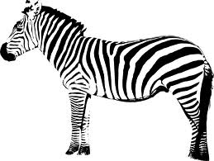
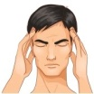

1- ………………… … 2- ……………………… 3- ……………………………
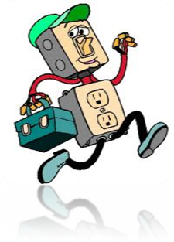




4- ……………………. 5- ……………………… 6- ……………………….…
2

B- cross the odd word :
1- camel - bat - lemon - zebra .
2- photographer – reporter – telephone – police officer .

2

C- Complete the chat speaks dictionary :
@ | 1…………….
THX | 2…………..
PLS | 3……………
CU | 4…………..

3
Spelling

Fill in the missing letters:-

Ti……er  ( h – b – g ) | foo…..  ( s – d – u ) | Firefigh…..er  ( n – r – t )

g……ggle  ( r – o – t ) | s…….reen  ( c – h – u ) | Feve…..  ( n – r – m )

Your teacher :
((دائما رددي: اللهم اني وكلتك أموري كلها فأنت لي خير وكيل ))

4
3

