Kingdom of Saudi Arabia  English language

24
Ministry of Education 2nd grade
Alsofairi 1436 / 1437 H
Intermediate School Time : 2 hours
المصحح
المراجع
اسم الطالب:- ....................................................................................الفصل :- .................الجلوس :..................... ..............

5

Q1: Read the following paragraph then answer the questions below:-

The Great Fire of London destroyed more than 13,000 houses and shops.
The summer of 1666 was very hot in London . There was no rain and everything was dry. Early on Sunday 2nd September , a bakery caught fire because the baker forgot to put his oven fire
out on Saturday evening . It was very windy , and the wind blew the fire to other buildings. Londoners woke up and ran away from their burning houses . The fire burnt for four days. It was amazing that no one died.
- When did the great fire of London happen ?
The summer of 1666
(b) Choose :-
- The fire burnt for [ 4 - 5 - 6 ] days.
- The [ farmer – baker – waiter ] forgot to put his oven fire out.

(c) Put ( X ) or ( √ ) .
1-The summer was very cold in London. ( X )
2-People ran away from their houses ( √ ) .

6
Q2: Choose the correct answer:
1- (Who – Whose – What ) is the camera ? It's Fatimah's
2- I asked ( all – both ) housekeeper and the servant about my jacket.
3- She was ( cook – cooked – cooking ) Kabsa.
4- She could ( cleaning – clean- cleans ) the room alone.
5- We make too ( many –much ) paper.
6- We should drive ( fewer – less ) cars.

4
Q3: Write the suitable word under each picture
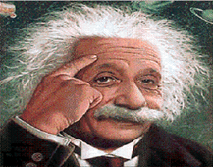
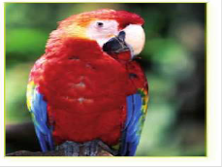

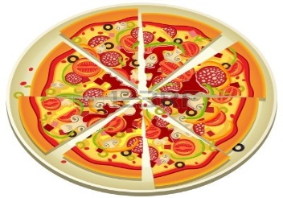

1- Think 2- Parrot 3- Castel 4- Pizza

5
Q4: Do as shown between the brackets:-
1-He ( come ) from Egypt last week. ( correct the verb)
He came from Egypt last week .
2- It is catching the fire. ( Change the sentence into past tense)
It was catching the fire.
3- Rakan found a mouse in his house. (Change the sentence into negative)
Rakan didn't find a mouse in his house
4- At five o'clock they were ( watch ) the TV. (Correct the verb )
At five o'clock they were watching the TV.
5- They could answer the question. (Make yes |No question from the following)
Could they answer the question ?

4

Q5: Give the opposite:-

Came X went Remembered X forgot

Learned X taught Slept X woke up

GOOD LUCK …

T. ABDULLRAHMAN M ALSHAMMARI

