
Kingdom of Saudi Arabia
Ministry of Education
Tabuk Educational Zone
The 1st Intermediate school

The Final Exam
First term
First Session
1435-1436 H
First grade

Final exam for 1st Grade intermediate (-1435 / 36 A.H.)
Seat No: ……….................................................................. : s nameۥStudent

Reviewed by | Corrected by | Marks | Question’s No.
 |  |  | Question 1
 |  |  | Question 2
 |  |  | Question 3
 |  |  | Question 4
 |  |  | Question 5
________  30 |  |  | TOTAL

5

5

I- Composition
Q1: Complete this paragraph about yourself using these words :
Hello - name's – age – student – country
Any suitable answer for the student.
2marks for ideas - 1 for structure - 2 for writing techniques ……………………………………………………………………………………………………………………………………………………………………………………………………………………………………………………………………………………………………………………………………………………
********************************************************************************************

( 1 )
II- Comprehension
5

5
Q2: Read the following passage then, answer the questions:
Miss Layla is a teacher in a kindergarten. She teaches little children.
She has twenty-one students in her class, ten boys and eleven girls. She likes her students; and her students like her. She's very patient and helps them a lot. She's a very good teacher.
A- Answer the following questions:
1- How many boys are there in the class ?
There are ten boys. (1 m)
2- Is Layla a teacher?
Yes, she is. (1 m)
B- Choose the correct words:
1. Miss Layla teaches ……………..(½ m)
a. little children b. young students c. old students
2. She has ten boys and eleven………………(½ m)
a. teachers b. girls c. farmers
C- Complete :
1- She likes her students ; and her students like her . (½ m)
2- She's very patient and helps them a lot. (½ m)
D- Put ( T  ) or ( F  ) :
1- Miss Layla works in a kindergarten . { T  } (½ m)
2- She has forty student in her class . { F  } (½ m)

************************************************************

6
III- Grammar
Q3: A- Choose the correct answers :
1- How are ( I - she - you ) ? (½ m)
2- It's ( Fatimah - Fatimahs - Fatimah's ) computer . (½ m)
3- We ( am - is - are ) studying English. (½ m)
4- Fatimah ( watches - watching - watched ) TV in the evening. (½ m)
5- I'm ( go - went - going )to England on Sunday . (½ m)
6- They ( don't - doesn't - does ) like shopping . (½ m)
7- Omar and his friends ( was - were - is ) in the park. (½ m)
8- Thank you for ( help - helps - helping ) me with my English . (½ m)

( 2 )
B - Do as shown between brackets :

1- a- an orange . b- a shirt .
c- a bag . d- an apple. (1 m)
( Use a or an )

2- winter / In / cold / it's / . (1 m)
In winter it's cold . ( Rearrange the sentence )

******************************************************************************

IV- Vocabulary

5

Q4: A- Match the opposites :

early | 7 | On the left(¼ m ) | 1
smart | 5 | east(¼ m ) | 2
On the right | 1 | long(¼ m ) | 3
west | 2 | different(¼ m ) | 4
never | 6 | scruffy(¼ m ) | 5
open | 8 | always(¼ m ) | 6
The same | 4 | late(¼ m ) | 7
short | 3 | closed(¼ m ) | 8
 |  | wet | 9

B- Put the right words under the right pictures:
library – soldier - camera – spring – kebab -son - headache


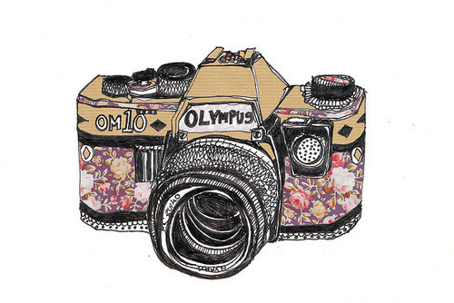


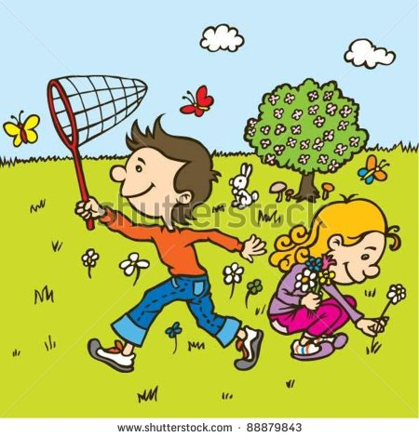

headache(½ m)soldier(½ m) son(½ m)spring(½ m) camera(½ m) library(½ m)
( 3 )

***********************************************************************************************
V- Spelling

3

Q5: A- Write the missing litter :

 |  |  | 
Cloud (¼m) | Door (¼m) | lion(¼m) | egg(¼m)
( l - m - d - r - e )

 |  |  | 
Fish  shfi  (½ m) | Otatop  potato  (½ m) | Chair  raich  (½ m) | nrreg peper  green pepper  (½ m)
B- Choose the right spelling :

***********************************************************************************************

( 4 )

