WAKE UP RIGHT WITH ANASTASIA  quick bites  -  170,000 migrants are waiting to illegally cross the border once Title 42 is lifted  -  FDA approves Remdesivir treatment for infants/children with covid  -  Murder increased 43% for Black Americans after 'Defund the Police' movement  Sources: Morning Consult, NBC News, The Gateway Pundit, History, FBI Data/ Daily Wire | the anastasia project  newsletter  First things first  Today is tuesday, april 26, 2022  First Word:  Joe Biden plans to run for re-election in 2024, but a new poll indicated that Americans would prefer he didn't...  The [Issues & Insights/TIPP] poll asked: “Who do you want to see run for president on the Democratic ticket in 2024?”  - "Joe Biden" scored a whopping 19%  - “Not sure” – 26%  81 million votes though...  in the headlines  DONE DEAL  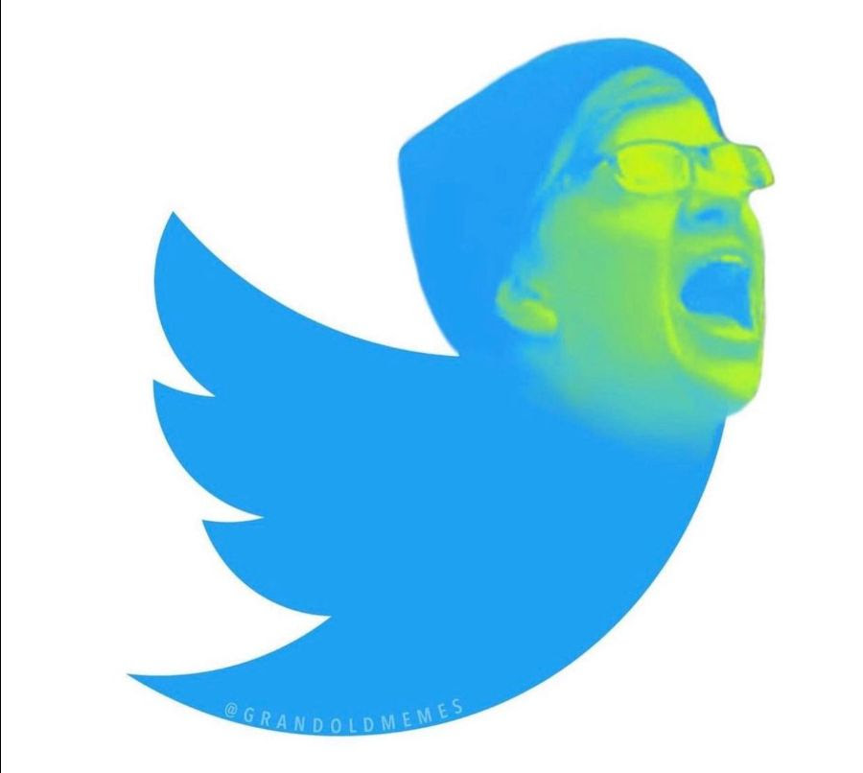  I led up to it in yesterday's newsletter, but I honestly didn't expect it to happen so quickly...  Twitter accepted Elon Musk's bid: Musk has now taken over the company in a deal worth $44 billion dollars, valuing the company at $54.20 per share - the original price Musk offered on April 14.  - The stock price closed at 5.6% following the news  - Musk plans to take the company private  Musk released a statement shortly after the acquisition, saying:  - “Free speech is the bedrock of a functioning democracy, and Twitter is the digital town square where matters vital to the future of humanity are debated."  - “I also want to make Twitter better than ever by enhancing the product with new features, making the algorithms open source to increase trust, defeating the spam bots, and authenticating all humans."  - "Twitter has tremendous potential — I look forward to working with the company and the community of users to unlock it.”  Musk also tweeted: "I hope that even my worst critics remain on Twitter, because that is what free speech means"  Which leads us to the reaction from the Left: It is exactly what you would expect - a total, unhinged meltdown, leading some to even go so far as to say his move is all "about white power."  Onto the “big question” from both Conservatives and Liberals is: Will President Trump’s account be reinstated? Trump answered that question for us, telling Fox News:  - "I am not going on Twitter, I am going to stay on Truth. I hope Elon buys Twitter because he’ll make improvements to it and he is a good man, but I am going to be staying on Truth."  My takeaway: The way I see it is this… Either it’s going to be the beginning of a free speech renaissance... OR this is all part of the evil villain's origin story where he uses his dominance over social media (Twitter), space (SpaceX), artificial intelligence (Tesla is moving to self-driving), and cyborgs (Neuralink implant chips in human brains anyone?) to take over the planet.  (Source: WSJ, CNBC)  notable facts  A federal judge has temporarily blocked the Biden administration from ending the Trump-era Title 42 policy that expels migrants from the United States’ borders to avoid the spread of COVID-19. (USA Today)  A NY judge held Trump in civil contempt for allegedly failing to comply with a subpoena for documents, fining him $10,000 a day until he resolves the ruling. Trump's attorney said he is not in possession of the sorts of written communications that were sought by the subpoena. (Human Events)  Russia's top diplomat has warned that NATO is now fighting a proxy war with Russia in Ukraine and there is a 'very serious' risk the conflict could turn nuclear. (Daily Mail)  Hunter Biden sent an email to his brother’s widow, (who, by the way, he was sleeping with) Hallie Biden, pressuring her to get an HIV test as their relationship deteriorated in July 2018, about a month before he fathered a child with another woman, according to new revelations from his infamous laptop. (Fox News)  Dozens of mysterious hepatitis cases spotted in children could be just 'the tip of the iceberg', experts warned today amid growing concerns about the mysterious global outbreak. Nearly 170 children have been affected. Experts say lockdowns may have weakened the immunity of children and left them more susceptible to the virus around the world. because we weren’t warning about something like this for two years…. (Daily Mail)  Florida Gov. Ron DeSantis approved the creation of a new stand-alone election police force designed to crack down on voter fraud in the nation’s third-largest state. (Politico)  Links  Watch as an NHL player laughs hysterically at Joe Bide as he struggles to speak. Did Biden say "BATMAN  Do these fools hear themselves? An MSNBC host warns that Elon Musk could "secretly ban one party's candidate..." Hey, Moron,… this is EXACTLY what Twitter has been doing to conservatives for YEARS. Musk bought it to stop the censorship.  Stasia’s HOT TAKE OF THE WEEK  NAILED IT!  