Mary Had A Little Lamb
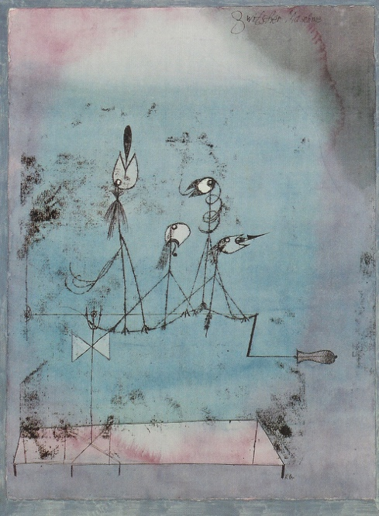
Staff paper is provided for you and your partner below. Compose your own version of Mary had a little lamb. Use “Twittering Machine” by Paul Klee as your inspiration for this assignment.
Remember: We just played part of the melody as a class!

The composition must have the following:
(check off as you complete)

- A Title
- A Melody (Mary Had a Little Lamb)
- A Background / Harmony
- A key signature ( you can use the same one as the example Concert F)
“Twittering Machine” By Paul Klee
- It must relate to your interpretation of the painting
- At least two composition techniques must be used (Meter changes, Key Changes (Major or Minor), Augmented rhythms, Articulation changes, Inversion of the melody, Varying Dynamics, etc.)
- Hint: Use a pencil so you can erase!




