GUNS of GLORY

By Lord Wrecking Bunny

Table of Contents

STRATEGIES
Upgrading Your Blimp |  | 1
False Rally |  | 3
Kill Event |  | 4
Traps |  | 5
Hunting |  | 7
Attack in Hive |  | 8
Creation |  | 9

BEGINNERS GUIDE
Buildings | 11
Events | 13
Questions and Answers | 15
Troops | 18
Expeditions | 20
Building an Alliance | 19
Guards | 23
Leaderboards | 24
References | 25

Upgrading Your Blimp
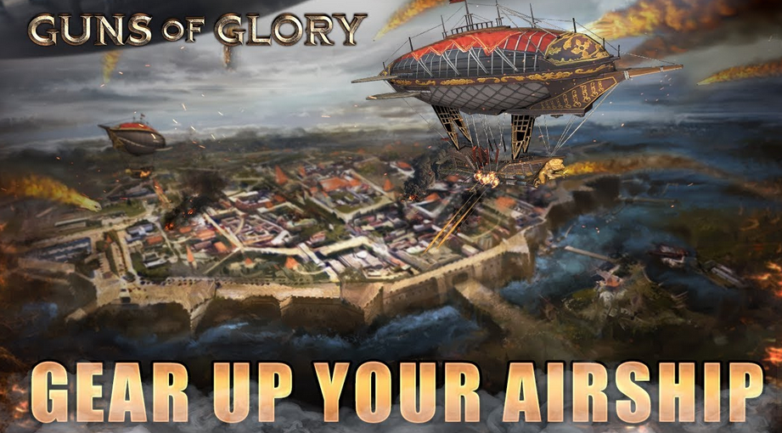

Overview & Purpose
Until recently the Airship was useful with a single march. Later, the Mercenary Airship was introduced, which allows you to send an airship with all of your marches. This feature is a most valuable during KVK, Alliance Campaigns, and crown events.

Your airship is a heavy contributor in battle, so much so that the first attribute in a kill report is “death from above”. When you send an attack march, you have a checkbox to send your Airship with that march. When the Airship is in your estate, your estate troops take on the buffs that are provided by the Airship.

The Airship has experience and can level up which unlocks more Airship skills. You will need Airship Components to upgrade them. Components are received while gathering, conquering beasts, conquering red guards, and as in game rewards. There are also Gears. Gears amplify the impact of each skill. In addition to skills, there are now Airship Parts, which are used to boost troops marching with your Airship, including attack and defense buffs. Gears are hard to get so choose them as rewards when you can.

Allocate airship abilities and components based on what helps with Expeditions. There are four types of marches that the Airship can help with: Attack, Defense, Gathering, and Beast. As the game progresses you can have up to eight Airship Abilities assigned.

Assign more and more Airship Abilities for each type of March. You can always reset later as needed. As you progress you can change them during times of peace and war:

- Attack: Add March of Fury, Distance Devastation I, Distance Devastation II, Distance Devastation III, Cavalry Canons I, Cavalry Canons III, Infantry Cover I, and Infantry Cover II. This will give you buffs to help kill as many troops as possible. When you receive components, only put them into those abilities. If you find any abilities with the icon for beasts in your attack configuration remove them and reclaim components if you can.
- Defense: Assign your Guardian abilities as Infantry Cover I, Infantry Cover II, Cavalry Canons I, Cavalry Canons III, Distance Devastation II, Distance Devastation III, Survivor Seeker, Distance Devastation I. When you receive components, only put them into those abilities. If you find any abilities with the icon for beasts in your guardian configuration remove them and reclaim components if you can.
- Gathering: Allows you to gather faster. Focus first on overall gathering speed and then spend points to gather faster for whatever your alliance mine is and distribute them evenly between the other resources. Initially focus on food and wood and later in the game you’ll get food and wood from red guard raids so focus on gathering iron and silver faster. When you get to a certain point, you’ll max out combat stats and be able to allocate your airship components to gathering. If you find any abilities with the icon for beasts in your gathering configuration remove them and reclaim components if you can.
- Beast: Don’t put resources into killing beasts. These are just a waste. I guess earlier in the game so you can kill better beasts you can, but reset them as soon as you can and either focus on gathering or focus on combat (or probably both).

At level 21 per skill, you will start receiving better stats. This will really help in combat so you want to get there as quickly as possible. Stats max at level 31.

Resetting Your Skills
- You can purchase a skill reset and /or enhancements reset with gold or honor points- it's expensive, so have a plan before you start moving things around.

Blimp Skill Enhancement
Intensity Gears / Stars
- Enhancing skills takes intensity gears. One star takes ten level one gears. The second star takes ten level two gears (which you can synthesize from 8 level one gears) and so on. Focus your stars on enhancing your assigned skills further.
- Crystals are tough to find, so use them wisely!

Monster Skills
Monster skills are those skills that help you with monsters and barbarians only.

Leveling Up
The catacombs are a great place to stock up on Blimp experience. Remember to activate VIP before entering the lab!

Keep your blimp busy and watch it grow with you.

Your Blimp’s name
It's unlikely anyone will ever know it ---but you can change it as much as you like- for a price.

False Rally

- Rally an empty stronghold (not an enemy alliance).
- Chose the 1 hour timer.

Imagine your troops standing in the gate of your castle waiting for the rally timer to end:
1. Your troops can not be scouted at all.
2. Your troops don't participate in castle defense
3. You can return your troops to your castle at any second by pressing cancel rally button.

Ways to Use
- Stand yourself near active enemy players.
- Hide your main force in a false rally keeping 5-10 low level troops in castle.
- Scout the enemy or even attack them with 5%...force Let them think that you are a completely crazy idiot or if you don't want to attack just wait until they scan and attack you).
- Keep your teammates calm they should NOT reinforce you even if you are rallied.
- Rally will hit you taking the bait.
- After that they will send single forces You have no troops that they are aware of only RSS for them to farm.
- Press cancel rally when enemy is close and enjoy the profit!
- If a strong player hitting you, you can have one of your friends to reinforce you, and then add your own troops to defend immediately for a little surprise.

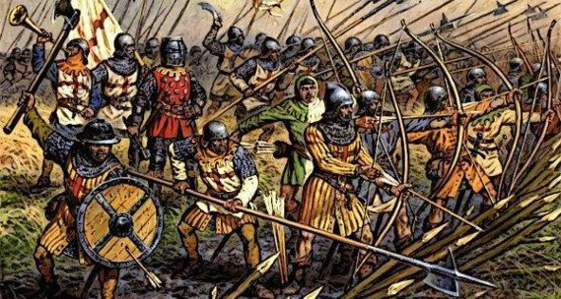
Kill Event (KE)

Smart Defense
Overview & Purpose
The Kill Stage is the final round of the week long Gold Event Just as players win gold for gathering during lithe gathering stage they win gold for kills during the kill stage.KE is played over the weekend. In this discussion we will talk about defending your stronghold during the kill stage. We will discuss getting kill stage gold at another time.

The Basics
- Be prepared
- Keep troops out of strong hold
- Keep on hand Resources (RSS) low

Being Prepared
1. Know your weekend plans. If it's your anniversary and you're going out with the spouse, buy a long shield or two and forget about it.
- If you are getting close to a big upgrade and resource laden buy a long shield or two and forget about it.
- While this may seem like not being active for the KE, your shields will provide safe haven for others who may not have shields and who can reinforce you for their safety.
- If you are shielding let others know in AC that they are welcome to share shield if needed.

Moving Troops
- Troops are what hunters seek during KE If you have RSS too well that's icing on a cake.
- Send all but one or two troops to gather if the Kingdom has a no tile hitting rule it is safe to farm.
- Keep one or two troops in your stronghold or your traps won't work!
- If you're going to be away for a long time and fear your gatherers returning before you, reinforce an ally with troops or shield yourself.
- Send RSS to the alliance storehouse.
- Don't leave the hive unless you're going to get your gold. Go as a team, there is safety in numbers. Hunters often seek isolated castles and weak alliances.

Last Words
The most delicious find for a KE hunter is a small stronghold with lots of troops, tons of RSS, and a small or no alliance. Don't be that guy! If they scout you and find that you have active traps few RSS and only a couple troops they will hunt on.

Always have a shield on hand. During an attack there is no time to go shopping or to start making alliance donations. Remember that we have an alliance shield spell if needed so don’t waste shields, but also always be prepared to use one if necessary.

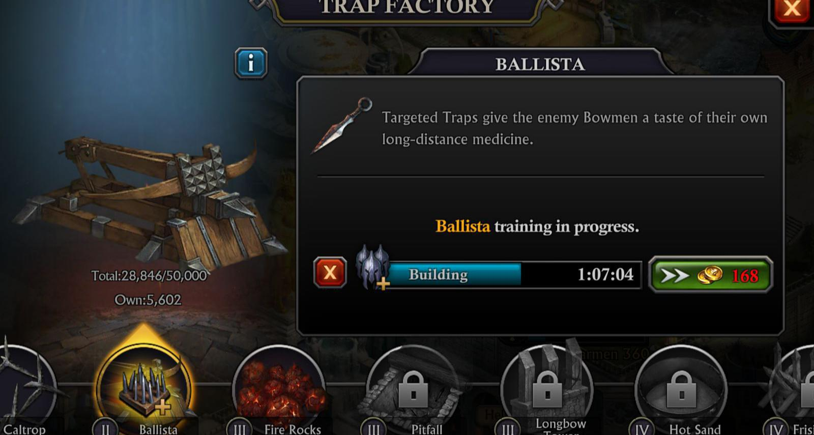
Traps

Defense: Traps
Overview & Purpose
To understand how to use the Trap Factory and the role it plays in defense.

3 Types of Traps
- Drop traps: example fire rocks; Drop traps target infantry
- Stationary traps: example pitfalls; stationary traps target cavalry.
- Targeted traps: example ballista; targeted traps target bowmen.

Name | Tier | Type
Siege Rocks | Tier 1 | Dropped Traps
Caltrops | Tier 1 | Stationary Traps
Mounted Mortars | Tier 1 | Targeted Traps
Death Rollers | Tier 2 | Dropped Traps
Bear Traps | Tier 2 | Stationary Traps
Mounted Culverins | Tier 2 | Targeted Traps
Boiling Water | Tier 3 | Dropped Traps
Spiked Trenches | Tier 3 | Stationary Traps
Mounted Cannons | Tier 3 | Targeted Traps
Flaming Oil | Tier 4 | Dropped Traps
Fougasses | Tier 4 | Stationary Traps
Thunder Cannons | Tier 4 | Targeted Traps

Why Traps are Needed
Traps are your mainstay for defending your stronghold. BUT BE AWARE!!!! You must have one troop in your castle for your traps to work. Traps target all types of troop: infantry, cavalry, bowmen and siege.

Scout report: when attacking pay attention to traps! They are troop killers! If your opponent has traps you must send siege, it will slow your march but it will save your men and your RSS!

Battle Formation
- An effective formation will start with Siege (if you have traps). One trap/one troop.
- A formation has 10 to 20k infantry. So you want that many drop traps.
- A formation has 10 to 20k cavalry. So you want that many stationary traps.
- Bowmen are the heavy hitters. Check your parade grounds and know your cap! Fill the rest with targeted traps.
- As you level to more advanced traps you can build the new and replace the old. Keep your traps strong and smart!

Hunting

Between Kill Events
Purpose
- To obtain resources without competition
- To scout Alliances
- To find and kill barbarians with a friend

Basics
- If it isn't Kill Event, please do not attack small alliances unless they are hostile to you. You may reach out, explain you're hunting if you like. Bookmark them for KE. Remember, we need small alliances growing for a healthy kingdom.
- Take a friend of similar rank. Barbarians have the same rewards if hit by two people or by six. So a smaller rally means bigger rewards, but if the person is much bigger or smaller you don't split the loot evenly.
- Scout the map. Try to find an area with lots of RSS, monsters and tiles but not too close to anyone who might be aggressive. This is strictly a RSS hunting trip.
- Share your chosen spot and port together. Make sure you will get two ports worth of play out of the trip each. Also, have a small shield on hand just in case.

1
- Scout and attack any empty or isolated Strongholds. You may want to communicate who your going for so you don't end up hitting the same person.
- Send groups to gather. These areas often have low tiles so you can clear them quickly.
- Find and rally your barbs. The level will depend on your combined strength. Rewards are split between two, so try to do your max level together.
- Be prepared to stay a while and/or spend gold for additional stam. Make it worth your tps. Clear the area completely. Leave no desired monster alive.
- Remind your alliance that you are not in Hive regularly and use a placeholder for your hive space if you don't want to lose it.
- Have fun!

Attack in Hive
General Guidelines
OVERVIEW & PURPOSE
To give a basic course of action for each stronghold during and enemy attack.

Gray Strongholds to Level 15
- Primary goal is growth. In an attack defend your RSS.
- Give to alliance daily, and use honor points to keep shields on hand at all times. Do not immediately shield but hold your position in the event that a shield spell is cast for whole hive.
- If you have t5 or over troops send them to reinforce pinks.
- If you have no shield, send t4 and under troops to neighboring shield or to camp.
- Make traps a troop focus. Goal should be 20k for infantry traps and cavalry traps, then max your trap cap on bowmen traps.

Pink Strongholds level 16 to 19
- Give to alliance daily, and use honor points to keep shield on hand at all times. Do not immediately shield unless directed. Hold position in the event that shield spell is used for whole hive.
- Send t6 and higher troops to reinforce golds if not active and able to participate.
- Await instructions of r4 and join rallies if counter attack is planned. Remember to attack as a team when counter offensive is launched.
- Only use rams for first round counter attack rally if the defending castle has traps.

Gold Castles level 19+
- Scout, share report and direct teams. Calculate team losses and risk before launching counter offensive.
- Give to alliance daily, and use honor points to keep shield on hand at all times. Do not use shield unless spell is unavailable or you are RSS laden.
- Activate shield spell if necessary.
- Recall all field troops and be prepared to direct rallies. Focus on the nearest offender and direct link teams and rallies.
- Be prepared to port and defend allies as needed.
- Designate an R4 to communicate with the opposing alliance.
- DO NOT remove alliance players who have troops in the alliance hospital.

***all Strongholds buff as needed.

Participate
Forbidden Knights and Portal events help you to prepare for a hive attack. In FK you practice quickly reinforcing your neighbors during a single attack or Larger rally. This is the same skill you want to keep in mind when a hive attack takes place. The portal event helps you prepare to quickly rally a single, larger foe like an enemy stronghold during a counter attack.

It's great training and it's fun! Participate whenever you can.

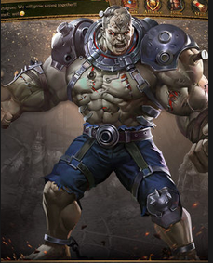
Creation

Introduction
The Creation is used in the Catacombs. It is a mini game within the game and it has its own, Talent Points, Research, Skills, Equipment and Experience Points.

Creation
Once your Blimp reaches level 10 you invoke your Creation. Once invoked, the Catacombs to the right of the Blimp Lair becomes available. In there you will battle monsters and collect rewards.

Levels and Talent Points
Each time you level up your Creation, you will receive Talent Points, which are used to assign Creation Talents. Make sure you use any Creation EXP items you have prior to entering the Catacombs.. If you level up, ensure you assign any Talent Points you received. Initially you receive one Talent point for each EXP level you upgrade. I believe that from level 31 to 40 you receive two Talent points for each level.

As your Creation Level increases it automatically unlocks Spirit Skills. These Skills are divided into tiers, each with a maximum level. The Spirit Skills within the tiers improve as their values increase each time the Creation Level upgrades until they reach their maximum level. Each Spirit Skill also has a Creation XP Level associated with it that unlocks it.

Creation Equipment
There are several menu items for Equipment for your Creation in the Doctor’s Lab. The equipment scrolls found in the Catacombs will only benefit your performance within the Catacombs.

There are three materials relevant for the forging of Creation Equipment: Fire Opals, Spider Silk and Soul Clay. The higher the level of the equipment scroll, the more resources which it requires. You can dismantle any forged equipment to regain the materials once again.

Creation Research Category
There is a special research category called Creation that allows boosts for your Creation and the Catacombs. At lower levels the research projects seem relatively easy with requirements so when you low on resources this is a good area to concentrate on. There are no dependencies between projects, so you can start researching any you find useful.

VIP
The VIP level can provide you with various boosts so consider activating it before you entering the Catacombs. This increases the number of potions you get, your Satchel Capacity and your number of Slots.

Catacombs
To enter the Catacombs you need to have invoked your Creation in the Doctor’s Lab. The Catacombs works with a cooldown timer, so you cannot enter it until it resets.

When you click Explore in the Catacombs menu there is an option to select a floor to start. It is confirmed that once you reached the following levels you can restart at those levels the next time you enter the Catacombs: 11, 21, 31 and 41.

Once you enter the Catacombs a cooldown timer of 2 days starts. You need to finish exploring within those two days, and without using a cooldown reset or speedup you cannot start again before the two days expire. It is possible, via the button on the right in the Catacombs to temporarily step out and come back later without losing progress.

In the Catacombs your Creation has a green Health bar. Once the Health bar reaches zero during a battle you are sent back to the previous room with the same health. The Stamina of your Creation is indicated by the number in the Avatar at the left top of the screen. When you explore a new room it will cost one health point of your Creation. Reaching 0 means you cannot explore further.

You get free Health and Stamina potions each time you enter the Catacombs, these can be used via the second round button at the bottom of the screen. At the right top you see a Floor map with the rooms you have explored so far. You can move around by clicking on the green arrows.

Some of the Rooms will have monsters and/or chests in them. You start a fight by tapping once, and if there are multiple monsters you can tap to select which one should be attacked first. You can also open a chest by tapping once. You can choose to select the contents of the chest for your inventory. If case your inventory is full, you can disregard items by selecting them in your inventory via the first round button at the bottom.

Each floor contains a door to the next floor guarded by a guardian. After winning the battle with the Guardian Monster you can select to either stay on the current floor, or go on to the next. Unlike some similar games there is no need to choose to leave the Catacombs at a certain level to keep your treasures.

At a certain point you will get stuck with either too little health to beat the next monster or too little stamina to explore any new room. When this happens you need to wait until the cooldown timer expires before you get your prizes. You will receive the prizes via a System Mail once the Catacombs Cooldown timer has expired and you need to Collect the prizes in the mail before they become part of your inventory.

Growing your Creation
You will likely find that while exploring the Catacombs you can pick up way more than you can carry, which forces you to make choices. To take a long term approach you might consider focusing your efforts first on increasing your Satchel Capacity rather than the strength of your Creation or gathering Materials for Creation Equipment. Some practical tips if you follow this approach is to focus on collecting Creation XP until you have reached Creation level 10, which gives you the Satchel Storage Skill, which increases your Satchel Capacity with 250. Another is to focus your research on Satchel Capacity.

Buildings
Stronghold | Your Stronghold is the heart of your City and your most important building. As you upgrade you unlock the ability to upgrade other buildings. Your March Capacity and overall Power increase as well. Details of your City’s resource production and resource boosts can be viewed in City Stats in your Stronghold. Details of your City’s current item boosts can be viewed in the City Buffs.
Barracks, Stables, Range and Artillery Foundry | You can train four different types of troops in these buildings: Infantry troops in the Barracks; Cavalry troops in the Stables; Bowmen troops in the Range; and Artillery troops in the Artillery Workshop. Upgrading will unlock higher level troops. Higher level troops will be unlocked as buildings reach levels 4, 7, 10, 13, 16, 19, 22, 26 and 30. The number and level of your Military Tents determine the number of troops you can train at one time and your troop training speed. You cannot train troops while you are upgrading the building, or upgrade while you are training. If you wish to dismiss any troops, tap on the building that trains those troops, tap Train, then select the type of troop you wish to dismiss. Tap the Info icon next to the image, select the number of troops you wish to dismiss, then hit DISMISS. Dismissing soldiers will not refund the resources used to train them.
Trap Factory | Different kinds of Traps target different kinds of enemy troops. For example, Dropped Traps target enemy Infantry, Stationary Traps target Cavalry, and Targeted Traps target Bowmen troops. When attacking, Artillery troops can be used to destroy Traps and help protect your troops by receiving the brunt of the enemy Trap attack. Upgrading a Trap Factory will unlock more powerful Traps and increase your Capacity. The speed with which your Traps are built can be increased through Research and using Talent Points. When your City is attacked your Traps are activated automatically. Bear in mind that Traps are only activated when you have one or more troops present. If you have no troops in your City, the Traps will not work. If you wish to demolish any Traps, go to Defenses in the Trap Factory, select the type of Trap you wish to demolish, and tap the Info icon next to the image. Select the number of Traps you wish to demolish, then hit DEMOLISH. Demolishing Traps will not refund the resources used to build them.
Storehouse | The Storehouse guarantees protection of a certain amount of your resources if you are attacked and lose the battle. The higher the level of your Storehouse, the more resources are protected. Uncollected resources from your Farms, Sawmills and Mines are not protected by your Storehouse so it’s a good idea to collect them whenever you can.
University | You can research skills and benefits in your University. Research is divided into categories: Development, Economy, Combat and Defense. Focus on them to improve areas which will benefit your strategy. Upgrading makes more items available for you to research.
Embassy | The Embassy allows you to receive timer help and defensive reinforcements from your allies. Upgrade it to increase the number and duration of timer helps you can receive, as well as the number of reinforcement troops you can hold. Your Embassy can only receive one reinforcement march from each Ally. When your Reinforcement Capacity has been reached no more troops can be received. Reinforcing is a useful way to protect your weaker allies. Whenever the Help icon appears over your Embassy it means one of your allies has requested help - simply tap it to help them.
Trading Post | Your Trading Post allows you to send and receive resources with your allies. You can send a request for whichever resource you require. Each request lasts for 24 hours. You can only request one type of resource at a time. The requests will be announced in a message within Alliance Chat. There is a Trade Fee taken to guarantee safe passage of the goods. This Trade Fee is reduced each time you upgrade your Trading Post. The amount of resources you can send each time is increased when you upgrade.
Hall of War | The Hall of War allows you to launch and join rallies with your allies. Upgrade it to increase the number of troops that can march in the rally. Rallies enable you to amass a much larger army than if you attacked by yourself. The size of the rally and the number of participants can also be increased through donations to Alliance Tech. Upgrading your Hall of War requires Books of War which will be used automatically.
Watchtower | The Watchtower is your lookout for incoming scouts and marches. Upgrade it to receive more detailed information about your opponent. Your screen will flash red if the Watchtower detects any incoming scouts or marches. A Watchtower icon will also appear. Tap on this to find out more about the incoming opponent.
Munitions Exchange | If you find yourself short on resources you can visit the Munitions Exchange and try your luck. It grants a number of free trades daily. You can receive up to 10 times the guaranteed amount of resources from each trade. It is unlocked once your Stronghold reaches level 8 and requires 250 Wood initially to upgrade to level 1. Upgrading it can increase the number of free trades granted per day. It also increases the guaranteed amount of resources.
Wall | Your Wall helps protect your City when you are attacked. If you are attacked and lose the battle your City will begin to burn. Throughout this burning state, your Wall Defense will decrease. You can extinguish the fire immediately with Gold, or it will cease automatically after thirty minutes. You can then increase your Wall Defense once more by repairing it. If your Wall Defense ever reaches zero, your City will be automatically relocated to a random location on the map and the Wall Defense will be restored to maximum immediately.
Hospital | The function of the Hospital is to heal your troops wounded in battle. The treatment of wounded troops costs half the time and resources needed to train new troops, so it is a good idea to have as large a Wounded Capacity as possible. You can achieve this by building more Hospitals and upgrading them. Research at the University as well as using Talent Points can also increase your Wounded Capacity and Healing Speed. Be sure to heal your wounded troops because when your Wounded Capacity is reached any further troops wounded in battle will be lost. What happens to your troops after a battle will vary depending on the kind of battle: When you are defending, all wounded troops will be sent to the Hospitals until Wounded Capacity is reached, after which they will be lost. When you attack Monsters, a small percentage of troops will be wounded and sent to Hospitals. When you attack an opponent on a resource tile, wounded troops will be sent to the Hospitals until Wounded Capacity is reached. When you attack an opponent’s City, ALL wounded troops will be lost.
Military Tent | The Military Tents provide housing for your troops. They are key to increasing the size of your army. Building more Military Tents and upgrading them will increase your Training Capacity and your Training Speed.
Farm, Sawmill, Iron Mine and Silver Mine | Your Farms, Sawmills, Iron Mines and Silver Mines are the buildings that produce Food, Wood, Iron and Silver, respectively. An icon will appear above them whenever there are resources ready for collection. Upgrading these buildings will increase the production as well as the amount of resources they can hold. The Iron Mines will be unlocked when your Stronghold reaches level 10. The Silver Mines will be unlocked when your Stronghold reaches level 15. Uncollected resources are not protected from enemy raids, so it’s a good idea to harvest regularly.

Events
Red Guard Events
This is an Alliance event during which players can earn rewards according to their individual and Alliance rank. During the event, the Guards will attack all members in the Alliance. The more you defend against successfully, the better rewards you will receive. Some are very powerful, therefore it would be wise to unite all allies together to defend against them. They will not attack you if you have 2 failed defenses in the same round. During this time you can send reinforcements to your allies. If all allies have a failed defense 2 times, then this round’s Alliance Event is over. A Peace Shield has no effect on the attacks of Fallen Knights.
Underworld Challenge
This is an Alliance event during which Alliance members can send their armies to battle Portal Monsters and gain rewards according to their rank. To open the Portal, Alliance members need to donate keys. These can be found when opening Barbarian Chests, which are gained randomly when attacking Barbarian Camps. To open the Barbarian Chests, you'll need Barbarian Keys which can be gained in the Daily Rewards. When the required amount of keys have been donated, and cool down times have been met, you can then rally against the Portal Monsters. Players who have been in the Alliance for less than 48 hours cannot join the Portal Challenge.
Night Siege
The Night Siege event can be joined via the Event Center. It is played on a special map, so account locations are not important. During the Event you protect the Underworld Gates from 30 waves of Creatures by occupying 5 fortresses. Each wave the fortresses will be attacked. Any Creature not beaten will damage the Underworld Gate. Once the Gate has 0% health remaining, the event ends. If you pass all waves with some health remaining, you win the Siege. When a wave is announced the number of Creatures in the wave appears above them. Each player defending a fortress only defends against one Creature each wave. If you have fewer players than Creatures, some will always get through.

It is possible to move between fortresses during one wave. Moving defenders between fortresses 1 to 4, 1 to 5 and 4 to 5 allows you to prevent damage if you don't have enough defenders. It’d be good to assign fortress leaders to make sure there are enough defenders, since It’ll be difficult for one person to monitor all fortresses at the later stages when you’ll need 1 or 2 extra accounts in a fortress than the attacking Creatures. To avoid confusion, select one person to pick up the chests when they appear.
Alliance Events
The Alliance Event is a cross-Kingdom event, during which Alliances can compete against Alliances in other Kingdoms! During the timed event your Alliance can obtain points for specific activities during the allotted time. There are five different stages, each with their own rankings and a different type of activity. The sequence of the activities is randomized. TOP Alliances in the stage rankings or overall rankings will receive great rewards sent through the in-game Mail at the end of the stages and overall event.
Gold Events
The Gold Event is a timed event in which you can obtain points for specific activities during the allotted time. When the amount of points you have obtained reaches the Target Points level, you will receive a reward automatically through the mail. You can view the details of the event by tapping on the Event Center next to your Blimp Lair. The type and sequence of the tasks are randomized each week. Tasks include:
Gathering Resources
Points are earned by gathering resources on the Kingdom Map. Different levels of points are awarded according to the type of resource collected.
Killing Monsters
Points are earned by killing Monsters on the Kingdom Map. The higher the level of Monster the greater the number of points earned.
Upgrading
Points are earned by increasing Power through upgrading buildings and research.
Troop Training
Points are earned by training troops. The higher the level of troop trained, the greater the number of points earned.
Killing Troops (Killing Event – KE)
Points are earned by killing enemy troops. The higher the level of troop killed, the greater the number of points earned.
Rewards
The Gold Event is divided into stages. Within each stage there are three levels of rewards. You will receive these rewards in your mailbox whenever your points reach the corresponding Target Points level. You must remember to collect the rewards from the mail to obtain them. Each stage of the event also has ranking rewards based on the number of points earned during that stage compared to other Lords in the Kingdom. The higher your ranking, the bigger the rewards. Finally, the biggest rewards are awarded according to the overall ranking at the end of the event. This is based on the total points accumulated across all of the stages. The Lord with the most overall points in your kingdom will be named Champion. Points are reset at the end of each event.
Halloween Event
During the Halloween event, your troops may discover Pumpkins when gathering resources on the Kingdom Map, and pick up Small Knives when killing Monsters. Synthesize the Pumpkins and Small knives into a Jack-'o-Lantern for Halloween! With the Jack-'o-Lantern you can rally the Vampire Lord on the Kingdom Map. By rallying against the Vampire Lord players will gain items, while taking down the Vampire Lord's health to zero will earn you the Halloween Candy. Using the Halloween Candy gives your Castle a chance to get a Haunted Castle skin on the Kingdom Map!
St Patrick's Day
This event can be found in the Event Center.
- The first step is to kill many monsters and collect lots of Leprechauns. Every time you slay a Monster on the Kingdom Map you will have a chance of collecting Leprechauns.
- The second step is to gather resources on the Kingdom Map (not from Alliance buildings). Likewise, when you collect resources you have a chance to find Shamrocks
- The third step will be directly from your inventory: tap either on the Shamrock or Leprechaun then tap on 'Use' to get great rewards!
The rewards vary and could include: Gold, Lord EXP, Blimp EXP, Creation EXP, Blimp Power, boosts, resources and also lots of crafting materials!
St George's
To honor his memory, during this event you will have a chance to get George’s Lance when defeating a monster on a Kingdom Map and Red Roses when gathering resources. Once you have collected them, from your inventory simply tap on use to exchange them for rewards! Roses will give you a random selection of the following rewards: Resources, Materials for lord equipment and Materials for Creation equipment. Lances will give you a random selection of the following rewards: Lord EXP, Blimp EXP, Gold, Resources, Guardian Power, Assault Power, Boost and Speedup. That’s it for this event! Get ready to fight tough monsters and gather resources on the map to protect the ladies of your Kingdom and get a lot of rewards!
Independence Day Event
You may find Fireworks when harvesting resources in your city. You can redeem them for rewards directly from your inventory by tapping on "use". Make sure to not mix them with the Party Popper! That are here for another feature of the game!

Alliance Conquest (AC)
Strategies: (Note any participation in the even yields rewards)
1. When you leave your hive to hunt, always coordinate someone to fill your hole first. Leaving a hole jeopardizes your clan’s defenses.
2. Pick a tower or building to defend. Use the “treasure details” option to send your troops to defend. They will return automatically at the end of AC.
3. When your troops are hit, heal them, then resend them to defend again.
4. Don’t forget to get your individual reward from within the event center upon completion of AC.

Questions & Answers
How do I increase my Power
You can increase your Power six different ways: training more troops; upgrading your buildings; building Traps; Researching at your University; and upgrading your Lord and Blimp levels.
How do I attack Monsters?
The Kingdom Map is infested with Monsters. Slay them to obtain rewards! You must defeat a lower-level Monster before you can challenge higher-level ones. The higher the level of Monster, the greater the loot. To attack, tap on the Monster of your choice. Note the Recommended Troop Power level and choose your troops accordingly. You will receive a mail detailing the fight and the loot gained. You will receive bonus First Kill rewards the first time you defeat a Monster of each higher level. A small number of troops may be wounded during the fight. If so, they will enter your Hospital automatically depending on your Wounded Capacity. Your Blimp Skills, Talent Points and other bonuses will increase the power of your army above the stated Troop Power so you may be able to overcome Monsters even if your Troop Power is less than the recommended amount. Repeatedly killing Monsters is a great way to acquire Gold and amass resources which will be protected from looters. It also offers you the chance to obtain dropped items and is a good way to increase your Lord EXP, Blimp EXP, and Assault Power.
How do I gather Resources?
On the Kingdom Map you can send troops to occupy a resource tile and gather the resources. You can then use these resources to develop your City. To gather, select a resource tile and then tap ‘Occupy’. Choose the troops you wish to send and tap “MARCH’. Your troops will return when they have gathered all the resources they can carry. The amount of resources your troops can carry is dictated by the number and type of troops in the march. The larger your troop load is, the more resources you can bring back. You can also boost the amount gathered through Talent Skills, Blimp Guardian Skills, Research and Gathering Boost items. The higher the level of resource tile, the more resources on offer. The closer you are to the center of the Kingdom, the higher the level of resource tile.
How can I protect my troops?
The easiest way to protect your troops is to use a Peace Shield. This prevents enemies from attacking or scouting your City. Note that any troops you have outside of your City that are gathering, reinforcing, or encamping will not be protected! If your City is under attack and you don’t have a Peace Shield, you have a couple of other options. You can choose to send your troops to encamp on a nearby or distant tile. Be careful where you send them because these troops will also be vulnerable to attack when they are encamping. You can also send them to reinforce an ally. Another option is to use a Teleport to change your location on the map. Using your Alliance or Beginner’s Teleport to move next to your allies is a good way to reduce your chances of being attacked as there is strength in numbers. Building and upgrading more Hospitals will enable you to heal more wounded troops and reduce your losses during battle.
How do I get Talent Points?
You will receive Talent Points each time your Lord Level is upgraded： between Lord levels 1 and 10, you will receive 3 Talent Points; Levels 11-20, 4 Talent Points; Levels 21-30, 5 Talent Points; Levels 31-40, 6 Talent Points; Levels 41-50, 7 Talent Points; and Lord Levels 51-60, 8 Talent Points. You can upgrade your Lord Level by increasing your Lord EXP level. Lord EXP can be obtained by killing monsters and using Lord EXP items. Each time you increase your Lord level you will receive item rewards and Talent Points. Deploy the Talent Points to increase your skills in three areas: War, Economy and Balance. They add significant boosts to your City. If you wish to change the emphasis of your strategy, the Talent Points can be reset and then redeployed as you see fit.
What are the different Teleports in the game?
There are five kinds of teleport in the game:
- Beginner's Teleport: this can teleport your city to a different Kingdom of your choice. For Cities with Stronghold level 5 and under, and registered within the past five days.
- Random Teleport: can teleport your City to a random location on the Kingdom map.
- Alliance Teleport: can teleport your City to a location close to your Alliance Leader's city.
- Advanced Teleport: can teleport your city to a chosen location on the Kingdom map. To use an Advanced Teleport, please tap on your preferred location on the Kingdom map then tap 'Teleport'.
- Fortress Teleport: can teleport your City to a location close to your Alliance Fortress.
What are Gemstones and Refining Stones?
Gemstones are precious stones which can be embedded into your equipment to make it more powerful! There are several ways you can obtain Gemstones in game: from Portal Monsters, Doctor’s Gift, in the Gold Event, Red Guard Event, Lucky Shot and in certain packages. Please note that Gemstones cannot be used on Scrolls. To use the Gemstones, you'll need to take them out of the inventory first so they can be accessed in the Armory. After using the Gemstones from the inventory, tap on the piece of equipment which has an available Gemstone Socket and tap on the empty socket to embed. Remember, the Gemstone can only be embedded successfully when its shape matches. Also note that not every piece of equipment has a Gemstone Socket! An embedded Gemstone can be removed from the piece of equipment with the item, 'Gemstone Reclaim Kit', or removed by destroying it. Destroying the Gemstones will not return anything, so be careful when reclaiming. There are also Refining Stones which can be used to refine other Gemstones. These Refining Stones cannot be embedded themselves. You can also use Gemstones for refining another Gemstone to improve its benefits.
What are the Creation Talents and Skills?
By distributing the Creation Talents you can evolve your Creation into 3 different kinds of fighter: Brutal, Warrior or Explosive!
A Brutal focuses more on damage and is considered DPS-based. A Warrior is more defense focused and is considered tank-based, while a Explosive is focused on magic damage. Spirit Talents can be increased when leveling up your Creation.
Creation is leveled up with Experience, which can only be obtained from Creation EXP items. These items can be obtained from chests in the Catacombs.
There is a set of Spirit Skills and these skills are unlocked automatically depending on the level of your Creation. Keep an eye on it from time to time to see your progress.
You may also want to check the University and do Research for your Creation in order to gain more bonuses!
Troops
Your army is composed of four different types of troops: Infantry, Cavalry, Bowmen and Artillery. They are trained in your Barracks, Stables, Range and Artillery Workshop respectively. Within each troop type there are a further two categories of troops. The different types of troops have different strengths and characteristics.
Infantry
Your Infantry troops are your foot soldiers. They are divided into Warriors and Spearmen. Warriors have an increased defense against Archers. Spearmen have an increased defense against Light Cavalry. Both act as shields for your other troops because of their high Health and Defense properties. They should be a priority when training your army.
Cavalry
Your Cavalry troops are your soldiers on horseback. They are divided into Heavy Cavalry and Light Cavalry. Heavy Cavalry have an increased Attack against Warriors. Light Cavalry have an increased Attack against Archers. It is worth noting that Cavalry troops have the fastest march speed.
Bowmen
Your Bowmen troops are able to strike from distance. They are divided into Archers and Crossbowmen. Archers have an increased attack against all Cavalry and Artillery troops. Crossbowmen have an increased attack against Spearmen. Archers can attack troops positioned behind the opponent’s Infantry.
Artillery
Your Artillery troops are your vehicles of war. They help protect your troops by absorbing the brunt of the opposition Trap Attack. Distance Sieges have an increased attack against Traps. Due to their size, Siege troops have the slowest marching speed but can also carry the largest resource load.
What are Temporary Relics
Temporary Relics are relics which grant you with great benefits during a limited time. To check out all these Temporary Relics it’s pretty easy- tap on your profile picture, then tap on the left relic icon to go to the Temporary Relics panel. Now tap on 'Go To Store' in the bottom right of your screen. From the Temporary Relic Store you can get an overview of all the new relics. Tap on any of them to discover their unique benefits. Once you own one of these relics go back to the Temporary Relics panel and simply tap on the one you want to equip and then tap on 'Equip'.
Note 1: These relics are temporary; they can range in effect duration from 2 hours to 30 days. This means that at the end of the timer they will be removed from your inventory.
Note 2: The timer will start at the exact moment you buy the relic.
Note 3: You can equip only 1 Temporary Relic at a time and will only benefit from an equipped relic.
What is in the Inn?
Lucky Shot
The Lucky Shot feature can be found from the Inn. It’s a small archery game that will let you win great rewards! This feature is only accessible to players who purchased at least 1 package in the game (even the cheapest one!).
Step 1. Once you’re in the Lucky Shot panel you'll see a list of available rewards (which can be refreshed by tapping 'Refresh') and the number of Lucky Shot Coins available to use in the top left corner. Click on 'Start' to access the shooting range.
Step 2. Shoot at a target by tapping on it to unlock rewards. Rewards will be sent directly to your Inventory or Armory (depending on the reward). The rewards get better with each subsequent shot but it will require more Lucky Shot Coins to take the next shot.
Step 3. Tap on 'Reward History' to see the list of available rewards and those you already obtained.
Step 4. Tap on 'Give Up' to get back to the previous screen and refresh the rewards possibilities
Lucky Shot Coins can be obtained in two ways. The first way is by completing daily quests; the second way is to buy some of the packages or bundles that contain them.
Crystal Ball
You can receive a Crystal Ball reading. If you draw three of a kind, you'll win one of that particular item; five of a kind, and you'll win all five of them. If you draw five Jackpot coins, then you've hit the Jackpot and a notification will appear in-game for all Kingdoms!
Note: Every time a Lord plays, a proportion of the Gold used is added to the Jackpot total. The more Lords that play, the bigger the Jackpot you'll have a chance of winning!
Fortune Teller
Each spin requires 4 knucklebones and provides different rewards depending on when the wheel stops. If you land on a book, it provides you a chance to use one of your tarot stones to retrieve an even greater reward from the 9 possible tiles depending on your choice. The first pick is free.
Prestige System
You can now gain additional buffs for your army! Prestige Banners can be used to upgrade the prestige level of some 16 Buildings in your city. To use Banners, simply tap on the prestige level icon on the desired building and simply tap on the “UPGRADE” button. The number of banner needed depends on your current building prestige level.
The following buildings can now have their prestige increased: Stronghold, Wall, Barracks, Stables, Range, Artillery Foundry, Trap Factory, University, Embassy, Forge, Storehouse, Munitions Exchange, Blimp Lair, Hall of War, Trading Post and Watchtower. Each of these building will unlock the Prestige function once they reach level 15. Prestige level starts from level 1 and goes up to level 30. However it can be capped by the level of the building. For example: A Stronghold at level 20 can have a maximum prestige level of 20.
To upgrade the prestige level of a building, click on the building, the “PRESTIGE LEVEL” and then “UPGRADE”
Here you can also check: your current building prestige level, the benefits of your current prestige level and the benefits of the next prestige level & how many banners are needed to upgrade to next prestige level
One building can boost up to a maximum of 3 stats and their buff is permanent. The number of banners needed for the next upgrade will increase with the Prestige Level of the building.
They can be found by: gathering Resources on the Kingdom Map, defeating Portal Monsters, defending against Fallen Knight, gathering fossils in the Fire Lands and from specific packages

TROOPS
INFANTRY STABLES
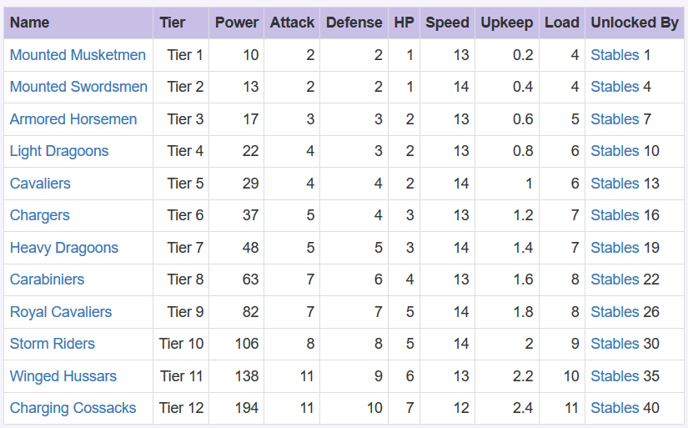
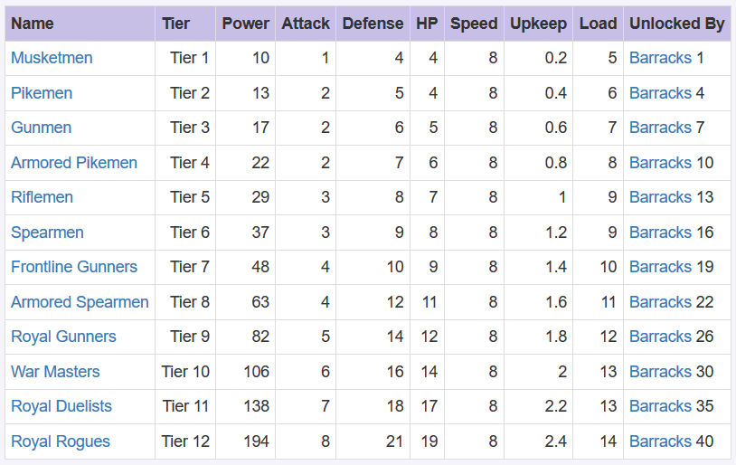
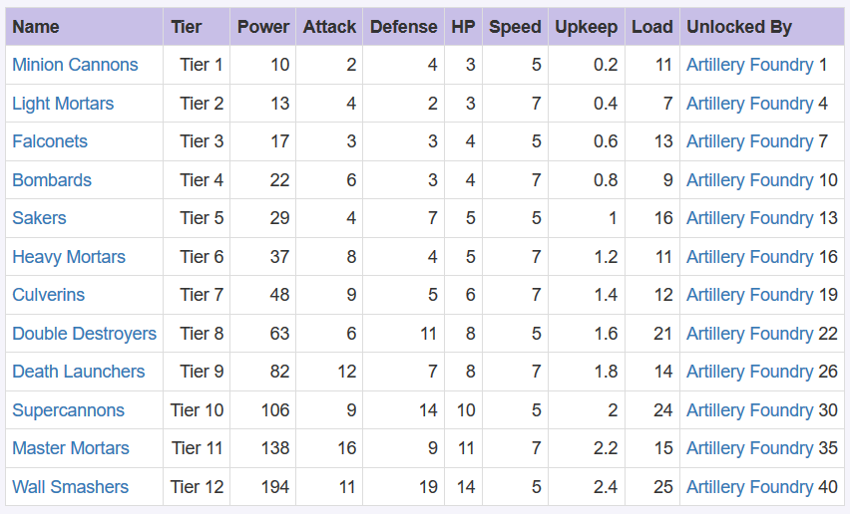
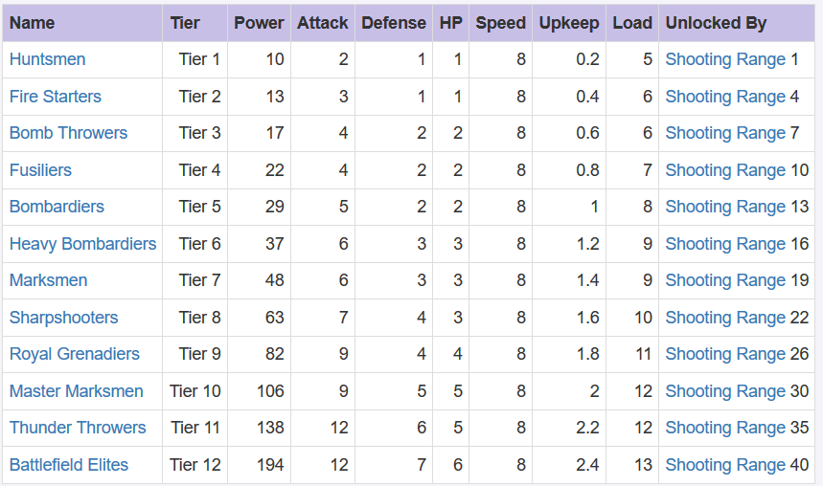
DISTANCE ARTILLERY

You can setup a troop formation in the Drill Grounds. Doing so is simple, just like combat. Drag the slider for each troop type until you have a number that you like. This helps for rapidly responding when you’re actually in battle. If you can’t do pre-sets then the approximate formulas can still be applied manually per troop type. If you only have Tier One (T1) and Tier Two (T2) troops you probably shouldn’t be attacking other players. Beyond that, this should help.

So how many troops of each type do you put in a march? All your top level? No. Instead, you want to march more of your top level than others, but less than half. Here’s a good breakdown of how many T10 and down you might send:

T10: 45k Infantry, 40k Cavalry, 25k Distance
T9: 25k Infantry, 20K Cavalry, 25K Distance
T8: 15K Infantry, 25K Cavalry, 15K Distance
T7: 10K of each type
T6: 5K of each type
T5: 3.5K of each type
T4: 2.2K of each type
T3: 1.5K of each type
T2: 1K of each type
T1: 1K of each type

Always include each troop type, unless you can actually get a scout report and see that someone has overloaded a specific tier of troops. If they have, then each class of troops actually gets a bonus against other troop types. These include the following:
- Heavy Cavalry are better against Infantry (Cavalry 1, 3, 4, 6, 8, 11)
- Light Cavalry are better against Distance (Cavalry 2, 5, 7, 9, 10, 12)
- Muskateers defend better against light Cavalry (Infantry 1, 3, 5, 7, 9, 11)
- Pikemen defend better against riflemen (Infantry 2, 4, 6, 8, 10, 12)
- Riflemen have an increased attack against all cavalry and artillery (Distance 1, 4, 7, 8, 10, 12)
- Grenadiers have an increased attack against Muskateers (this is Distance 2, 3, 5, 6, 9, 11)
- Cannons help protect against trap attack (Artillery 1, 3, 5, 8, 10, 12)
- Mortars have higher attack on traps (Artillery 2, 4, 6, 7, 9, 11)
- Targeted Canons (Traps 3, 6, 9) do additional attack on distance troops
- Stationary traps (Traps 2, 5, 8) do additional attack on cavalry troops
- Dropped Traps (Traps 1, 4, 7) do additional attack on infantry troops

Expeditions
Expeditions are events where your Lord tries to conquer Non-Player Character (or NPC) castles in NPC kingdoms. Each day has a different expedition that provides different rewards and sometimes unlocks a new Accolade. Accolades increase stats and give you a frame to put around your avatar in the game.

Sunday | Combo Expedition should be a mix between gear and gems, so the average level of those two is likely what your Combo expedition is. Once you have full demon hunter at level 5 and full gemstones. Once you have maxed out Justice Stones, Maxed out Heroism Stones, and maxed out demon hunter you’ll finish this. As you upgrade you various gems along that path, you’ll clear multiple levels.
Monday | Equipment Expedition is all about your gear. You’ll need full Demon Hunter maxed to clear this level. But as you move from green gear to blue gear to orange gear, you’ll clear a few levels at a time.
Tuesday | Airship Expedition is all about how powerful your airship is. Here, focus on march capacity, Distance Devastation II, Cavalry Cannons I, Infantry Cover I,Cavalry Cannons III, Distance Devastation III, Distance Devastation I, Infantry Cover II, pretty much in that order. Additionally, make sure your airship is set to hostile titan.
Wednesday | Combo See Sunday
Thursday | Research Expedition, is all about research. Your research stats apply to troops attacking. Here, you’ll focus on attack and health research and primarily on distance and cavalry with a little research in infantry.
Friday | Gemstone Expedition is all about gems. The ultimate goal is to have maxed out Justice Stones, Maxed out Heroism Stones. As you upgrade you various gems along that path, you’ll clear multiple levels. Obviously you can’t start with those, so each time you upgrade your gems in gear, see if you can kill another castle on this path.
Saturday | Building Expedition, is all about Glory Banners. Focus on the distance, cavalry, then infantry boosts. Check the buildings section earlier for more on banner application, but suffice it to say that to clear this expedition, you’ll need C35 with all Glory Banners on all level 35 buildings except the artillery foundry. Every increment towards that will bring you a castle further on the path, with the exception of smaller increases and defensive buildings. As you clear levels, you’ll get banners and speedups!

Building an Alliance
In the beginning, R4s should look for players in Kingdom Chat. Good communication amongst players is a must. It’s also important to kick players that go dormant for too many days. This allows new players to come in so you find active players. Many players go inactive and never return.

You want to find an active alliance of nice people (unless you aren’t nice) who want to play the game similarly. It helps if you can have at least one player who has played in other kingdoms.

Alliance Buildings
Alliance Fortress | This is the first building you must build. Once built, you will have a green outline around the building. Most players should then move their estates to within the boundaries of this building. You can garrison the fortress to hide your troops when they are attacked. If the fortress is ever torn down, you will lose any troops garrisoned in the fortress and end up with all of your buildings being torn down and will have to rebuild everything. Moving the fortress also means all buildings are lost and you will have to rebuild the fortress then the other buildings.
Alliance Towers | You can build four towers, which extend the reach of certain strategies you can use. You can also garrison towers, although this is mainly done during mini-events or to empty your estate to avoid having your troops killed.
Alliance Warehouse | A warehouse is where you can store resources so they can’t be plundered. When you build a warehouse in your estate, each resource type is protected up to a certain amount. Consider this warehouse another place to store resources. If the warehouse is destroyed the resources are lost.
Alliance Hospital | Increases the healing capacity of all members of the alliance. Troops that are wounded in battle can be healed through the hospital in your estate up to a certain amount. When that is exceeded troops will be sent to the Alliance Hospital. Tap on the Alliance Hospital to heal troops. In the beginning of the game try to keep enough hospital space for all of your troops. Later in the game you will find that you can’t have enough hospital space for all of your troops but should still focus on trying to have enough for a full march or two.
Strategy Center | The Strategy Center is how you get the ability to deploy strategies. Some examples of strategies include speeding up resource gathering, healing faster, running doom canon to kill troops of an invader, poising troops in an invading alliance, etc. One of the best is the ability to freeze a player who keeps porting their estate to avoid rally hits. Strategies require gunpowder and/or strategy points and has a cool down period, so use strategies wisely.
Underworld Gates | The Underworld Gates is a mini-event that you can get great rewards for. You start by getting underworld keys, and once enough are donated you can conquer beasts in the Underworld every two days. The rewards are great, so run new Underworld raids every chance you get. The basic strategy here is to get 2 to 4 players with the best statistics and run rallies for half an hour or until the beast is defeated. The better the stats of the attacker, the more damage done. It’s fine to run raids against the same foe should you find yourself unable to conquer one. In the earlier stages, run several smaller rallies to allow more participation. At this time it’s better to have smaller level castles closer to the gates. The faster rallies are released, the more damage is inflicted. Later on, have players with better stats rally the Underworld Gates. Additionally, artillery doesn’t really damage beasts so avoid sending artillery and focus on putting a troops from every level into your marches, especially distance and cavalry. According to the communication and personalities in your alliance you may find different strategies here to be more effective.
Hall of Heroes | Once you build a Hall of Heroes you can start running Alliance Celebration events, raising bounties, and your players can use the Alliance Store. The bounties can come with special items that are hard to obtain otherwise. Alliance Celebration events are a great way to get lots of banners or gears for alliance members, and the Alliance Store is probably the best place to get the gems required to craft various types of armor. While you can get other rewards from these, it’s best to stick with the long-term benefits just described.
Alliance Resources
Alliance Farm | A farm that multiple players in your alliance can use to gather food. Gathering is faster and you can gather for well over a dozen hours if you send a full march to the Alliance Farm. Armies are protected when gathering in an alliance farm, unlike when gathering on a resource tile, where they can be killed or wounded. This makes sending a full march to a farm another great way to empty your castle to avoid an attack. And get lots of resources in the process.
Alliance Lumberyard | A lumberyard that multiple players in your alliance can use to gather wood. Gathering is faster and you can gather for well over a dozen hours if you send a full march to the lumberyard. Armies are protected when gathering in an alliance lumberyard unlike when gathering on a resource tile, where they can be killed or wounded. This makes sending a full march to a lumberyard another great way to empty your castle to avoid an attack
Alliance Iron Mine | A mine that multiple players in your alliance can mine. Mining is faster and you can mine for well over a dozen hours if you send a full march to the mine. Armies are protected when mining in an alliance mine unlike when mining on a resource tile, where they can be killed or wounded. This makes sending a full march to a mine another great way to empty your castle to avoid an attack.
Alliance Silver Mine | A mine that multiple players in your alliance can mine. Mining is faster and you can mine for well over a dozen hours if you send a full march to the mine. Armies are protected when mining in an alliance mine unlike when mining on a resource tile, where they can be killed or wounded. This makes sending a full march to a mine another great way to empty your castle to avoid an attack.

And don’t be afraid to swap out alliances. You can usually come back. Even if you love-love-love your alliance spending a couple of weeks in another will be a good learning experience. Just be up front about what you’re doing. Like tell them, “hey I’d like to join you for a couple of weeks and then return to my alliance.” You don’t see a lot of spies in the game. Don’t be that person or you’ll have permanent trust issues.

Guards
Guards will increase stats, decrease the requirements for building and research, and increase troop training and trap capacity. Throughout the game you will receive guard fragments and/or Recruitment Banners. You will see an icon over your Recruitment Hall when there are free items for your guards, which include guard fragments and guard experience. For every 30 recruitment banners you can recruit an epic guard. You can then use guard experience to increase the stats for guards. While these increases seem minimal, every 10 levels you can increase the number of stars that each guard has. The stars unlock potentially huge buffs, like providing a 50% increase in defense. You can have up to 8 guards.

The types of guards you can obtain include:
- Captain: Jussac as an Epic guard will give you infantry damage reduction. But at two stars, he increases cavalry defense by 30% and distance damage received by 16. The four star 18 percent troop defense boost and the 5 start 21% troop health boost are some of the best stat boosts in the game. While you’re saving up to get him or Gustavus Adolphus, check out Bernajoux. In fact, in many ways he’s as good as Jussac or better for the first few stars.
- Weapons Master: Your ultimate goal will be to get the Duke of Buckingham and/or Dominique and to get them to five stars. This will take a long time. So I recommend starting with lady Silver at two stars and then maybe Brisemont at two stars. Don’t bother wasting guard experience beyond that, as by the time you get two stars you’re likely getting to the point where you can recruit an epic guard.
- Master of Defense: Your long-term goal should be to get Colonel Essarts or General Dumas to 5 stars. As you’re starting out Madame Brutal and the Executioner of Life are fine, but don’t dump any experience into them.
- Strategist: Lord Winter is dumb. Yes recruit him, but get to Madame Lannoy as quickly as possible. She will give you a boost to training capacity. It might take awhile to recruit Jules Mazarin, and then get him up in levels, but once he hits 4 stars, you get an additional 25k march boost.
- Advisor: Your Advisor is going to help with production. These are the resources you make in your estate. Additional stars will unlock higher levels of advisors. If you can get Descartes to a second star then you will actually get an iron gathering buff as well. And at five you’ll get a silver gathering buff. Additionally, Captain Treville can be purchased with real money, and he immediately increases cavalry health, then at stars unlocks infantry defense +50, which is huge. Additional buffs as he levels up, but it’s expensive.
- Ambassador: The ambassador helps with resources. Chancellor Seguier should be taken to two stars, if not three. Troop upkeep is a joke so unless you can get the Count of Wardes up to four stars, don’t bother. Constance rules. Early on, she gives you faster gathering. The higher you level her up, the better she gets. She can be swapped out in times of war with Benoit. He’s all about military buffs. You can get him from the Lucky Draw mini game or via in-app purchases.
- Innovator: Pascal is worthless unless you can get faster buildings at 17%. You want to get to Galileo with three stars as quickly as possible as you should end up building and researching with about 30% buffs when you do.
- Aide: The aides help you reduce your resource requirements for research and construction. Given that a lot of the game is building and researching, do as much as you can here, even if they look dumb.

Later in the game you will find that guard fragments you won’t use can be traded out for hero points. That allows you to get more items you actually need. Never trade out your epic fragments, but if you play it right and kill enough red guards, you should quickly be able to get epic guards and start getting the killer buffs they can provide.

Swapping out guards is a great way to boost various types of troop formations, or go from peace to wartime. For example, Constance should be used to boost gathering and so used in peace while Benoit can swap her out when you go into war. Once you start gathering, you can swap your guards out.

Leaderboards
Alliance Power | How much power the alliance has. This is based on Alliance Research, Alliance Hero Stature, number of members in the Alliance, and amount of Individual Power the members have.
Alliance Kills | How many kills all members of the alliance have.
Hero Stature | How many donations, bounties, red guard raids, etc that you have done.
Individual Power | Your Power increases when you build buildings, make gear, embed gems into your gear, and train troops. When troops die or when you switch gear then your power can change.
Weekly Celebration Points | Raising bounties and donating to alliance research will give you celebration points. Each week, the person in the kingdom who did the most of these will be recognized with how many points they acquired.
Airship Level | The more Airship experience you have, the higher the level of the Airship. You can also add parts to your Airship and assign points to each type of buff, which can count toward your Individual Power but doesn’t impact the experience you have for your Airship.
Lord Level | The amount of experience you gain increases your Lord level, thus unlocking rewards and points, which are used to increase your resource farming speed, combat stats, defense, creature, etc. You will likely mix talents from different categories of Lord Points and can reset them provided you have a talent reset item or enough gold to reset.
Individual Kills | How many troops from other Estates that you have killed. You do this by attacking Estates, or tiles and buildings occupied by other Estates.
Castle Level | Your Castle basically amounts to your character. Tap in the estate and you will see all of your estate buildings. Here, you can build and upgrade buildings, access mini-games, train troops, and build new gear, which in turn gives better stats for your troops.

In the beginning of the game, you can laser focus on power. The reason is that you’re doing the tasks that result in the greatest rewards. Once you exceed 1M power, don’t look at that statistic again. Every time you switch gear your power could go up by 10 to 20M. Later on it becomes about stats. You can train 2M troops and get a lot of power fast. But you can lose them all in one battle against a player who understands stats and troop formations better than you do

References
http://krypted.com/guides/guns-glory-primer/

