**BOYS TOWN**

**HIGH SCHOOL**

**“COWBOY BATTALION”**

# Promotion Board

**STUDY GUIDE**

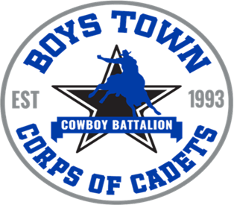

***PURPOSE:***

This booklet is to be utilized as a procedure manual and study guide for Cadets appearing before the Promotion board.

*Note: The J.R.O.T.C. Cadet of the month Board is an equal opportunity program. The term “he”, “him”, or “his” are used to avoid redundancy.

LET 1 Cadets will have three opportunities to attend a promotion board their First year (PVT, PFC, CPL,)

LET 2 Cadets will have three opportunities to attend a promotion board their Second year (CPL, SGT, SSG)

LET 3 Cadets will have three opportunities to attend a promotion board their Third year

(SSG, SFC, MSG)

LET 4 Rank will be decided by the SAI and AI.

**TABLE OF CONTENTS**

* Chapter 1: Reporting to the Board

* Chapter II: Cadet Creed

* Chapter III: JROTC History/Mission of JROTC

* Chapter IV: Leadership Traits/Values

* Chapter V: Basic Knowledge

* Chapter VI: Physical Fitness

* Chapter VII: Wearing of the Uniform

* Chapter VIII: First Aid

* Chapter IX: Drill and Ceremonies

* Chapter X: Cadet Ranks

* Chapter XI: Flags

* Chapter XII: Map reading

* Chapter XIII: Sling arms/15 Count manual arms
* Chapter XIIII Winning Colors

## CHAPTER I

### REPORTING TO THE BOARD

1. Knock 3 times before entering the boardroom.
2. Walk in a military manner taking the most direct route until you are centered three steps in front of the President of the promotion Board.
3. Salute and report “(MSG), Cadet (Cadet and your last name) reporting to the President of the Board as ordered.” Do not drop your salute until the President of the Board drops his/her salute.

ANSWERING THE QUESTION

1. Address the person.

OFFICER (MALE) Sir

OFFICER (FEMALE) Ma’am

C/CSM Command Sergeant Major (CSM or SGT Major)

C/1SGT First Sergent

C/MSGT Sergeant

C/SFC Sergeant

C/SSGT Sergeant

C/SGT Sergeant

1. Repeat the question.
2. Answer the question.

EXAMPLES

Q. Cadet Tan, what is the first objective of JROTC?

A. Sir, the first objective of JROTC is good citizenship and patriotism.

Q. Cadet Tan, what is a directive?

A. Sergeant-major, a directive is an oral order given by a commander to direct or cause a subordinate leader or lead element to take action.

Q. Cadet Tan, what is a map?

A. First Sergeant, a map is a line drawing to scale of a portion of the earth’s surface as seen from above.

1. Exiting the Board
2. Once all questions has been asked and the President says you are allowed to leave, stand at attention, salute the President, wait for them to return your salute sound off with a loud and thunderous “Cowboys” and exit the classroom in the most direct route as possible.

## CHAPTER II

**Cadet Creed**

**I am an Army JROTC Cadet**

**I will always conduct myself to bring credit to my family, country, school, and the corps of cadets.**

**I am loyal and patriotic. I am the future of the United States of America.**

**I do not lie, cheat, or steal and will always be accountable for my actions and deeds.**

**I will always practice good citizenship and patriotism.**

**I will work hard to improve my mind and strengthen my body.**

**I will seek the mantle of leadership and stand prepared to uphold the Constitution and the American way of life.**

**​**

**May God grant me the strength to always live by this creed?**

## Chapter III

### JROTC HISTORY/MISSION

The U.S. Army Junior Reserve Officers’ Training Corps (JROTC) is one of the largest character development and citizenship programs for youth in the world. The National Defense Act of 1916 established organized JROTC programs at public and private educational institutions. In 1964, Congress expanded the program to all military services and changed from active duty to shared support from the services and schools. As congressionally mandated by Title 10 United States Code, Section 2031, each military service must have a JROTC program to “instill in students in United States secondary educational institutions the values of citizenship, service to the United States, and personal responsibility and a sense of accomplishment.” JROTC’s mission, “To Motivate Young People to be Better Citizens”, is the guide post for the program’s success. JROTC Cadets today

The U.S. Army’s JROTC program currently operates in more than 1,700 public and private high schools, military institutions, and correctional centers throughout the United States and overseas. Approximately 40% of JROTC programs are in inner city schools, serving a student population of 50% minorities. As JROTC students (Cadets) progress through the program, they experience opportunities to lead other Cadets. A major component of the JROTC leadership and citizenship program is female Cadets. Female Cadets make up 40% of the Cadet population. The JROTC faculty is led by nearly 4,000 instructors who are retired from active duty, reserve duty, or National Guard Army service. Instructors are trained and qualified in accordance with the National Defense Authorization Act 2007 to teach and mentor approximately 314,000 JROTC Cadets annually.

Q. When was the National defense act established?

A. 1916

Q. When did Congress expand the program to all other Military services?

A. 1964

Q. What is the Mission of JROTC?

A. “To motivate young people to be better Citizens”

Q. What Year was Boystown JROTC established?

A. 1993

## CHAPTER IV

**LEADERSHIP TRAITS/VALUES**

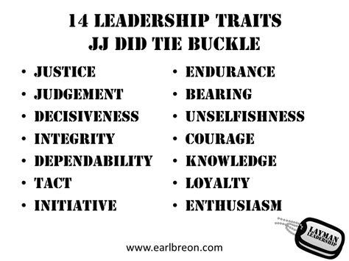

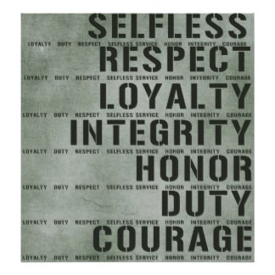

## CHAPTER V

**BASIC KNOWLEDGE**

Q. What does LET stand for?

A. LET stands for Leadership, Education, and Training.

Q. What is the key to success in the JROTC program?

A. The key to success in the JROTC program is “teamwork”.

Q. What does JROTC stand for?

A. JROTC stands for Junior Reserved Officer Training Corps.

Q. Who was the founder of JROTC?

A. The founder of JROTC was Captain Alden Partridge.

Q. Who is the SAI for the Boystown program?

A. LTC (r) Rex

Q. Who is the AI for the Boystown program?

A. 1SG (r) Smith

Q. What are the Drill Floor expectations?

A. 1. Must be on the line when the Class Leader says Fall-In

2. Must have Card and Pen on you

3. No coats or jackets, hoodies are authorized

4. Nothing in your mouth

5. No Talking

**CHAPTER VI**

**PHYSICAL FITNESS**

Q. What are the 7 Basic principles to exercise?

A. Progression, Regularity, Overload, Variety, Recover, Balance, Specificity

Q. What are the 5 components of Physical Fitness?

A. Cardio respiratory endurance, Muscular strength

Q. What are the commands to get a formation into the extended Rectangular formation?

A. Extend to the left –March, Arms downward-Move, Left- Face, Extend to the left-March, Arms downward –Move, Right-Face, From front to rear- count off, Even Numbers to the left, Uncover.

Q. Name two types of physical formations?

A. Extended rectangular formation, Circular formation

Q. what are the five events for the Cadet Challenge?

A. V-sit and reach, Push-ups, Curl-ups, 1 Mile Run, Pull-ups/Flex-arm

**CHAPTER VII**

**WEARING OF THE UNIFORM**

Q. How are the ribbons positioned?

A. For males: on the left side one eighth of an inch above the pocket and centered

A. For females: on the left side one eighth of an inch above the imaginary line centered on the vertical line

Q. What does ACU stand for?

A. ACU stands for Army Combat Uniform.

Q. What type of earrings can a female cadet wear with the Class A or B uniform?

A. The type of earrings that a female cadet can wear with the Class A or B uniform are small spherical earrings and not exceed one fourth of an inch in diameter.

Q. What type of uniform is worn during ceremonies and social functions?

The type of uniform that is worn during ceremonies and social functions is the Class A or B uniform.

Q. What type of uniform is worn during summer camp and for participation in special teams?

A. The type of uniform that is worn during summer camp and for participation in special teams is the BDU.

Q. What color socks are worn with Class A or B uniform?

A. The color of the socks that are worn with the Class A or B uniform is black.

Q. How is the nameplate worn on the Class A uniform?

A. For males : The nameplate is center on the right pocket flap between the top of the pocket and the button.

A. For females: The nameplate is 1 inch above the top button, centered horizontally on the right side of the coat

Q. What is a Gig Line?

A. A gig line is a term used to refer to the alignment between a seam on a shirt, a belt buckle and the seam of zippered pants.

## CHAPTER VIII

### FIRST AID

Q. What is first aid?

A. First aid is the emergency care given to the sick, wounded, or injured before medical personnel can administrate medical treatment.

Q. What are the four lifesaving steps?

A. The four life savings steps are: 1) Open the airway and restore breathing, 2) Stop the bleeding, 3) Prevent shock, and 4) Dress and bandage the wound to avoid infection

Q. Name two ways to open the airway to restore breathing.

A. The two ways to open the airway are the head-tilt method and the jaw-lift method.

Q. What are the two primary methods of administrating artificial respiration?

A. The two primary methods to administrate artificial breathing is by mouth-to-mouth and chest-pressure arm lift.

What is the preferred method of controlling severe bleeding?

The preferred method to controlling severe bleeding is the use of pressure dressing.

Q. Name some of the symptoms of shock?

A. Some of the symptoms of shock are restlessness, thirst, pale skin, and rapid heartbeat.

Q. Name two types of fractures.

A. Two types of fractures are the closed and open fractures.

Q. Why is a fracture immobilized?

A. A fracture is immobilized to prevent the razor sharp edge of the bone from moving and cutting tissue, muscle, blood vessels, and nerves.

Q. What is self-aid?

A. Self-aid is the emergency treatment one applies to oneself.

Q. Name three types of bleeding?

A. The three types of bleeding are arterial, venous, and capillary.

## CHAPTER IX

### DRILL AND CEREMONIES

Q. What are the three marching steps used in drill?

A. 15in step, 30in step, 30in step, DOUBLE TIME 180 steps per minute

Q. What are the 3 rest positions that can be given at the halt?

A. Parade rest, Stand at ease, Rest

Q. What foot is your leading foot?

A. Your left foot

Q. What command is given to reverse the direction of a march?

A. Rear march

Q. From what position are all stationary movements given?

A. Position of attention

Q. What is cover?

A. Aligning yourself directly behind the man to your immediate front, while maintaining correct distance

Q. What are the two parts of most drill command?

A. Preparatory command, Command of execution

Q. What is Close Interval?

A. The lateral space between soldiers, measured from right to left by the soldier on the right placing the heel of his left hand on his hip, even with the top of the belt line, fingers and thumb joined and extended downward, with his elbow in line with the body and touching the arm of the soldier to his left.

Q. What is Double Interval?

A. The lateral space between soldiers, measured from right to left by raising both arms shoulder high with the fingers extended and joined (palms down) so that fingertips are touching the fingertips of the soldiers to the right and to the left.

Q. What is Normal Interval?

A. The lateral space between soldiers, measured from right to left by the soldier on the right holding his left arm shoulder high, fingers and thumb extended and joined, with the tip of his middle finger touching the right shoulder of the soldier to his left.

Q. The end of year event in JROTC is called what?

A. Pass and Review

## CHAPTER X

### CADET RANKS

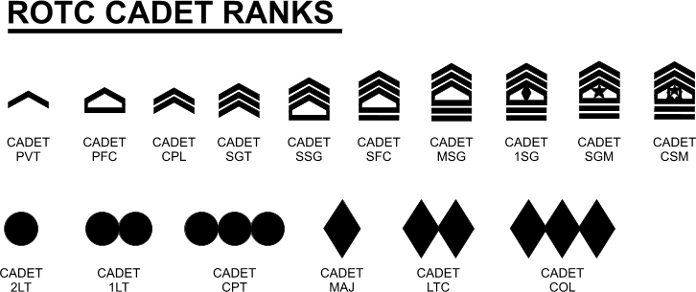

## CHAPTER XI

### FLAGS

**Q. What does the flag being positioned at half-staff mean?**

A. The flag being at position at half-staff means a sign of mourning.

**Q. What are the three types of flags and their sizes?**

A. The three types of flags and their sizes are:

Garrison flag – 20 ft. hoist x 38 ft. fly

Post flag – 8 ft. 11 3/8 in. hoist x 17 ft. fly

Storm flag – 5 ft. hoist x 9 ft. 6 in. fly

**Q. What is a Guidon?**

A. A Guidon is a swallow-tailed flag carried by companies, batteries, troops, and certain detachments.

**Q. What are the colors of the American flag and what do they stand for?**

A. The colors of the American flag are red, white, and blue; red for hardiness and valor, white for purity and innocence, blue for vigilance, perseverance and justice.

**Q. What do the stripes and stars on the American flag represent?**

A. The stripes on the American flag stand for the original 13 colonies and the stars represent the 50 states that make up the nation.

**Q. What is known as the “hoist” of the flag?**

A. The hoist is known as the width.

**Q. What is known as the “fly” of the flag?**

A. The fly is known as the length.

**Q. What is the ball on top of the flagpole called?**

A. The ball on top of the flagpole is known as the truck.

**Q. When a number of flags, including the American, are displayed in a row, what position does the American flag take?**

A. the American flag will be at the right of the line.

**Q. How is the flag raised to the half-staff position?**

A. The flag is first hoisted to the top and then lowered to the half-staff position.

**Q. How is the American flag lowered from the half-staff position? A.** the American flag is first hoisted to the top then lowered.

**Q. How many stripes does the American flag have and how are they arranged?**

A. the American flag has 13 stripes, 7 red and 6 white; the first and last stripes are red.

## CHAPTER XII

**Map Reading**

Q. What is a map?

A. A map is a line drawing to scale of a portion of the earth’s surface as seen from above.

Q. What are the 5 basic colors of a map, and what does each color represent?

A. Black - Indicates cultural (man-made) features such as buildings and roads.

Blue - Identifies hydrography or water features such as lakes, swamps, rivers, and drainage.

Green - Identifies vegetation with military significance, such as woods, orchards, and vineyards.

Brown - Identifies all relief features and elevation.

Red - Classifies cultural features, such as populated areas, main roads, and boundaries, on older maps.

Q. How many Norths are there on a military map?

A. 3-True north, Magnetic north, Grid north

Q. What are 5 major terrain features found on a map?

A. Hill, Ridge, Valley, Saddle, Depression

Q. What is the general rule for reading military grid coordinates?

A. Right and UP

Q. The arrow on a compass always points what direction?

A. Magnetic north

Q. How close will an eight-digit grid get you to your point?

A. 10 meters

Q. How close will a six-digit grid coordinate get you to your point?

A.100 meters

## CHAPTER XIII

**SLING ARMS/15 Count Manual Arms**

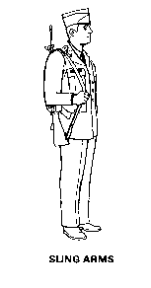

The command for sling arms is Sling, ARMS. On the command of execution ARMS, grasp the rifle barrel with the right hand and raise it vertically. Grasp the sling near the upper sling swivel with the left hand, and release the right hand. Place the right hand and arm between the sling and rifle and place the sling over the right shoulder. Regrasp the sling with the right hand so that the wrist is straight, the right forearm is horizontal, the elbow is tight against the side, and the rifle is vertical. Release the grasp of the left hand and move it sharply to the left side as in the position of attention

**15 Count Manual arms**

**From Order Arms:**

1. **Right shoulder arms(four count movement)**
2. **Present Arms (three count Movement)**
3. **Left Shoulder Arms(four count movement)**
4. **Order Arms(four count movement)**