Class: 801

Name: Ivan Shih

Tr. Ava

Due Date: 12/13/18

DNA Lab Proposal

Different kinds of fruit VS the amount of DNA

**1.**  **Variables**

* My independent variables will be between Strawberry and Kiwi, and I'll see the difference between how much DNA I can extract.
* For my Dependent variables, I will measure how much grams of salt and how much MLS of water I will use, and how much alcohol I will use for the extraction procedure. I will also measure how much DNA I will get from both plants using a scale.
* For my controlled variables will be how much alcohol I will be using for both plants extracting procedure, and how much salt and water I will be using for both plants, and how much alcohol I will use to extract the DNA from the fruit and the process will also be the same.
  + The type of alcohol I will be using will be 70% ethanol for both experiment
  + I will measure the same amount of water for both experiments

**2. Defining the Problem**

* The effect will be the amount of DNA I will get at the end of the DNA extraction. In my research, I found out that that there are more DNA in the Strawberry then there is in the Kiwi, and I am going to find out if it is true or not. I will also be using the same procedure for both fruits, so it will be fair, and accurate.
* In this experiment, it is all about plants DNA extraction, and the amount of DNA that I get in the end will tell me which fruit has more DNA in them, so I can do my lab report, and also see do the Strawberry really has more DNA than the Kiwi does?

**3. Hypothesis**

* What I think will happen is in this experiment is, the strawberry is going to extract a lot more DNA than the Kiwi because of that's what I saw in the in the experiment video, and also because strawberry has eight sets of DNA. In this experiment, I use two different kinds of fruit, the fruit will affect the whole experiment.
* My prediction is from a DNA extraction video I saw on YouTube.

Format: If I use strawberry, I will get more DNA (grams), because strawberry has eight sets of DNA.

If I use kiwi, I will get less DNA, because of the Kiwi (grams) only have one set of DNA.

**(My lab experiment set up)**

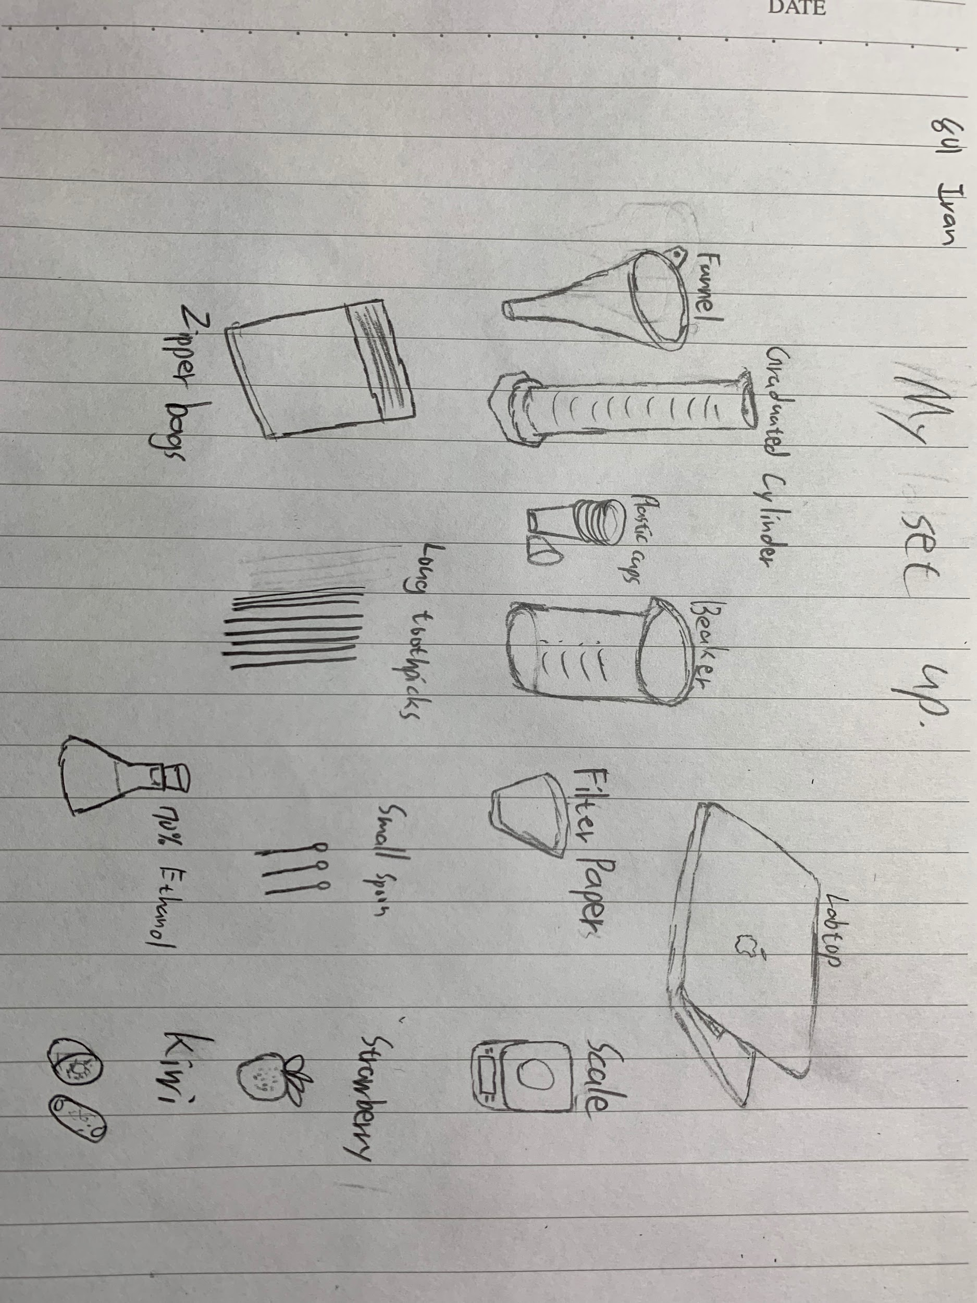

**4. Method**

1. Mash the strawberry and the kiwi separately in two different zipper bags.
2. Make salt water using 100mls of water and 10 grams of salt mixed together
3. Add salt water into the plastic bags that have my mashed fruits in them, and the salt water will break the cells open, and release the DNA.
4. Then I am going to filter out both of my salted with100ml of water and 10grams of salt fruits, mashed up fruits by using filter papers and a funnel into small cups.
5. Then I will add 10 ML of 70% of alcohol into the two cups that have my salted, mashed up fruits.
6. Last, I will use a toothpick to collect the DNA from both fruits, and put them separately into two empty cups, then measure how much grams of DNA I got from both plants. Make sure that the scale has been set to 0 when you put the empty cups on it, so you can measure the exact grams of DNA you get from both plants.

**5. Materials**

* Strawberry and Kiwi
* 6 zipper bags
* 70% Alcohol (Ethanol) 100 ML
* Some toothpicks
* Four cups
* 2 filter papers
* Funnel
* Saltwater 100 ML (10 grams salt)

**6. Safety Precautions**

All the things we do will be under teachers control, and everything we do will be watched by our teacher.

We will not be eating any of our foods, because they are for experiments.

Look up safety precautions using 70 % ethanol.

**DNA LAB REPORT**

|  |  |
| --- | --- |
| **Independent** | **Dependent** |
| Strawberry and Kiwi | For my independent variables, I use the same amount of water (100ml) and 10 grams of salt for each experiment. I also use the same alcohol (70% ethanol) for both of my experiment. And for my both experiment, I will use the same exact method to extract my DNA for both plants. |

**Raw Data**

|  |  |  |  |
| --- | --- | --- | --- |
| Types of fruit | Trial 1 (Amount of DNA in grams) | Trial 2 (Amount of DNA in grams) | Trial 3 (Amount of DNA in grams) |
| 3 Strawberries | 0.38 | N/A | 0.32 |
| 2 Kiwis | 0.28 | 0.30 | 0.23 |

**Processed Data**

|  |  |
| --- | --- |
| Types of fruit | Mean (Amount of DNA in grams) |
| Strawberry (X3) | 0.35 |
| Kiwi (x2) | 0.27 |

**The amount of DNA I extracted between Strawberries and Kiwis using the same method.** Note:Trial 2, 3 strawberry has no results. 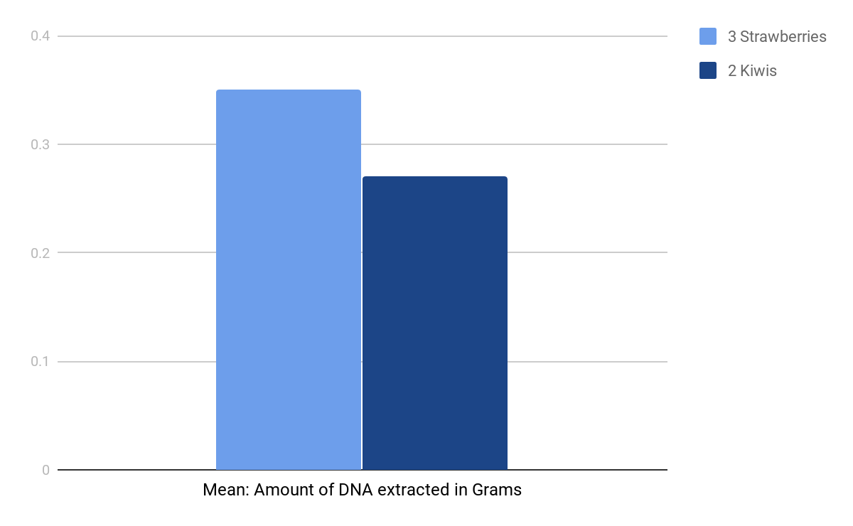

**Interpretation and Explanation**

* + For my results, mine is constant, because of my data sometimes goes up and down, so its constant. For my Strawberry results, my first DNA extraction, I got 0.38 grams of DNA, and the second time, my I got 0.32 grams of DNA, and for my Kiwi results, my results are 0.28 grams, 0.30 grams, and 0.23 grams. So my data are constant.
  + My relationships between variables are indirect because of all my data are opposite. For this experiment, my independent variables are the difference between Strawberry and Kiwi. The results of my strawberry, I got a more DNA than my Kiwi does, and sometimes the data goes up and down, so they are indirect.

* + For my Strawberry and Kiwi, the mean between both fruits are, the strawberry has o.35grams of DNA, and for my Kiwi, I got 0.27Grams of DNA, so the strawberry has 0.08grams more DNA than the Kiwi has just like what you can see in the graph above.

**Validity of the Hypothesis**

* So in my hypothesis, I said that I think the Strawberry is going to have more DAN than the Kiwi. The data support the hypothesis. In my experiment, my results are, for my strawberry: the first extraction I got 0.32, for the second time I didn’t get any data, and for my third extraction I got 0.32grams of DNA. And for my Kiwi extraction, the first extraction I got 0.28 grams of DNA, and the second extraction I got 0.30grams of DNA, and the third time I got 0.23grams of DNA. So as you can see, overall the Strawberry has more DNA than the Kiwi has, and it is just as I expected and what I said in my lab proposal.
* There is also research that supports my hypothesis. So the in my research, I watched a Strawberry and Kiwi DNA extraction video, the extraction method is the exact same as mine method, and the results of the video support my hypothesis. In the DNA extraction video, the strawberry has more DNA than the Kiwi does, and in my experiment, the strawberry also has more DNA than the Kiwi has, so it supports my hypothesis.

**Validity of the Method**

* There is an error in my method. In my method, I decided to use a toothpick to collect how much DNA I get in the extraction, and because of the toothpick is too small and thin, so I can’t collect all the DNA I got from my extraction. And because I use a toothpick as a tool to collect my DNA, it has affected the results of my DNA extraction, because it is too thin and small, so I can’t get 100% DNA in my DNA extraction experiment.
* For the things, I did well in my method are, I have fully mashed up all my fruit my hand nicely so the salt water can work better to break out more DNA, and I have measured the exact amount of water, salt and alcohol in the exact grams and MLS as they should be. And for what I did well using my tools are, I have used them wisely, and I have also use the tools I requested wisely. I have used the tools to measure how much grams or MLS I need in my experiment. I have used the Beaker to measure how much MLS of water I need. I have used the Graduated Cylinder to extract my DNA, and I have used the scale to measure how much grams of DNA I need, and how much DNA I got from both fruit extractions.

**Improvements and Extensions**

* If I am going to do this experiment again I will measure the temperature of the alcohol I am using before I add it into the extraction process, because of the temperature of the alcohol will affect the work better or not as good. I should also measure the temperature of the fruits because if the fruit is cold, I will get not as much DNA as if the temperature of the fruit is homeothermy. If the fruit’s temperature is homeothermy, the more DNA can be extracted in the experiment. So the next time I should measure the temperature of the alcohol and the fruits.

**Work Cited**

“Is It Dangerous To Eat Pure DNA? Extracting and Eating Pure DNA.” YouTube, YouTube, 15 Oct. 2017, youtu.be/etGZS0zapm4.

“DNA and DNA Extraction.” Plant and Soil Sciences ELibrary,

passel.unl.edu/pages/informationmodule.php?idinformationmodule=957882007&topicorder=6&maxto=7.

“Strawberry DNA Extraction.” YouTube, YouTube, 22 Oct. 2010, youtu.be/vPGKv53zSRQ.

Buddies, Science. “Squishy Science: Extract DNA from Smashed Strawberries.” Scientific American, 31 Jan. 2013, [www.scientificamerican.com/article/squishy-science-extract-dna-from-smashed-strawberries/](http://www.scientificamerican.com/article/squishy-science-extract-dna-from-smashed-strawberries/)

.

“DNA Extraction from Kiwifruit.” [PDF] Kiwi, [PDF] Kiwi, 26 Jan. 2018, <http://staceyk.org/diybioworkshop/submissions/Kiwifruit_DNA.pdf>

“How to Extract DNA from a Kiwifruit - Basic Science: Understanding Experiments.” YouTube, YouTube, 6 Aug. 2014, youtu.be/6q7xEjfnTZg.