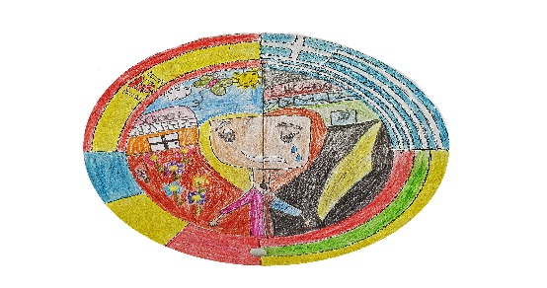
OBSERVATION SHEET OF PUPIL IN ESL RISK
Name________________________________________________
Age________________ Grade_________________
Responsabile teacher:....................................................................................................
Date :................................................

The indicators observed active at the first evaluation of the child (tick):
A. Large number of unmotivated absences
B. Difficult family situation
C. Serious health problems and / or disability of the child
D. History of school dropout in the child's family
E. Major difficulties in going to school
Part I: Explaining the specific situation of the child, to the identified active indicators Indicator.......
The situation at the time of filling in the observation sheet :
................................................................................................................................................
................................................................................................................................................
................................................................................................................................................
................................................................................................................................................
Other relevant aspects that were not described in the analysis of the indicators
Social behavior
• In the classroom
…………………………………………………………………………………………………………
• Outside school
…………………………………………………………………………………………………………
School data (level of school success):
• Motivation for learning
................................................................................................................................................
• Number of failures/bad marks specifying the school subjects
.................................................................................................................................................
• School subjects with good and very good results

...............................................................................................................................................
• School subjects with low/bad results

.................................................................................................................................................
• The relationship of the school with parents / legal representatives

.................................................................................................................................................
• Strenghts
...............................................................................................................................................
...............................................................................................................................................
• Weaknesses
.................................................................................................................................................
................................................................................................................................................
Part 2: Proposed solutions for reducing the risk of school dropout
Taking into account the specific situation of the child: the causes of the problem that determines one or more active risk indicators, the weaknesses and the strengths - propose solutions for reducing the risk of school dropout.
Consider at least the following categories of measures that you can take as a teacher or supervised child's leader:
- Request for support from teachers (teachers from the disciplines with high number of absences, poor results, etc.);
- Training of classmates: one or more colleagues of the child offers to help him / her in the respective disciplines
- Train the parent community - to help the family in difficulty
• Carrying out a social inquiry if the socio-economic situation of the family is precarious and / or there are suspicions of neglect or abuse of the child (mayor's office)
• Intervention of a psychologist -complex evaluation of the child with disabilities
• Counseling and professional guidance of parents (school counselor)
- Involvement of private bodies (NGOs, sponsors, etc.) in the community (examples of activities):
• Involvement in curricular or extracurricular activities (vocational or voluntary)
• Support in re / arranging the home
• Donate books / clothes, etc.
• Identification of alternative means of transport

