Projection is a kind of phenomena that are used in computer graphics to map the view of a 3D object onto the projecting display panel where the viewing volume is specified by the world coordinate and then map these world coordinate over the view port.
Projection is of the following kind :
a) Parallel Projection b) Perspective Projection

Parallel Projection : Parallel projection is a kind of projection where the projecting lines emerge parallelly from the polygon surface and then incident parallelly on the plane. In parallel projection, the centre of the projection lies at infinity. In parallel projection, the view of the object obtained at the plane is less-realistic as there is no for-shortcoming. and the relative dimension of the object remains preserves.

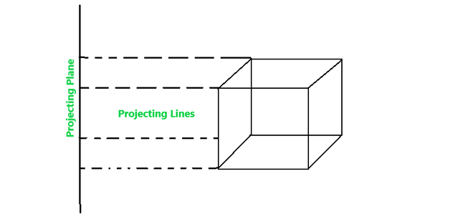
Parallel projection is further divided into two categories :
a) Orthographic Projection

b) Oblique Projection
(a) Orthographic Projection : It is a kind of parallel projection where the projecting lines emerge parallelly from the object surface and incident perpendicularly at the projecting plane.
Orthographic Projection is of two categories :
(a).1. Multiview Projection : It is further divided into three categories –
(1) Top-View : In this projection, the rays that emerge from the top of the polygon surface are observed.

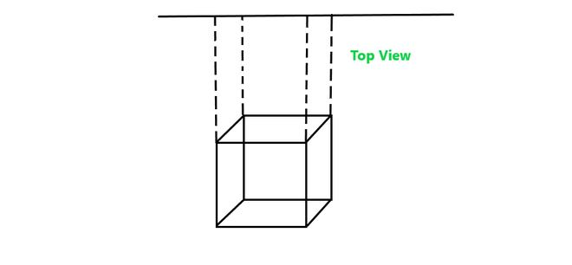

2) Side-View : It is another type of projection orthographic projection where the side view of the polygon surface is observed.

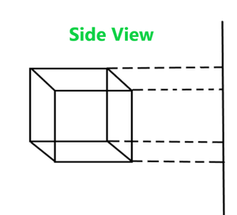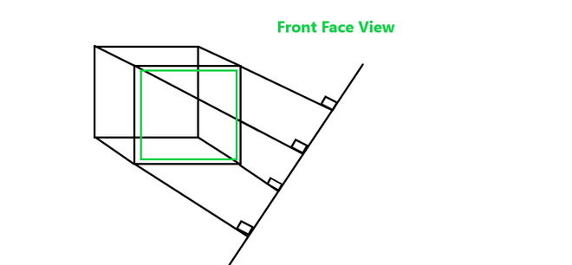
3) Front-view : In this orthographic projection front face view of the object is observed.
a.2) Axonometric : Axonometric projection is an orthographic projection, where the projection lines are perpendicular to the plane of projection, and the object is rotated around one or more of its axes to show multiple sides.
It is further divided into three categories :
(1) Isometric Projection : It is a method for visually representing three-dimensional objects in two-dimensional display in technical and engineering drawings. Here in this projection, the three coordinate axes appear equally foreshortened and the angle between any two of them is 120 degrees.

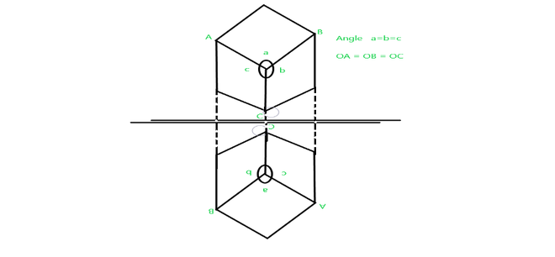
(2) Dimetric Projection : It is a kind of orthographic projection where the visualized object appears to have only two adjacent sides and angles are equal.

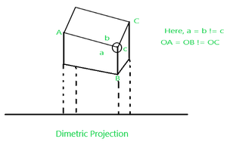
(3) Trimetric Projection : It is a kind of orthographic projection where the visualized object appears to have all the adjacent sides and angles unequal.

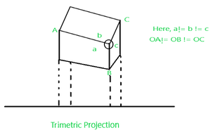
(b) Oblique Projection : It is a kind of parallel projection where projecting rays emerges parallelly from the surface of the polygon and incident at an angle other than 90 degrees on the plane.
It is of two kinds :
(b).1. Cavalier Projection : It is a kind of oblique projection where the projecting lines emerge parallelly from the object surface and incident at 45‘ rather than 90′ at the projecting plane. In this projection, the length of the reading axis is larger than the cabinet projection.

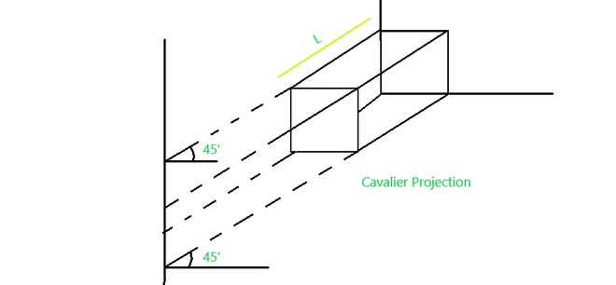
(b). 2. Cabinet Projection : It is similar to that cavalier projection but here the length of reading axes just half than the cavalier projection and the incident angle at the projecting plane is 63.4′ rather 45′.

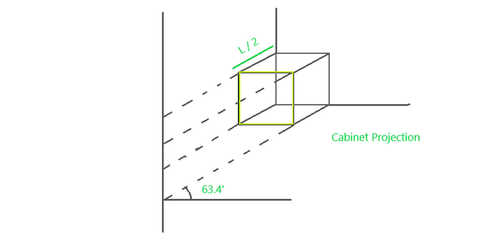

Projection are defined as mapping of three-dimensional points to a two-dimensional plane. There are two type of projection parallel and perspective.
- Parallel Projection :
Parallel projections are used by architects and engineers for creating working drawing of the object, for complete representations require two or more views of an object using different planes.
Parallel Projection use to display picture in its true shape and size. When projectors are perpendicular to view plane then is called orthographic projection. The parallel projection is formed by extending parallel lines from each vertex on the object until they intersect the plane of the screen. The point of intersection is the projection of vertex.
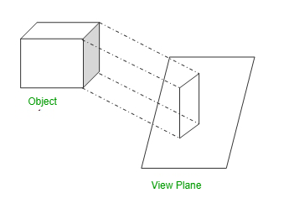
- Perspective Projection :
Perspective projections are used by artist for drawing three-dimensional scenes.
In Perspective projection lines of projection do not remain parallel. The lines converge at a single point called a center of projection. The projected image on the screen is obtained by points of intersection of converging lines with the plane of the screen. The image on the screen is seen as of viewer’s eye were located at the centre of projection, lines of projection would correspond to path travel by light beam originating from object.
Two main characteristics of perspective are vanishing points and perspective foreshortening. Due to foreshortening object and lengths appear smaller from the center of projection. More we increase the distance from the center of projection, smaller will be the object appear.
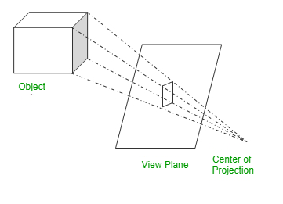
Difference Between Parallel Projection And Perspective Projection :
SR.NO | Parallel Projection | Perspective Projection
1 | Parallel projection represents the object in a different way like telescope. | Perspective projection represents the object in three dimensional way.
2 | In parallel projection, these effects are not created. | In perspective projection, objects that are far away appear smaller, and objects that are near appear bigger.
3 | The distance of the object from the center of projection is infinite. | The distance of the object from the center of projection is finite.
4 | Parallel projection can give the accurate view of object. | Perspective projection cannot give the accurate view of object.
5 | The lines of parallel projection are parallel. | The lines of perspective projection are not parallel.
6 | Projector in parallel projection is parallel. | Projector in perspective projection is not parallel.
7 | Two types of parallel projection :  1.Orthographic,  2.Oblique | Three types of perspective projection:  1.one point perspective,  2.Two point perspective,  3. Three point perspective,
8 | It does not form realistic view of object. | It forms a realistic view of object.

