Prime Factorization

Prime Numbers
A Prime Number can be divided exactly only by 1 or itself.
And it must be a whole number greater than 1.
The first few prime numbers are: 2, 3, 5, 7, 11, 13, and 17 ..., and there is a prime number chart with more.
A Prime Number is:
a whole number that cannot be made by multiplying other whole numbers
(if we can make it by multiplying other whole numbers it is a Composite Number)
Here we see it in action:
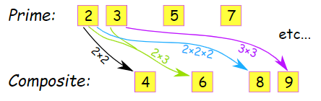
2 is Prime, 3 is Prime, 4 is Composite (=2×2), 5 is Prime, and so on...
Here is a list of all the prime numbers up to 1,000:

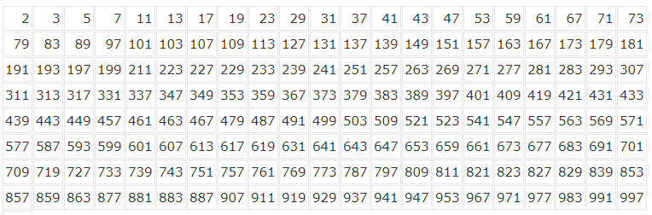

Factors
"Factors" are the numbers you multiply together to get another number:
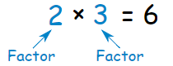
Prime Factorization
"Prime Factorization" is finding which prime numbers multiply together to make the original number.
Here are some examples:

Example 1: What are the prime factors of 12?
It is best to start working from the smallest prime number, which is 2, so let's check:
12 ÷ 2 = 6
Yes, it divided exactly by 2. We have taken the first step!
But 6 is not a prime number, so we need to go further. Let's try 2 again:
6 ÷ 2 = 3
Yes, that worked also. And 3 is a prime number, so we have the answer:
12 = 2 × 2 × 3

As you can see, every factor is a prime number, so the answer must be right.

Note: 12 = 2 × 2 × 3 can also be written using exponents as 12 = 2² × 3

Your Notes:

Example 2: What is the prime factorization of 147?
Can we divide 147 exactly by 2?
147 ÷ 2 = 73½
No it can't. The answer should be a whole number, and 73½ is not.
Let's try the next prime number, 3:
147 ÷ 3 = 49
That worked, now we try factoring 49, and find that 7 is the smallest prime number that works:
49 ÷ 7 = 7
And that is as far as we need to go, because all the factors are prime numbers.
147 = 3 × 7 × 7
(or 147 = 3 × 7² using exponents)

Example 3: What is the prime factorization of 17?
Hang on ... 17 is a Prime Number.
So that is as far as we can go. 17 = 17

Another Method
We showed you how to do the factorization by starting at the smallest prime and working upwards.
But sometimes it is easier to break a number down into any factors you can ... then work those factors down to primes.

Example: What are the prime factors of 90?
Break 90 into 9 × 10
- The prime factors of 9 are 3 and 3
- The prime factors of 10 are 2 and 5
So, the prime factors of 90 are 3, 3, 2 and 5

Factor Tree
And a "Factor Tree" can help: find any factors of the number, then the factors of those numbers, etc, until we can't factor any more.

Example: 48
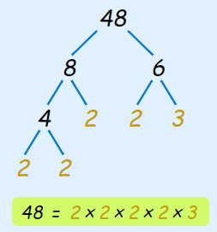
48 = 8 × 6, so we write down "8" and "6" below 48
Now we continue and factor 8 into 4 × 2
Then 4 into 2 × 2
And lastly 6 into 3 × 2

We can't factor anymore, so we have found the prime factors.
Which reveals that 48 = 2 × 2 × 2 × 2 × 3
(or 48 = 2⁴ × 3 using exponents)

Why find Prime Factors?
A prime number can only be divided by 1 or itself, so it cannot be factored any further!
Every other whole number can be broken down into prime number factors.
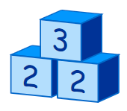 |  | It is like the Prime Numbers are the basic building blocks of all numbers.
This idea can be very useful when working with big numbers, such as in Cryptography.

Your Notes:

Cryptography
Cryptography is the study of secret codes. Prime Factorization is very important to people who try to make (or break) secret codes based on numbers.
That is because factoring very large numbers is very hard, and can take computers a long time to do.
If you want to know more, search the subject is "encryption" or "cryptography".
Unique
And here is another thing:
There is only one (unique!) set of prime factors for any number.
Example: The prime factors of 330 are 2, 3, 5 and 11:
330 = 2 × 3 × 5 × 11
There is no other possible set of prime numbers that can be multiplied to make 330.
In fact, this idea is so important it is called the Fundamental Theorem of Arithmetic.

The Fundamental Theorem of Arithmetic
Let us start with the definition:
Any integer greater than 1 is either a prime number, or can be written as a unique product of prime numbers (ignoring the order).
What does it mean?
Let's build up the ideas piece by piece:
"Any integer greater than 1" means the numbers 2, 3, 4, 5, 6, ... etc.
Integers = { ..., -5, -4, -3, -2, -1, 0, 1, 2, 3, 4, 5, ... }
Negative Integers = { ..., -5, -4, -3, -2, -1 }
Positive Integers = { 1, 2, 3, 4, 5, ... }
Non-Negative Integers = { 0, 1, 2, 3, 4, 5, ... } (includes zero, see?)
A Prime Number is a number that cannot be exactly divided by any other number (except 1 or itself).
"...product of prime numbers" means that we multiply prime numbers together.
So, by multiplying prime numbers we can create any other whole number.

Example: 42
Can we make 42 by multiplying only prime numbers? Let's see:
2 × 3 × 7 = 42
Yes, 2, 3 and 7 are prime numbers, and when multiplied together they make 42.
Try some other examples for yourself. How about 30? Or 33?
It is like the Prime Numbers are the basic building blocks of all numbers.
"... unique product of prime numbers" means there is only one (unique!) set of prime numbers that will work

Example: we just showed that 42 is made by the prime numbers 2, 3 and 7:
2 × 3 × 7 = 42
No other prime numbers will work!
We could try 2 × 3 × 5, or 5 × 11, but none of them will work:
Only 2, 3 and 7 make 42

Your Notes:

