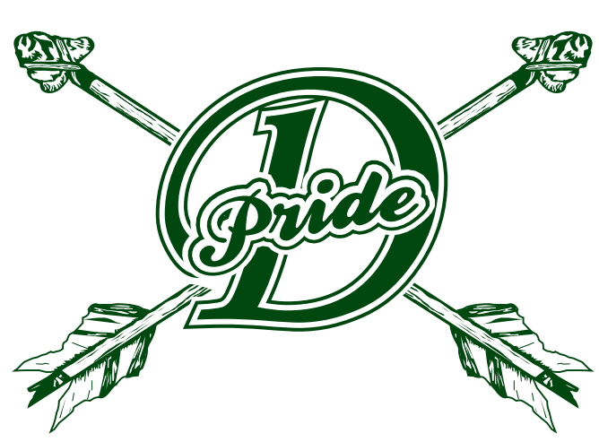
DANVILLE SCHOOL
148 Peacham Road, Danville, Vermont 05828
802.684.3651 - danvilleschoolvt.org
David Schilling, Principal
Sarah Welch, Assistant Principal

9/12/19

Dear Parents and Guardians,

On Tuesday October 8th, I will be taking a group of 8th grade students to Northern Vermont University in Lyndon to attend the Kingdom Career Connect fair. We will leave the school at 8am and plan to return by or before 2:00pm. Students will meet in my office in the morning and will attend their 6th block class upon our return.

The Kingdom Career Connect fair is a great opportunity for students to explore various careers. The goal of the event is to inspire and empower youth to start thinking about and planning for their future. There are 24 different workshops offered during the event. Your child will choose two workshops they would like to attend. Lunch will be provided at the event.

Please complete the permission form below by September 18th and feel free to contact me with any questions or for more information.

Student name (print)___________________________________ Date___________

Parent/Guardian (print) ________________________________________________

Signature _____________________________________________Date___________

Sincerely,

Adrianna Watrobski

Adrianna Watrobski
Middle School Counselor
Danville School
802-684-2292 x 160
Adrianna.watrobski@ccsuvt.net

