

**SUMMER CLUB PROGRAMME**

**COME ALONG AND JOIN THE FUN……….**

**WELCOME**

**Dates:**

The Summer club will run for 6 weeks of the summer break, **from Thursday the 28th of June through to Tuesday 14th of August. The only week this year we will not be facilitating is the 16th-20th of July**

**Location:**

**Please Note:** We run our Summer club from the Lenzie Public Hall, Kirkintilloch Road, G66 4LD

**Activities/Trips:**

Throughout the Summer, we offer a **wide range of activities**. Some days will be spent at the premises where the children will take part in lots of fun activities. On these days we will also make use of our local resources, e.g. local parks, library and canal walks. Other days we will be going further afield on day trips to fun and interesting places, such as a trip to the coast. We have activities planned for each day of the summer which are all outlined within the programme below.

Throughout the Summer we aim to follow the programme as planned, but as we all know the Scottish Summer weather can sometimes be quite unpredictable and therefore some of the weather dependant activities are subject to change.

**Session Times:**

The following two sessions are available on most days throughout the program

8am – 1pm

8am – 6pm

The programme below, outlines times that we plan to leave the premises for the day trips. Please arrive on time to allow us to leave at the planned time. I am sure you can appreciate when leaving late, this can compromise daily plans as well as the children’s time at the excursion.

**Sickness**

If for any reason your child/ren will not be attending on the day of the trip, due to illness etc, could we ask that you phone as early as possible, so I can inform the staff of this.

**Fees**

Fees for each session are as follows,

8am to 1pm - £15.00

8am to 6pm - £30.00

After receiving your booking form, you will be provided with an invoice for each week of your booking. Payments must be received the week prior to your child attending. (Fees can be paid weekly in advance or fully at the start of the Summer). We accept credit/debit card payments or childcare vouchers.

**Bank Details:**

**Sort Code: 80-22-60**

**Account Number: 16623766**

**Spending Money**

Spending money is not essential for the Summer club however, for some of our day trips you may wish to give your child a little spending money. Some activities they may use this for are, crazy golf, amusements, trampolines, souvenir shops or for extra drinks or snacks. If you do decide to give your child sending money, we would ask that you only give your child a very **maximum of £5.**

**Cancellation Policy**

Please Note: If you cancel your booking, within more than 7 days’ notice no charges will be incurred. If you cancel your booking out with our 7 - day cancellation period, your booking will be subject to the full charge of your cancelled session.

**Lunch**

Throughout the summer we ask parents to provide a packed lunch and snacks for their childexcept any days stated in the programme. We also ask that the children have plenty of drinks to last them throughout the day, or provide a refillable bottle, to enable us to give them refills.

**Clothing**

We would ask that children come along, with appropriate clothing for the planned activities. E.g. If we have planned to go on an outdoor trip we would ask you to please bring along a waterproof jacket and appropriate outdoor footwear, or if we have sports activities planned at the base we would ask that children wear trainers and comfortable sports clothing.

We also have a number of messy and wet days within our programme this year, therefore we kindly ask that you look at the programme in the morning and take into account the premises activity or type of trip involved.

If you have any questions about the programme, or any of the details outlined above please do not hesitate to get in touch.

Finally, we look forward to seeing everyone over the Summer holidays for lots of fun trips and activities.

See you all soon,

**Debbie Lawrence**

**Nino’s Afterschool Care Ltd**

**Email:ninosafterschool@yahoo.com**

**Tel: 07927711662**

**Companies House No: 574448**

**CI No: CS2017361646**

**Thursday 28th of June – Local Park**

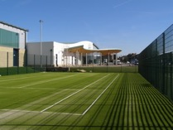Come and explore this fantastic woodland park, great facilities and great wildlife trails.

**PACKED LUNCH REQUIRED**

**LEAVING PREMISES: 12PM –RETURNING 3:00PM**

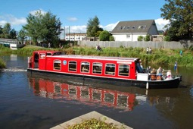

**Friday 29th June- Boat Trip down the Canal**

**PACKED LUNCH REQUIRED**

**LEAVING PREMISES: 12.45pm RETURNING 3.30PM**

**BOAT TIME: 1.30PM**

**Week 1**

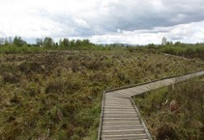**Monday 2nd of July – Lenzie Moss Loop –** A nature –walk around the Lenzie moss exploring the natural outdoors.

**PACK LUNCH REQUIRED**

**LEAVING PREMISES: 11AM RETURNING 2PM**

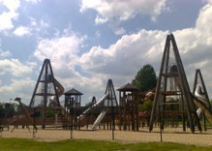

**Tuesday 3rd of July – Glasgow Green -** Enjoy a day out at Glasgow Green. There will be group games and activities on the greens and then onto the ultimate fun adventure playground.

**PACKED LUNCH REQUIRED**

**LEAVING PREMISES: 10:30AM –RETURNING 4:30PM**



**Wednesday 4th of July – Large Field – Outdoor Games –** The children will have the opportunity to burn if their energy within a large grass field, football games, cricket, rounder’s, Capture the flag, skipping etc.

**PACK LUNCH REQUIRED**

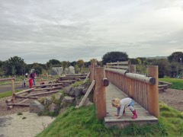

**Thursday 5th of July – Cuningar Loop Country Forest Park, Rutherglen -** Come and explore this country park adventure playground with its new and exciting equipment ranging from sand pits, climbing frames and tree tunnels. Then off to explore through the forest.

**LEAVING PREMISES: 9.30AM - RETURNING 4.30PM**

**PACK LUNCH REQUIRED**



**Friday 6th of July - Super Hero Fun Day**

Come and join in with our exciting super hero day!!!

The children will have the chance to turn into their favourite superheroes for the day. There will be face painting, costume building and exciting games/ activities run throughout the day!

**PACKED LUNCH REQUIRED**

**WEEK 2**



**Monday 9th of July – Wallace Monument –** A fun day outvisiting the place where history is something you can touch and feel, as you follow the story of Sir William Wallace.

**PACK LUNCH REQUIRED**

**LEAVING PREMISES: 10.30am RETURNING 4pm**

**PACKED LUNCH REQUIRED**



**Tuesday 10th of July – BOAT TRIP DOWN THE CANAL**

**PACKED LUNCH REQUIRED**

**LEAVING PREMISES: 12.45pm- 3.30PM**

**BOAT TIME: 1.30PM**

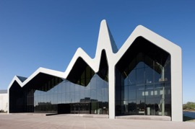

**Wednesday 11th of July – Riverside Museum** Come and see the 3,000 objects on display including some old favourites from the old transport museum. Exhibits include more interactive and hands-on activities for the children!

**PACKED LUNCH REQUIRED**

**LEAVING PREMISES: 9:00AM – RETURNING 3:00PM**



**Thursday 12th of July - Water fun -** Come and get wet with our super water fun day! Getting involved with water fights, water games and our crazy kids water slide!!!

**PACKED LUNCH REQUIRED**

**Please remember to bring a change of clothes, towel and shoes for after the water play.**

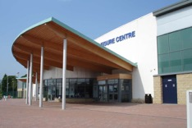

**Friday 13th of July – Leisure Centre Courts –** Enjoy the experience of playing, tennis, football, badminton and many more sports.

**PACK LUNCH RECQUIRED**

**LEAVING PREMISES 11AM- RETURNING 3PM**

**WEEK 3**

**Monday 23rd of July - Ayr Beach and Adventure Playground,**

This is one of our most popular visits! The children can play in the adventure park, then after lunch; enjoy playing on the beach as well as join in with our sand-castle competition.

**PACKED LUNCH REQUIRED**

**LEAVING PREMISES: 9:00AM - RETURNING 5:30PM**

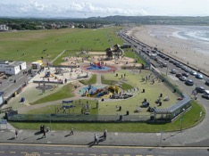

**Tuesday 24th of July – Causeway-head Park -** Come and explore this fantastic park situated below the Wallace Monument, great facilities and great wildlife trails.

**LEAVING PREMISES: 10AM – RETURNING 3PM**

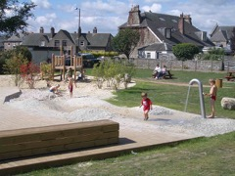**PACK LUNCH REQUIRED**

**Wednesday 25th of July - Lenzie Moss Loop –** A nature –walk around the Lenzie moss exploring the natural outdoors.

Pack lunch required.

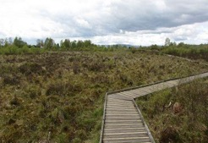**LEAVING PREMISES: 11AM – 2PM**

**PACK LUNCH REQUIRED**

**THURSDAY 26TH OF JULY - IM A KID GET ME OUT OF HEREEEEEEEEEE!**

Come join us for an exciting new adventure! Work as a team to complete gruesome bush tucker trails and spine-tingling challenges to win to chance to take over our luxury camp CROC CREEK

**WATCH OUT FOR THOSE CREEPY CRAWLIES!!!**

**PACKED LUNCH REQUIRED**

**Friday 27th July – Campsie walk –** Enjoy a peaceful walk through the hills, exploring the world outdoors.

**PACK LUNCH REQUIRED**

**LEAVING PREMISES - 1PM RETURNING 4PM**

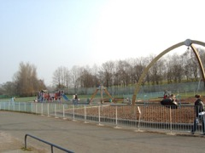

**WEEK 4**

**Monday 30th of July – Hogganfield Loch -** A leisurely stroll or scoot around the loch and then fun at the adventure playground on the slides, climbing frames, fling fox and much more.

**PACKED LUNCH REQUIRED**

**LEAVING 9AM RETURNING 4PM**



**Tuesday 31st July - The Great British Bake off –** Choose from a selection of ingredients to create your very own marvellous recipes in the morning and then onto making your delicious masterpieces, for all to try in the afternoon. Prize for the best creations!!!!

**PACKED LUNCH REQUIRED**



**Wednesday 1st August – Stirling University -**

Explore the grounds of the university feeding ducks, nature trials and the Art Gallery.

**PACK LUNCH REQUIRED**

**LEAVING PREMIESES 11AM RETURNING 4PM**

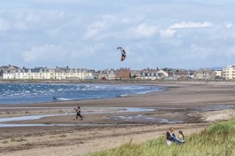

**Thursday 2nd of August – Troon Beach**

Join us for our sandcastle competitions on Troon Beach. The children can then dip their toes in the water, enjoying lunch and then onto the children’s play park

**PACKED LUNCH REQUIRED**

**LEAVING PREMISES: 9:00AM RETURNING 5:30 PM**



**Friday 3rd of August – Health and Well- being sports day (to be confirmed) –** Come along and take part in our health and well-being experiences. We have the fantastic sports squad coming to provide a fun filled sports day for the children to take part in.

**PACK LUNCH REQUIRED**

**WEEK 5**

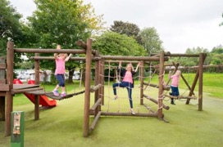

**Monday 6th of August – Balloch Country Park, Alexandria**

Join in with a trip to Balloch Country Park where all staff and children will take part in fun group sports. Then afterwards we can go for a walk around the park grounds and explore the surroundings.

**PACKED LUNCH REQUIRED**

**LEAVING PREMISES: 9:30AM RETURNING 4.30PM**

**Tuesday 7th of August** - **Ahoy there mateys!!!**

Come and join in with our fun filled day!! The children will make their own pirate props using lots of arts and craft materials and then take part in an exciting treasure trail to find the hidden treasure. Follow the clues to find the prize!!!

**PACKED LUNCH REQUIRED**



**Wednesday 8th of August - Tuesday 10th of July – BOAT TRIP DOWN THE CANAL**

**PACKED LUNCH REQUIRED**

**LEAVING PREMISES: 12.45pm- 3.30PM**

**BOAT TIME: 1.30PM**



**Thursday 9th of August – Peoples Palace –** Come along and join us to the People’s Palace is set in historic Glasgow Green. It is home to a collection of objects, photographs, prints and film which give a unique view into how Glaswegians lived, worked and played in years gone by to the present day.

**PACK LUNCH REQUIRED**

**LEAVING PREMISES 10AM RETURNING 4PM**



**Friday 10th of August** **– Local Park** - Come and join us to our local woodland park, with great facilities and woodland trails.

**PACK LUNCH REQUIRED**

**LEAVING PREMISES 11AM – RETURNING 3PM**

**WEEK 6**



**Monday 13th of August - Wednesday 4th of July – Large Field – Outdoor Games –** The children will have the opportunity to burn if their energy within a large grass field, football games, cricket, rounder’s, Capture the flag, skipping

**PACK LUNCH REQUIRED**

**Tuesday 14th of August - A mixture of indoor activities already taken place: Treasure hunt, Superhero day, Bake off, Sports Squad (waiting for confirmation). NO PACK LUNCH REQUIRED!!! A SPECIAL DOMINOS PIZZA TREAT!!**





**Please note: As we can’t predict the Scottish weather, some trips may change from day to day depending on the weather. We will keep you updated of any changes.**